Programming pins is SPI
TX/RX for seriall pins
Use 5v

Connect Arduino
Open ArduinoISP
Burn bootloader , Arduino as isp
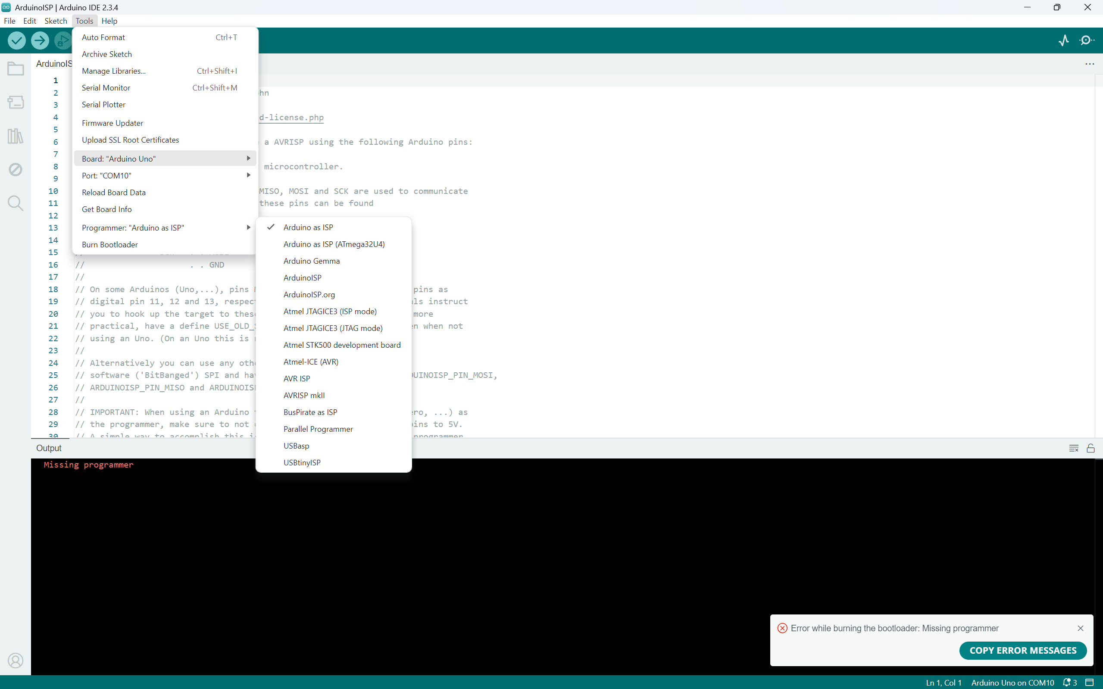

Then upload using programmer for rcode
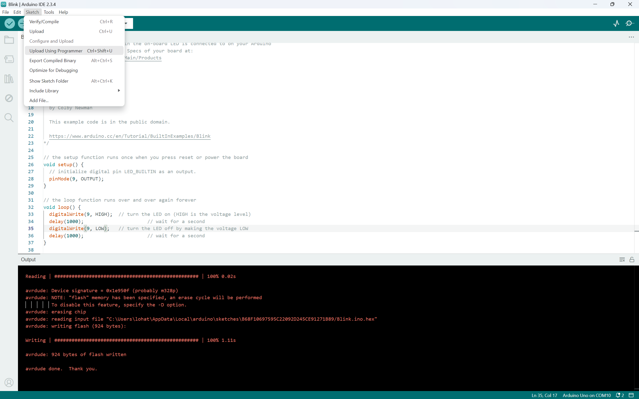

- Upload Arduino as ISP to Arduino Uno
- Connect Arduino to Atmega (RST, SCK, MISO, MOSI) -> (10, 13, 12 , 11)
- New Sketch -> tools -> programmer = Arduino as isp
  - Tools - > burn bootloader
- Get normal sketch
- Sketch -> upload using programmer
