OSDR_Q10

User’s Guide

V1.0



|  |  |  |  |
| --- | --- | --- | --- |
| Version | Changelog | Revised by | Data |
| V1.0 | New document | YingHong | 2021.2.18 |
|  |  |  |  |
|  |  |  |  |
|  |  |  |  |
|  |  |  |  |
|  |  |  |  |
|  |  |  |  |
|  |  |  |  |

**Contents**

**User's Guide**

**1 Introduction of SDR 3**

**2 Introduction of OSDR_Q10 4**

**2.1 Hardware architecture 4**

**2.2 Basic parameters 4**

**2.3 Interface and supporting materials 7**

**3 PC software 7**

**3.1 Version 7**

**3.2 Interface 7**

**4 Instructions 8**

**4.1 Power on/off 8**

**4.2 Automatic firmware upgrade 8**

**4.3 Connect computer 8**

**4.4 Parameter settings 9**

**4.5 RX 9**

**4.6 TX 11**

# **1 Introduction of SDR**

Software Defined Radio (SDR) is a radio broadcast communication technology,which is based on a software-defined wireless communication protocol instead of hardwired implementation.Frequency bands,air interface protocols and functions can be upgraded through software downloads and updates, without completely replacing the hardware.

The key idea of the so-called software radio is to construct an open, standardized, and modular general hardware platform. Various functions, such as working frequency band, modem type, data format, encryption mode, communication protocol, etc., are completed by software , And make the broadband A/D and D/A converters as close to the antenna as possible to develop a new generation of wireless communication systems with high flexibility and openness.This kind of platform can be controlled and redefined by software. Different functions can be realized by selecting different software modules, and the software can be upgraded and updated. Its hardware can also continuously update modules and upgrades just like computers. Because the various functions of software radio are realized by software, if you want to realize a new service or modulation mode, you only need to add a new software module. At the same time, because it can form various modulation waveforms and communication protocols, it can also communicate with various radio stations of the old system, which greatly extends the service life of the radio station and saves costs.

The main features of SDR:

（1）Flexibility. SDR can easily add new functions by adding software modules.

（2）Openness. SDR adopts a standardized and modular structure, the hardware can be updated or expanded with the development of devices and technologies.

# **2 Introduction of OSDR_Q10**

OSDR_Q10 is independent research and development by Orion Innovations Inc.，which can complete single/multi-channel data collection and RF signal receiving/sending similar as almost SDR equipment, its suitable for MIMO algorithm development.

# **2.1 Hardware architecture**

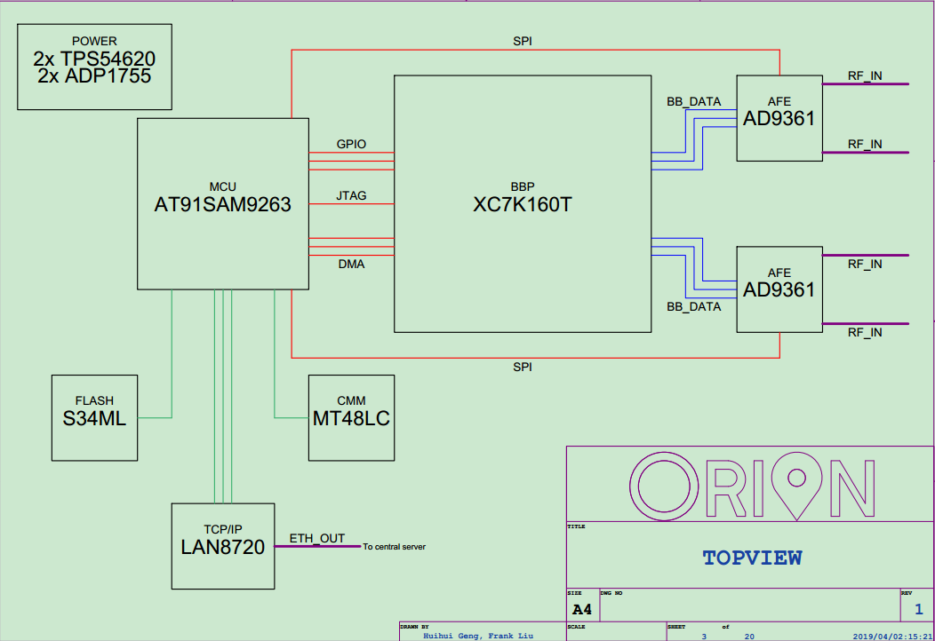

attention：Please confirm the FPGA model is XC7K160T or XC7K325T according to the actual product. OSDRs produced after July 2020 all use XC7K325T.

**2.2 Basic parameters**

|  |  |
| --- | --- |
| **Model** | **OSDR_Q10** |
| **Frequency** | **70MHz-6GHz** |
| **Bandwidth** | **200KHz-20MHz** |
| **Sampling depth** | **8bits** |
| **Sampling Rate** | **20-40MSPS** |
| **Tx channel** | **4** |
| **Rx channel** | **4** |
| **Operating mode** | **Tx/Rx/FDD** |
| **Interface** | **USB3.0，POE** |
| **FPGA editable logic gate** | **326K** |
| **Oscillator accuracy** | **+/-2ppm** |
| **Maximum tx gain** | **89dB** |
| **Maximum rx gain** | **71dB** |
| **IP** | **Automatic acquisition** |

**2.3 Interface and supporting materials**

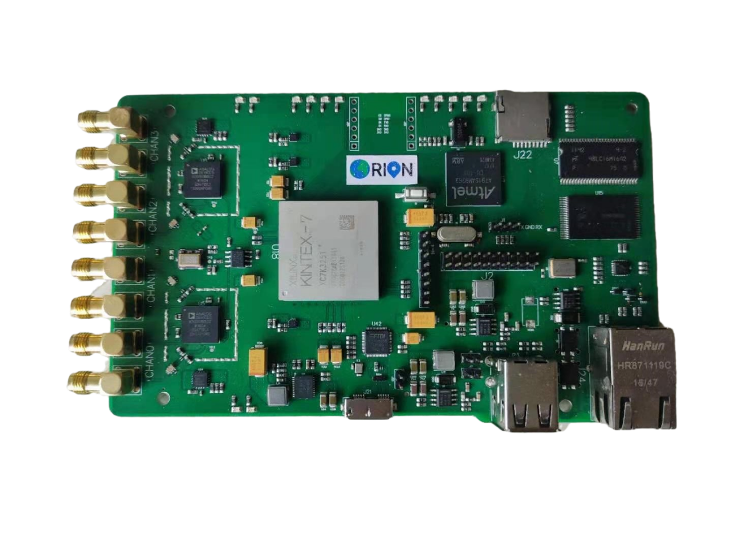

RX3

POE

USB2.0*2

USB3.0

TX3

RX2

TX2

TX1

TX0

RX1

RX0

Materials：USB3.0 line*1，cable*1，POE power plug*1

POE power plug：

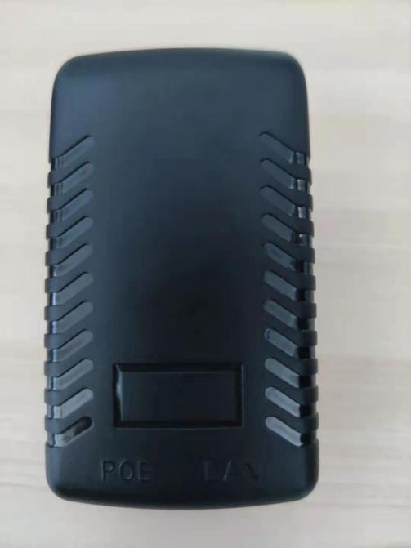

LAN口：Connect to router for network upgrade

POE口：Connect to OSDR

# **3 PC software**

## **3.1 Version**

This software is write by Orion Innovations Inc. which used to set the basic parameters of OSDR and receive/send signals，the name is "OSDR control panel", version V0.1。

## **3.2 Interface**

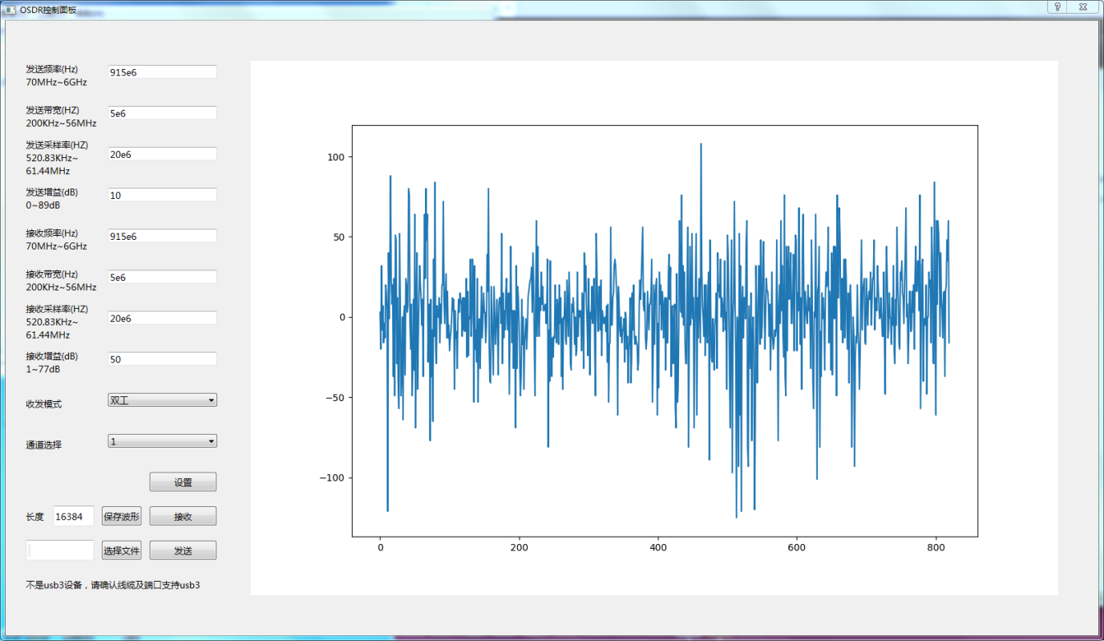

|  |  |  |  |
| --- | --- | --- | --- |
| TX | | TX | |
| Frequency | 70MHz~6GHz | Frequency | 70MHz~6GHz |
| Bandwidth | 200KHz~20MHz | Bandwidth | 200KHz~20MHz |
| Sampling depth | 20MHz~40MHz | Sampling depth | 20MHz~40MHz |
| Sampling Rate | 0~89dB | Sampling Rate | 1~71dB |

Mode select：TX，RX，FDD，停止，you can choose by yourself。

Channel select：Single channel（channel0），Two channels（channel 0，1），

Four channels（channel 0，1，2，3）。

# **4 Instructions**

## **4.1 Power on/off**

Power on: Connect the network cable to the POE port of the POE power plug and the OSDR network port, plug in the power ;

Power off: Disconnect the power to the POE power plug.

## **4.2 Auomatic firmware upgrade**

Depending on the firmware, the automatic update takes 5-10 minutes, and it needs to be performed once for the first startup. The operation steps are as follows：

1、Connect the network cable to the LAN port of the POE power plug and the LAN port of the router；

2、Power on the OSDR and wait for the upgrade to complete；

## **4.3 连接计算机**

开启上位机软件，显示“OSDR未连接”；

将USB3线接入OSDR的USB3接口和计算机USB口，若连接正常则显示“OSDR已连接”；

若计算机USB口不支持USB3，则显示“不是usb3设备，请确认线缆及端口支持usb3”，可以使用，但是会增加丢包概率；

目前一台计算机只支持同时使用一台OSDR设备，若计算机同时连接了多台OSDR设备，则显示“连接了多个OSDR设备，只支持一个设备”；

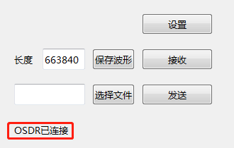

## **4.4 参数设置**

填写好频率、带宽、采样率和增益，并选择收发模式之后，点击“设置”，弹出“设置成功”，表示设置成功；

参数设置超出范围则会弹出“超出允许范围”；

若USB3未连接或者连接断开，则会弹出“参数写入错误”。

设置示例如下：

频率设置915MHz，可以输入915000000，也可以输入915e6，带宽设置同上，参数默认为整数，小数点后面会忽略，若输入915000000.123456789，虽然可以设置成功，但是实际数值为915000000Hz。

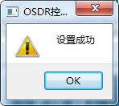 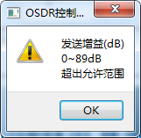 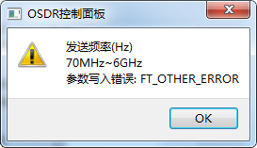

## **4.5 接收**

参数设置完成之后，填写好需要的数据长度（<999999），点击“接收”，会显示接收到的波形。

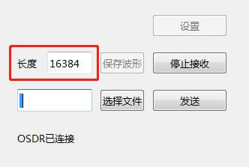

接收数据时无法保存波形，若需要保存相关数据，停止接收后，点击“保存波形”，文件默认格式为.bin格式文件，保存的数据为当前界面显示波形对应的数据，数据格式如下图：

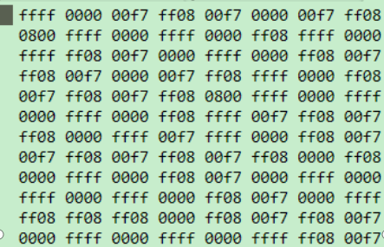

如文档中第一组数据“ffff”前两字节ff为该通道接收到的I数据，后两字节ff为该通道接收到的Q数据。

根据选择通道数量不同，分为以下几种：

1. 单通道：每组数据均为“通道0”接收到的数据；
2. 双通道：数据排列格式为“通道0，通道1，通道0，通道1......”

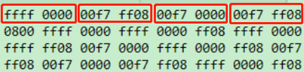

1. 四通道：数据排列格式为“通道0，通道1，通道2，通道3......”

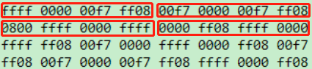

若在使用途中出现USB3线拔出等操作，则会出现“数据接收错误”弹窗，并需要重启软件之后才能继续操作。

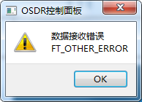

## **4.6 发送**

参数设置完成之后，点击“选择文件”，选择需要发送的文件，文件格式默认为.bin格式文件，数据格式和通道同上；

选择完成之后，点击“发送”，开始发送信号，发送按钮变为“停止发送”，文件内数据循环发送，点击“停止发送”可停止发送信号；

若未选择文件，点击“选择文件”，则弹出“文件不存在”；

