Lecture 3

February 4, 2019

**Basic Microcontroller Programming**

**Breadboard**

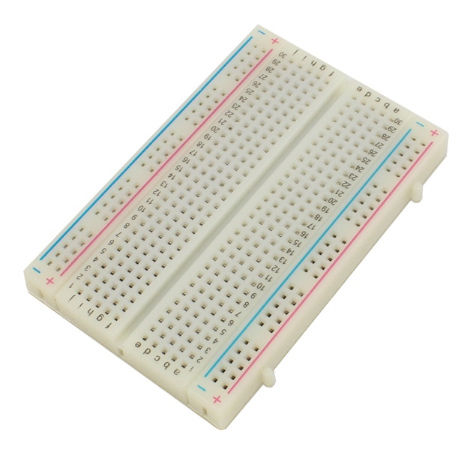

- Great for creating temporary circuits without any soldering

- Two sections of the Breadboard

Middle section (labeled alphabetically)

Each nodes in a row is connected

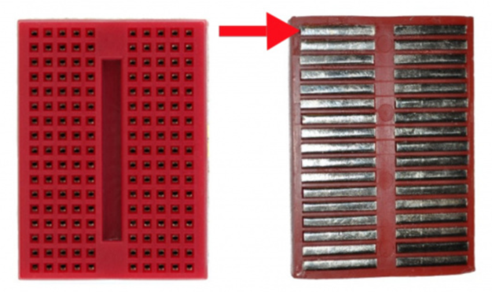

Outer section (labeled +/-)

Each nodes in a column is connected

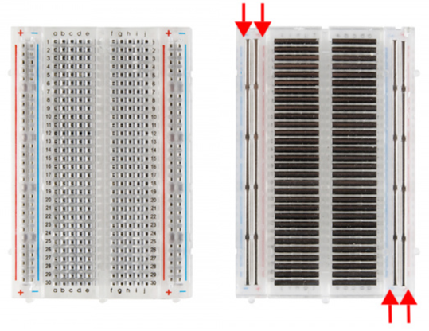

**Simple Project 1**

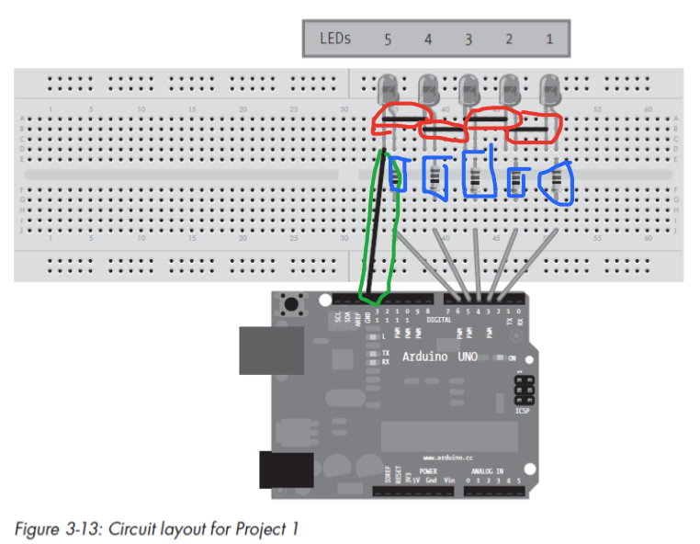

Green – Jumper wire connected to the ground port of the Arduino

To close electric circuits

Red – Jumper wire connecting all negative legs of the LED together

Blue – Resistor

Plugged into the positive legs of the LED

Resistors are useful as it limit the LED’S current. To find out what the resistor needs to do, utilize Ohm’s Law.

Ohm’s Law : V (Voltage) = I (Current) * R (Resistance)

What we know

Arduino outputs 5V : Vs

LED requires 1.7 V : Vf

Current : I : 10mA = 0.01A

Utilizing that, we can find the R

R = V / I

R = Vs – Vf / I

R = 5V – 1.7V / 0.01A

= 330 Ω

For now, we’ll be using 1000 Ω Resistor

**LED parts**

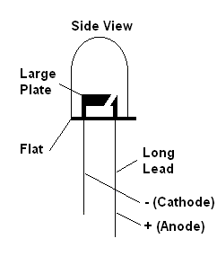

**Other way for Simple Project 1**

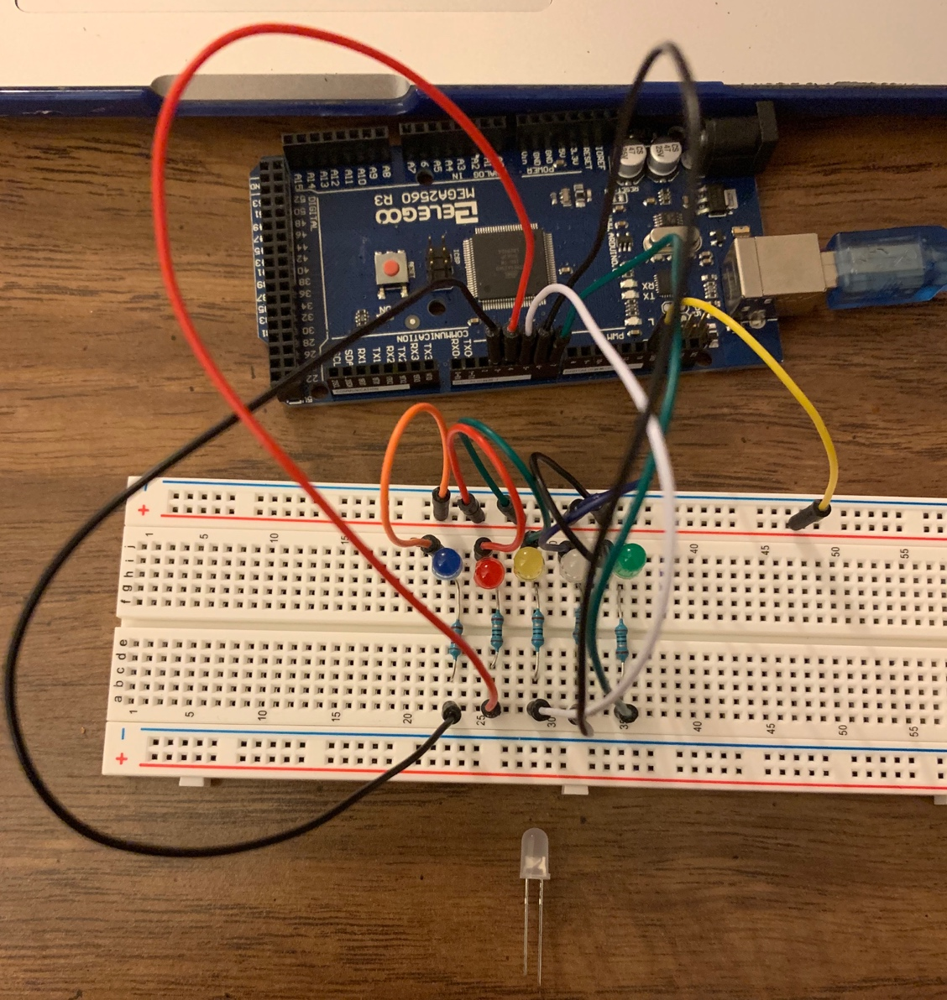

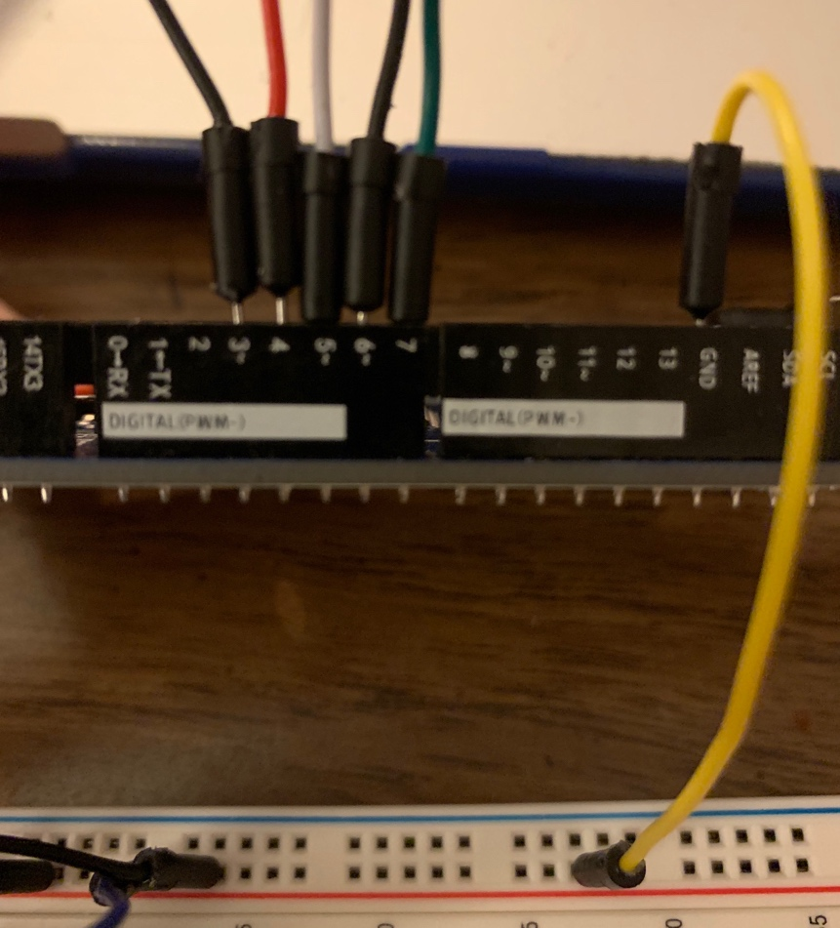

**Sketches**

Sketches are C programs

So you can utilize C logic

**Basic Sketch**

// Five LEDS blink sequentially for 500 milliseconds

void setup() {

pinMode(3,OUTPUT);

pinMode(4,OUTPUT);

pinMode(5,OUTPUT);

pinMode(6,OUTPUT);

pinMode(7,OUTPUT);

}

void loop() {

digitalWrite(3,HIGH);

delay(500);

digitalWrite(3,LOW);

digitalWrite(4,HIGH);

delay(500);

digitalWrite(4,LOW);

digitalWrite(5,HIGH);

delay(500);

digitalWrite(5,LOW);

digitalWrite(6,HIGH);

delay(500);

digitalWrite(6,LOW);

digitalWrite(7,HIGH);

delay(500);

digitalWrite(7,LOW);

}

**Formatted Basic Sketch**

int d = 500; // delay is 500 ms

void setup() {

pinMode(3,OUTPUT);

pinMode(4,OUTPUT);

pinMode(5,OUTPUT);

pinMode(6,OUTPUT);

pinMode(7,OUTPUT);

}

void loop() {

for(int a = 3; a < 8 ; ++a) {

digitalWrite(a,HIGH);

delay(d);

digitalWrite(a,LOW);

}

}

**Another Basic Sketch W/ analogWrite()**

// Each of the 5 LEDS blink slowly sequentially

int d = 5; // delay is 5ms

void setup() {

pinMode(3,OUTPUT);

pinMode(4,OUTPUT);

pinMode(5,OUTPUT);

pinMode(6,OUTPUT);

pinMode(7,OUTPUT);

}

void loop() {

for(int a = 3; a <= 7; a++) {

for(int b = 0; b < 256; ++b) {

analogWrite(a,b);

delay(d);

}

for(int b = 256; b >= 0; --b) {

analogWrite(a,b);

delay(d);

}

delay(200);

}

}