**4/18/2019**

-Instruction on how to install soil for Macs are available on Piazza now.

-Rigid Bodies: are defined by two state variables.

    - Position (x,y,z) coordinates

    - Orientation

-Purpose of World frame: in particular anything made in OpenGl is transformed to world frame. Directly computing in world frame is not optimal. Bottle necks are created because of this limitation.

-Material/Object Frame: is directly connected to an object created. It will have a relation to worldframe. Vector that goes from world frame and object frame show center of mass of object.

Rotation Matrix:

R = [ x’ y’ z’] (vectors)

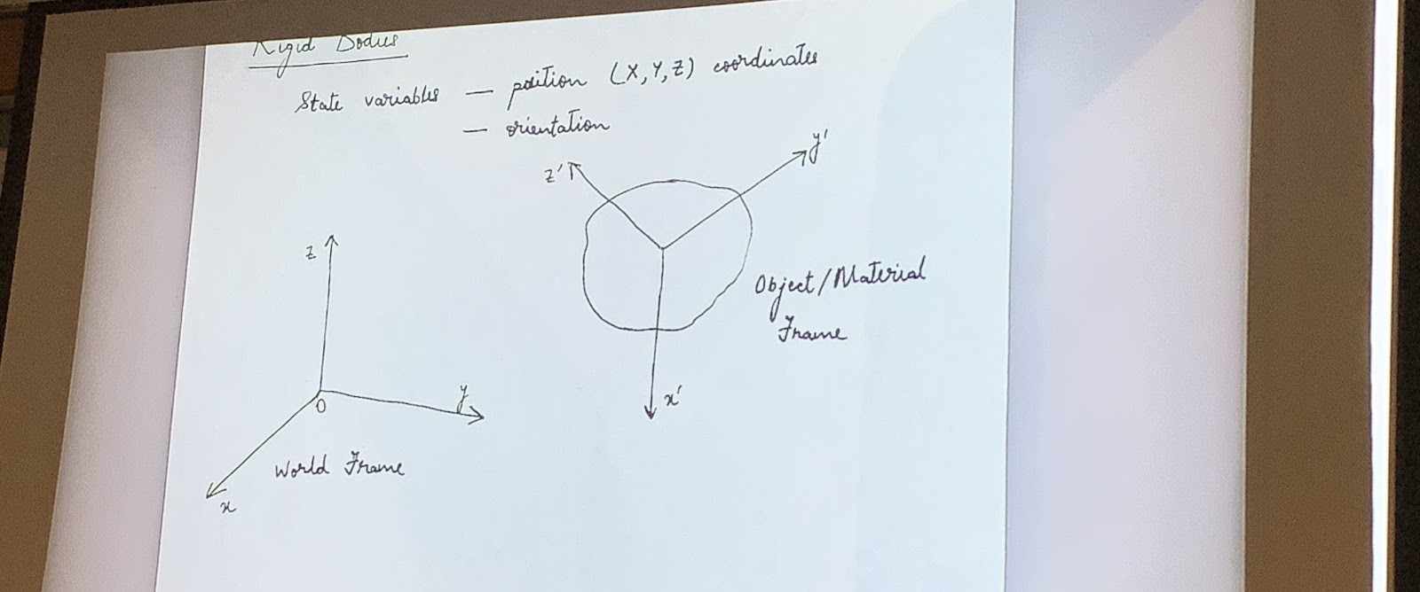

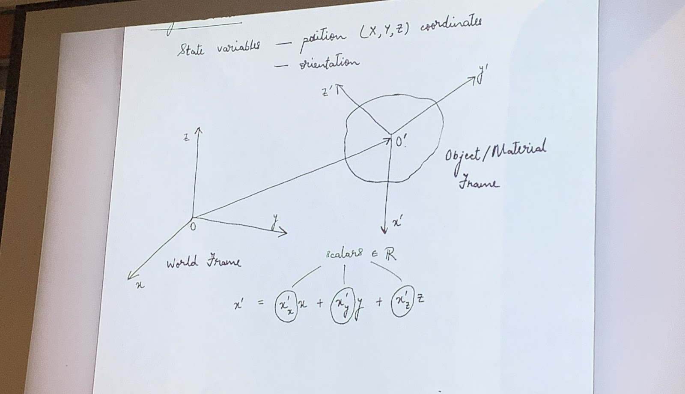

Prime Transpose vectors = 0 basically they are orthogonal to each other.

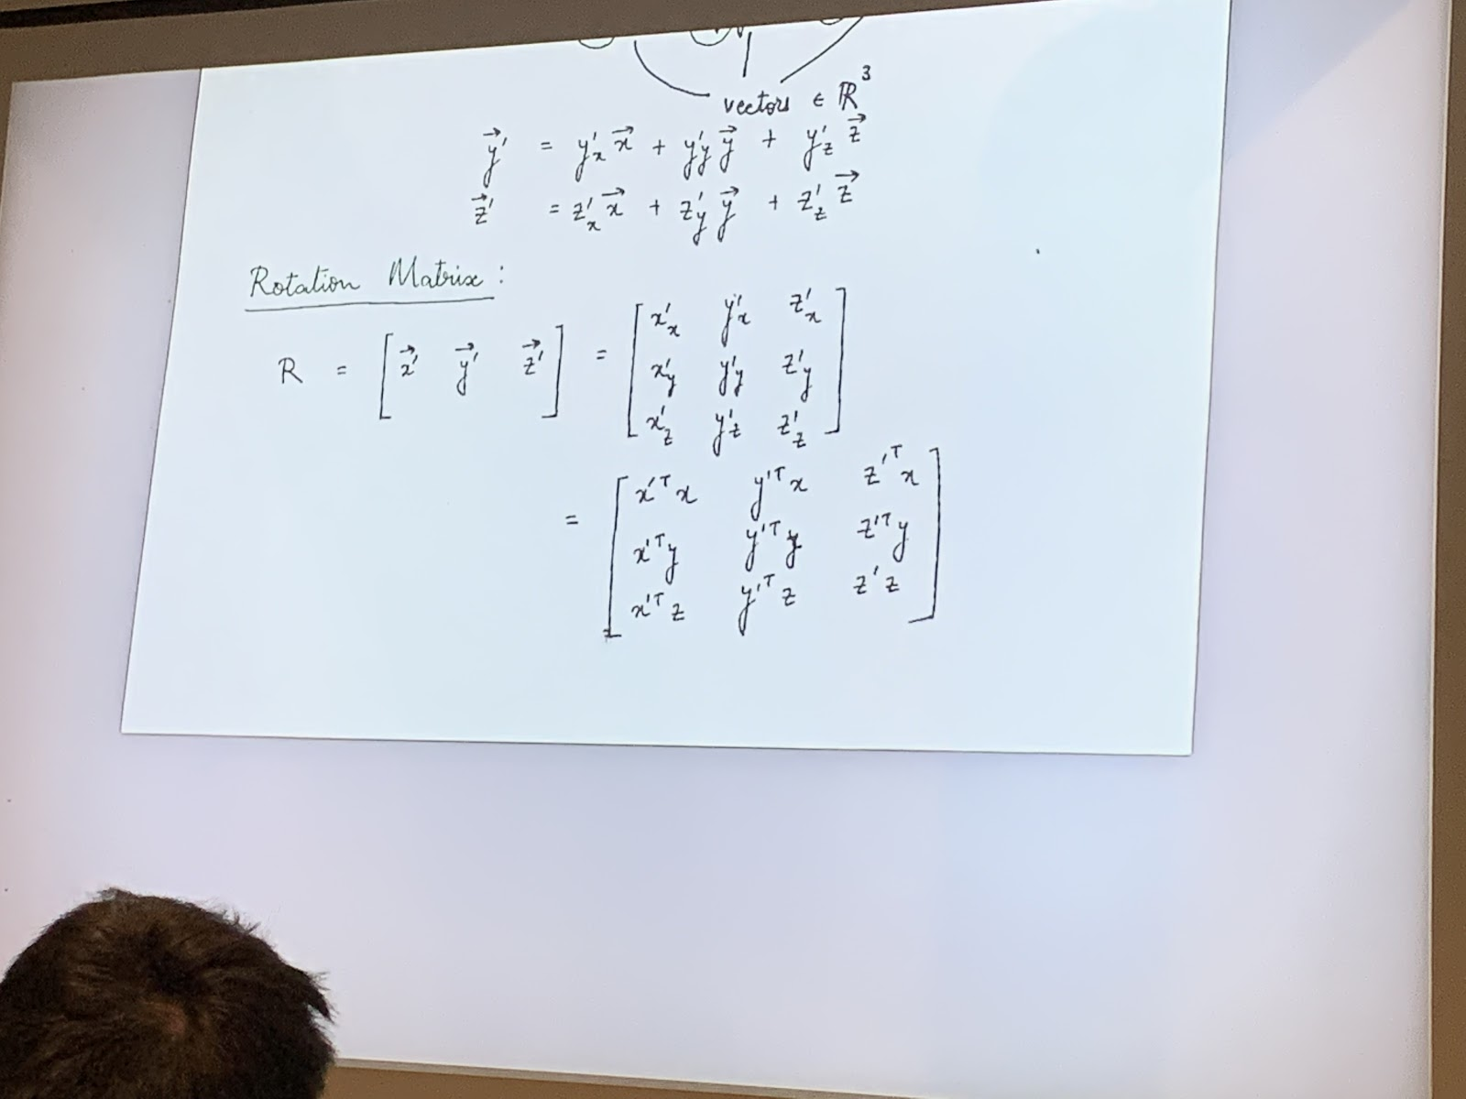

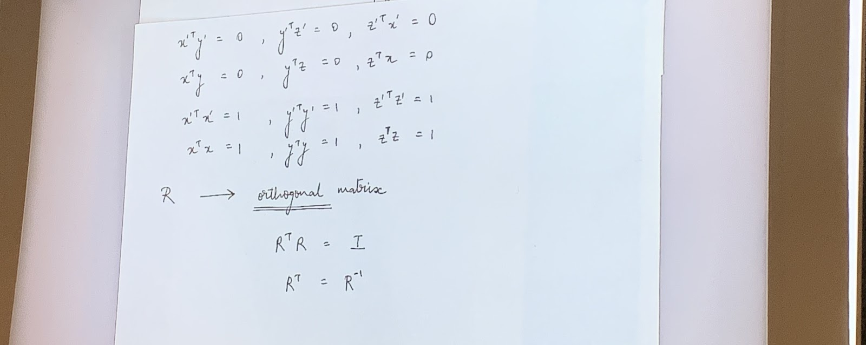

Transpose vectors themselves =  1… rotational matrix is orthogonal matrix.

R → orthogonal matrix.

So if u have to apply inverse rotation. Multiply by the transpose.

det(R) = |R| = 1 … right handed system

det(R) = |R| = -1 … left handed system

**-Elementary Rotations:**

Let’s suppose we have a plane with x,y,z coordinates and we slightly rotate it with respect to z axis. Where we have x’ and y’. Z remains the same z = z’.

Rotation matrix would be

| cos (alpha)   -sin(alpha) 0 |

| sin(alpha)      cos(alpha) 0 | = Rz(alpha)

| 0                     0 1 |

_________________________________________________________________________

| cos(beta)     0 sin(beta)  |

| 0                  1 0 |   = Ry(beta)

| -sin(beta)     0 cos(beta) |

_________________________________________________________________________

| 1                 0 0               |

| 0     cos(gamma)       -sin(gamma) | = Rx (gamma)

| 0     sin(gamma)        cos(gamma) |

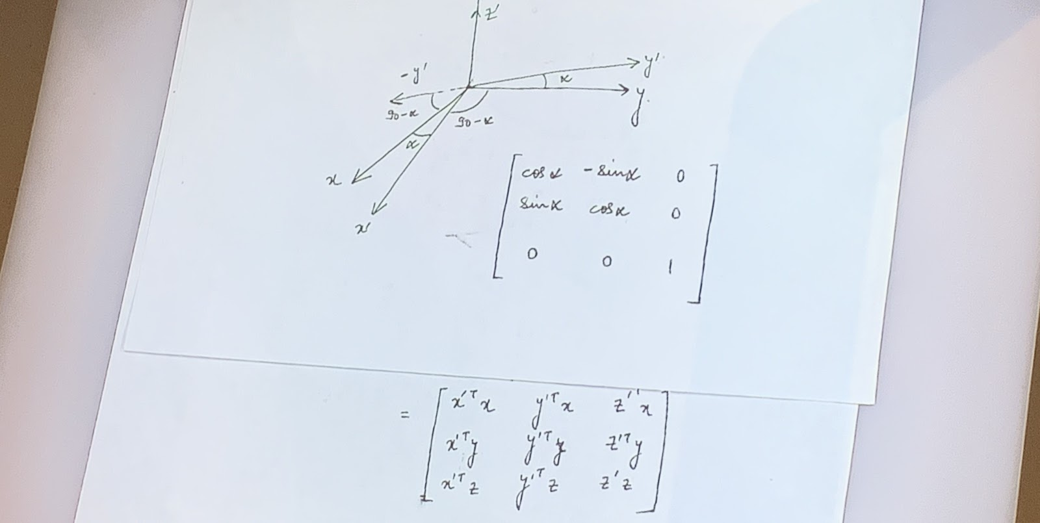

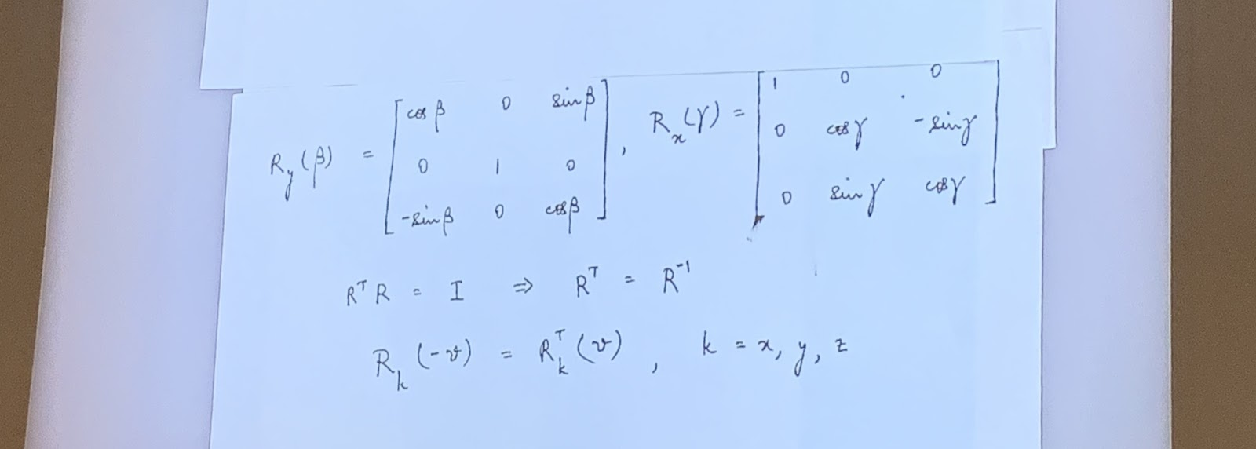

If you rotate by negative V degrees then it is the same as transpose rotating by v degrees.

-Now consider two planes, one with x,y,z vectors and the other with x’,y’,z’ vectors.

What is the relation between P and P’ given in an absolute space?

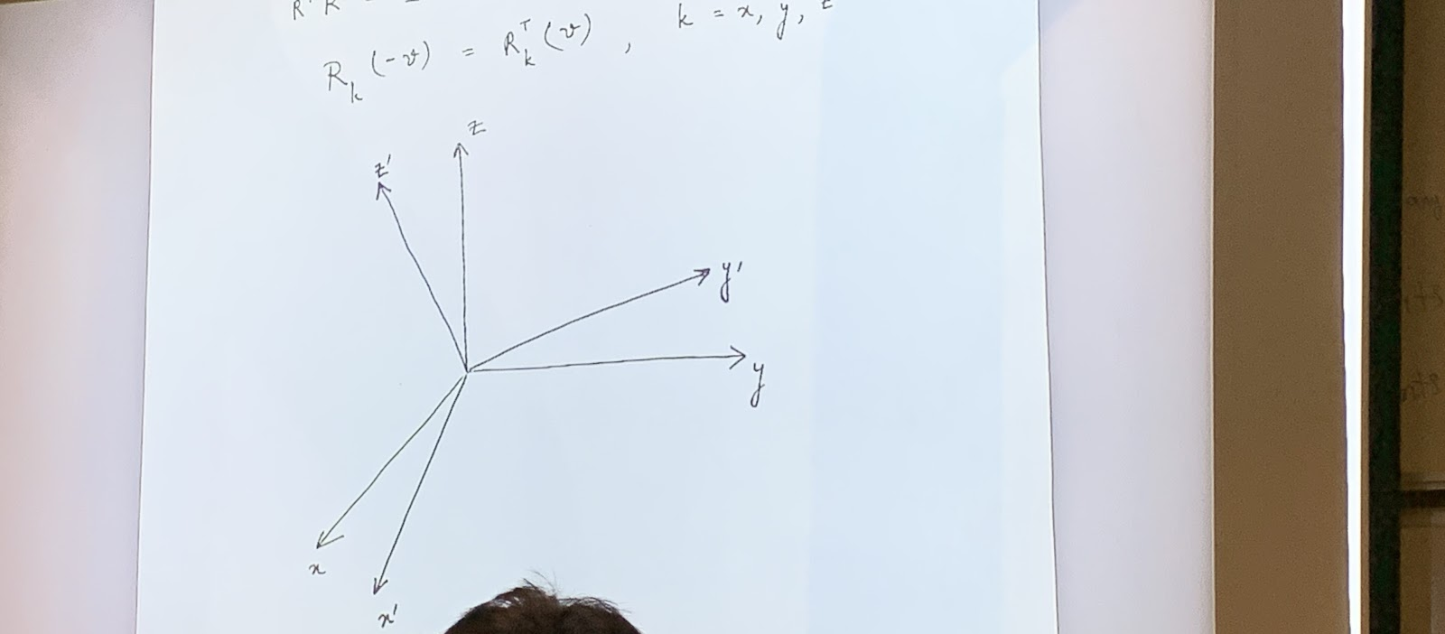

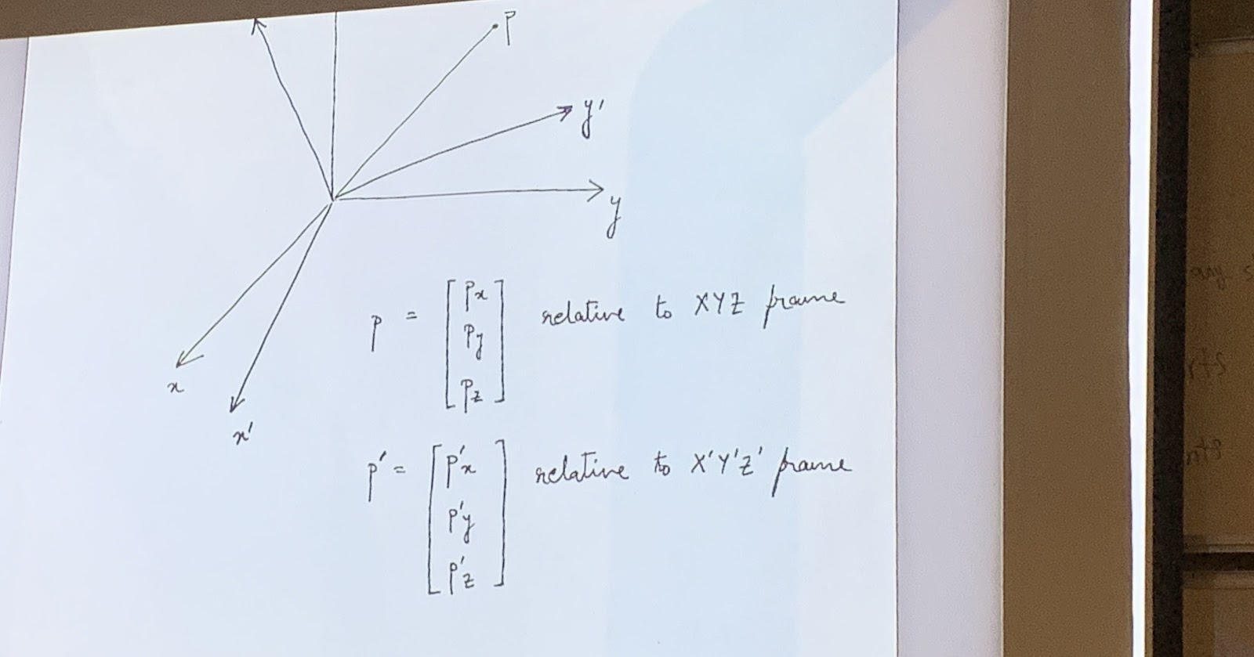



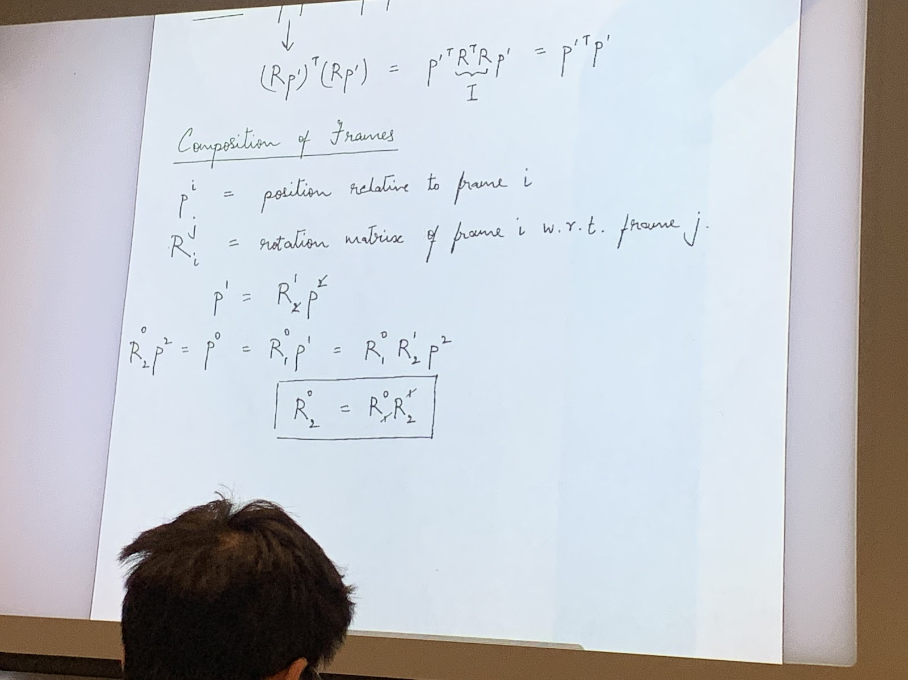

Composition of frames:

p^i= position relative to frame i

R^j i = rotation matrix of frame i w.r.t frame j.

-Commutative property: AB = BA

Does not apply to rotation matrix.

-Rotations along the plane

    Rotate along z and then y.

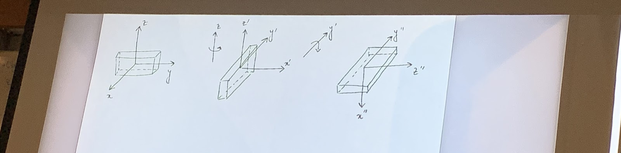

    Do the reverse. Rotate about y and then z.

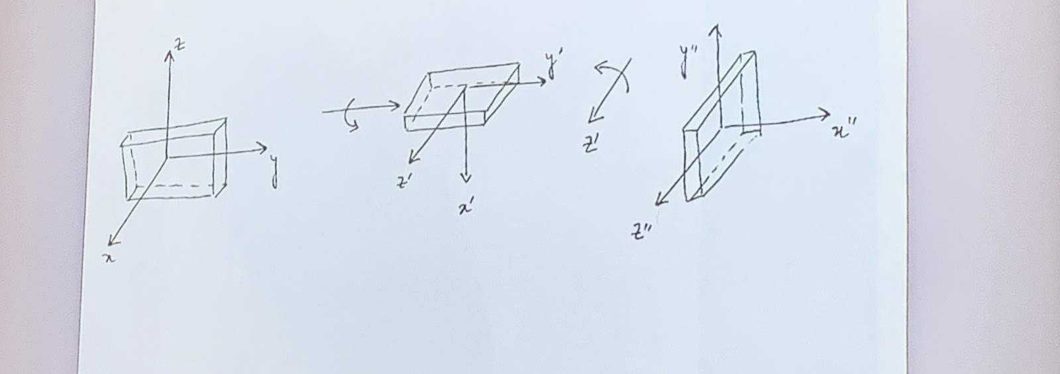

The result is different. Hence order matters. What if we apply rotation w.r.t one fixed frame?

(picture) the object is upright

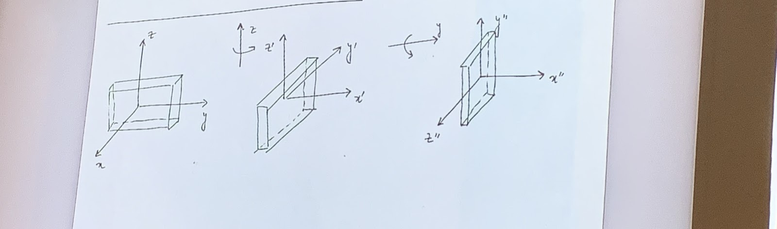

Now, do the reverse rotation

(picture) the object is flat.

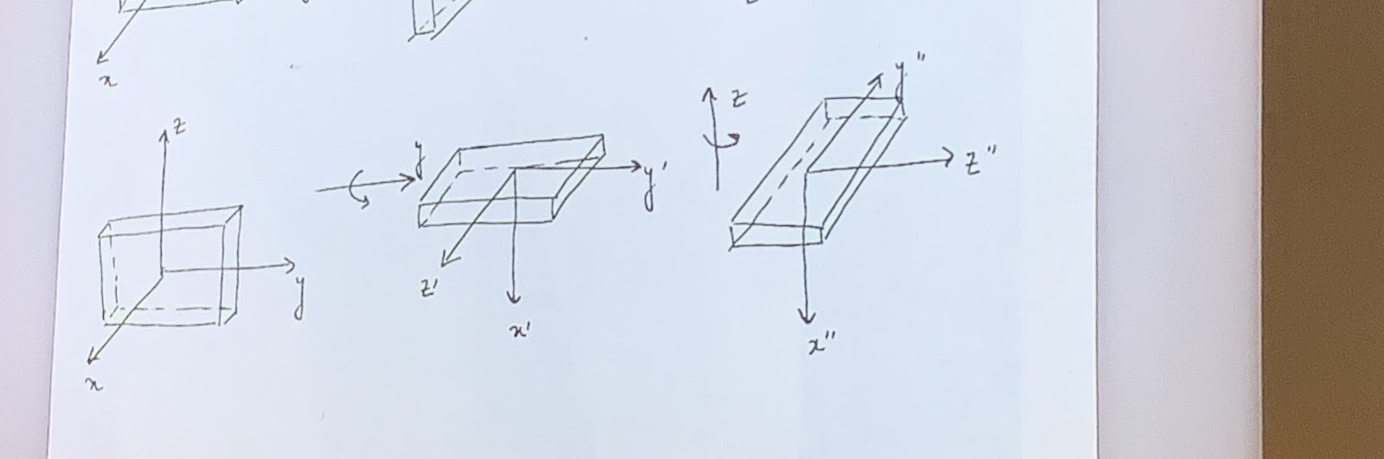

So even with fixed frame, the rotation does not commute.