Internship Report
Artificial Intelligence and Machine Learning

Dlithe Consultancy Services Pvt. Ltd.


Internship Report

Intern Name: Pratham Ganji
Reg. no: 4NM21IS108
Period:
Job Assignment:
Organization: Dlithe Consultancy Services Pvt. Ltd.
Supervisor’s Name:

Observations:

Submitted To:

Signature of Training Supervisor Signature of Co-ordinator
Date: Date:

Letter of Transmittal

To,
Program Co-ordinator
DLithe Consultancy services
Bengaluru

Dear Sir/Madam,

I am writing to submit my report on the AIML Internship Program that I recently completed. The training program was an invaluable learning experience, and I am grateful for the opportunity to participate.
The training program covered various aspects of AI and ML, including basic concepts, algorithms, programming languages, and practical applications. I gained a comprehensive understanding of the role of AI and ML in modern technology and industry, and also gained hands-on experience with AI and ML tools and platforms. The training highlighted the potential of AI and ML to revolutionize various fields, including healthcare, finance, and manufacturing.
The report includes a detailed overview of the training program, including the topics covered, the learning objectives, and the outcomes achieved. It also provides observations and insights into the potential benefits and challenges of implementing AI and ML solutions in different fields.
I believe that the knowledge and skills that I acquired during the training program will be valuable to our organization. AI and ML are rapidly becoming more ubiquitous in various industries, and the ability to work with AI and ML tools and platforms will be increasingly important for our organization's success.
I hope that the report provides useful insights into the benefits of on-job training and the potential of AI and ML.

Sincerely,

Name: Pratham Ganji

Reg. no: 4NM21IS108

Table Of Contents

Sl. No | Content | Page No
1 | Introduction | 5
2 | Overview | 5
3 | Problem Statement | 6
4 | Solution Methodology | 6
5 | Tools and Technologies Used | 7
6 | Hardware Requirements | 8
7 | Software Requirements | 8
8 | Schematics and Code | 9
9 | Result | 13
10 | Project / Use Case Implementation | 14
11 | Literature Survey | 16
12 | Training Experience | 18
13 | Observation | 19
14 | Key Learnings | 20
15 | Conclusion | 21

Introduction
Artificial Intelligence and Machine Learning are two of the most popular and rapidly growing fields in computer science. They are transforming the way we live, work, and interact with technology. The purpose of this report is to provide an overview of my Internship Training experience on Artificial Intelligence and Machine Learning, and to describe the various concepts and techniques that I learned during the training.
Overview
The Internship Training program on Artificial Intelligence and Machine Learning that I participated in was conducted by a technology company. The program was designed to provide a comprehensive overview of the latest advancements in the field of AI and ML, and to equip participants with the skills and knowledge required to build intelligent systems and applications.
The training program consisted of practical hands-on sessions. The lectures covered a wide range of topics, including the fundamentals of AI and ML, various techniques and algorithms used in machine learning, and the latest developments in deep learning and neural networks. The practical sessions involved working on various projects and implementing machine learning algorithms on real-world datasets.

Problem Statement
Accurately estimating the number of calories burned during physical activity can be difficult because calorie expenditure varies from person to person depending on factors such as age, gender, height, weight, exercise duration, heart rate, and body temperature. Traditional methods often rely on generalized calculations that may not accurately reflect an individual's actual energy expenditure. Therefore, there is a need for a machine learning-based system that can analyze these factors and predict the approximate number of calories burned during exercise. The proposed project aims to develop a Calorie Burn Prediction System that uses relevant personal and exercise-related data to train a machine learning regression model and provide calorie-burn predictions for new users. The system is designed to provide a simple and accessible way for users to estimate their energy expenditure and support fitness and activity monitoring.

Solution Methodology
The proposed Calorie Burn Prediction System follows a systematic machine learning methodology to predict the calories burned during physical activity.
Data Collection: A dataset containing attributes such as Gender, Age, Height, Weight, Exercise Duration, Heart Rate, Body Temperature, and Calories Burned is collected.
Data Preprocessing: The dataset is cleaned by handling missing values, removing duplicate records, and converting categorical values such as gender into numerical form. The data is prepared for machine learning.
Feature Selection: Relevant input features such as age, gender, height, weight, duration, heart rate, and body temperature are selected. Calories Burned is considered the target variable.
Data Splitting: The dataset is divided into training and testing sets. The training data is used to build the model, while the testing data is used to evaluate its performance.
Model Training: Regression-based machine learning algorithms are trained using the selected features to learn the relationship between an individual's characteristics, exercise parameters, and calorie expenditure.
Model Evaluation: The trained models are evaluated using performance metrics such as MAE, MSE, and R² Score to determine their prediction accuracy.
Prediction and Deployment: The best-performing model is saved and integrated into a Streamlit application. Users can enter their details, and the system processes the input and displays the predicted calories burned.
Result Analysis: The predictions and model performance are analyzed to determine the effectiveness and practical usability of the proposed system.
Tools and Technologies Used:
During the project, I used various tools and technologies such as:
Python: for data preprocessing, feature selection, and model training.
Scikit-Learn: for clustering algorithm selection and model training.
Matplotlib: for data visualization.
Jupyter Notebook: for creating and running the code.

Hardware Requirements
Processor: Intel Core i5 or equivalent processor
RAM: Minimum 8 GB
Storage: Minimum 10 GB of available storage
Display: 1366 × 768 resolution or higher
Internet Connection: Required for downloading libraries, datasets, and deploying the application
Software Requirements
Operating System: Windows 10/11, Linux, or macOS
Programming Language: Python 3
Development Environment: Visual Studio Code / Jupyter Notebook
Libraries: Pandas, NumPy, Scikit-learn, Matplotlib, Joblib, streamlit
Web Framework: Streamlit
Dataset: Calorie Burn Prediction dataset in CSV format
Machine Learning: Regression-based machine learning algorithms
Browser: Google Chrome, Microsoft Edge, or Mozilla Firefox

Schematics and Code
Flowchart:
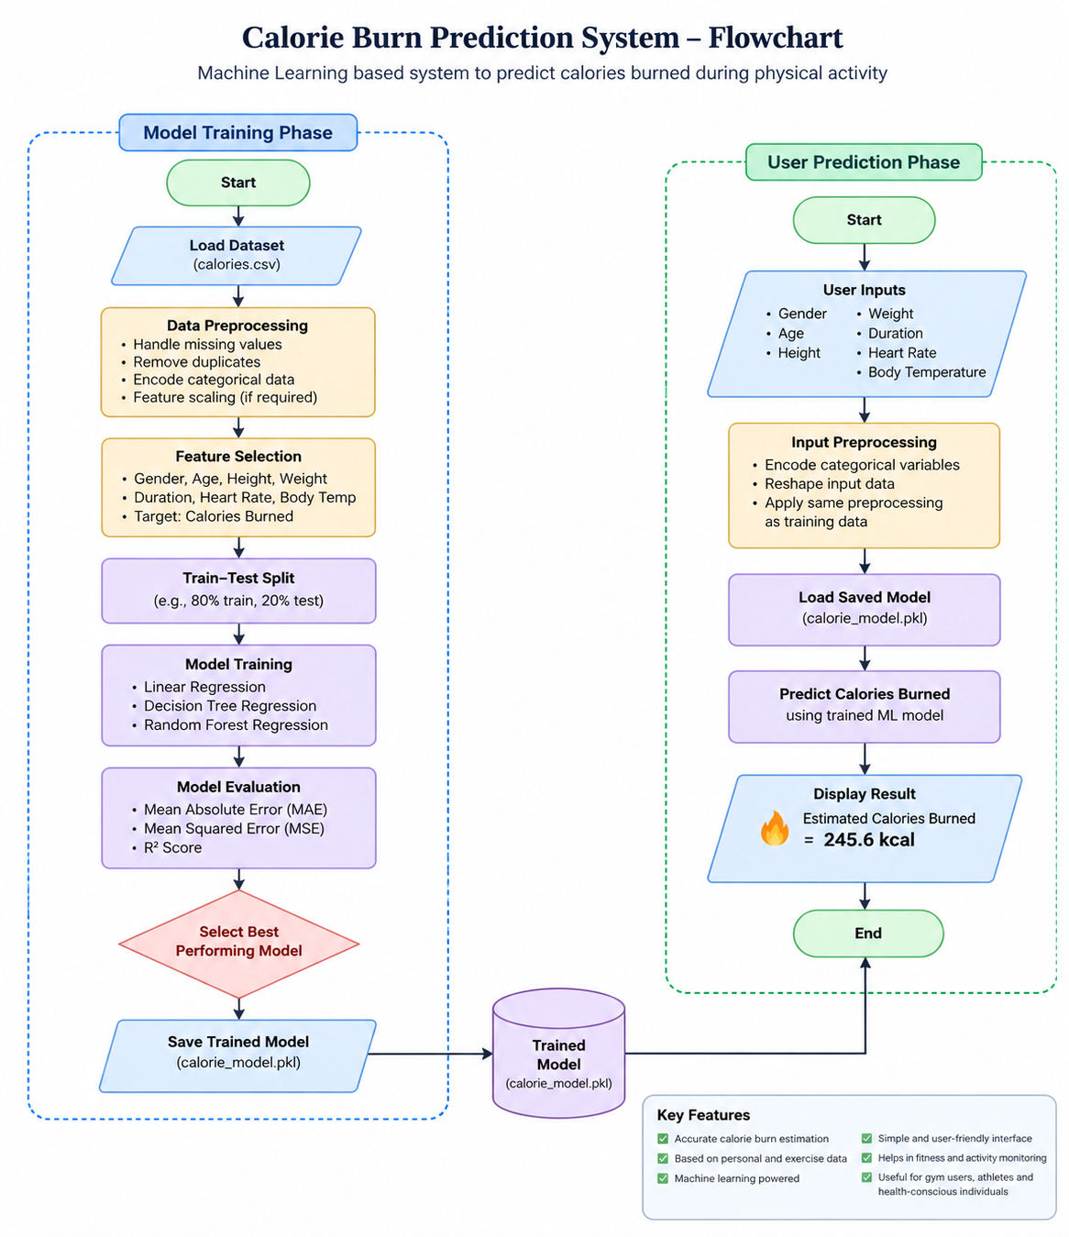

Actual v/s Predicted Calories (For the selected Model):
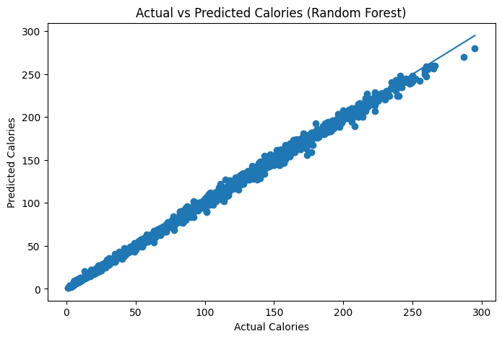
Comparison of R2 scores:
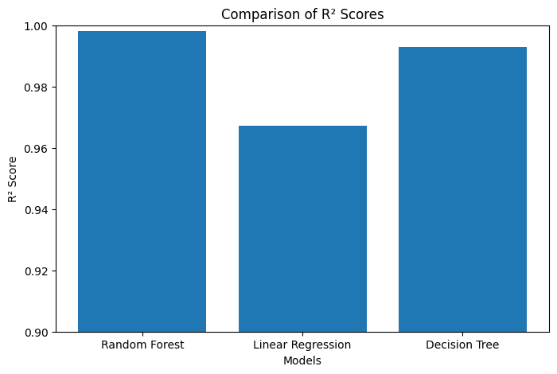
Comparison of MAE:
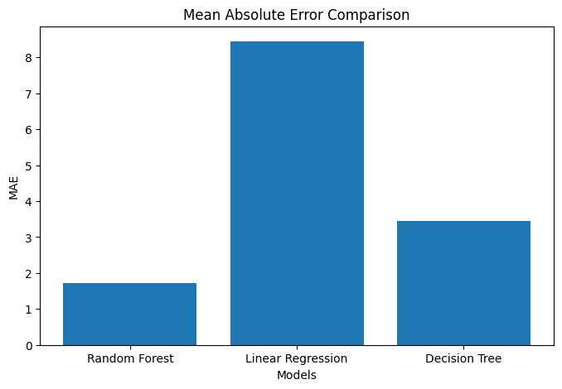
Important Code Snippets:
Data Pre-processing:
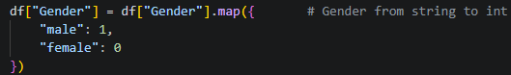
Feature and Target Selection and Train-Test Split:
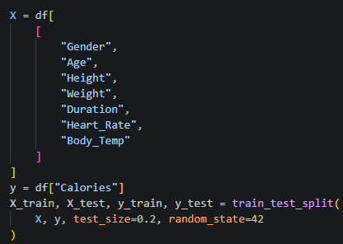
Model Training and Prediction:
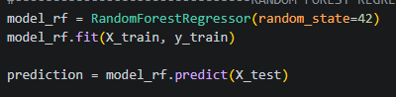
Streamlit Interface:
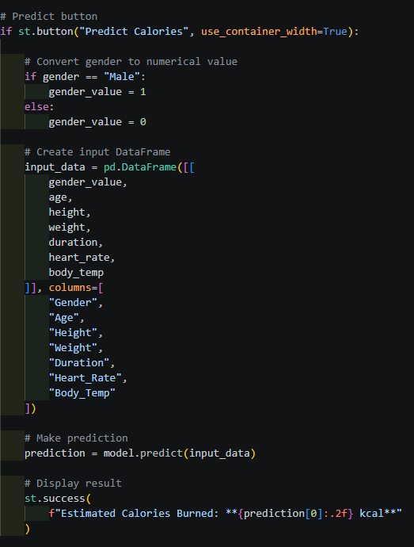
Result
The developed Calorie Burn Prediction system was successfully implemented using machine learning techniques. The model was trained using important features such as Gender, Age, Height, Weight, Duration, Heart Rate, and Body Temperature to predict the number of calories burned during physical activity.
The trained models were evaluated using Mean Absolute Error (MAE), Mean Squared Error (MSE), and R² Score. Based on the evaluation results, the best-performing regression model was selected for the final prediction system. The selected model was then integrated into a Streamlit web application, allowing users to enter their personal and exercise-related information and obtain an estimated calorie-burn value.
The system provides predictions quickly and presents the results in a simple and user-friendly interface. The results demonstrate that machine learning can effectively identify relationships between physical characteristics, exercise intensity, and calorie expenditure. The developed application can therefore serve as a useful tool for fitness tracking and calorie expenditure estimation.

Project / Use Case implementation
The objective of the project was to predict the number of calories burned by an individual during physical activity based on their personal and exercise-related characteristics. This would help fitness enthusiasts and individuals monitor their energy expenditure and better understand the relationship between exercise intensity and calorie consumption.
Data Collection: The first step was to collect a dataset containing information such as Gender, Age, Height, Weight, Exercise Duration, Heart Rate, Body Temperature, and Calories Burned. These attributes provide relevant information about an individual's physical characteristics and exercise intensity.
Data Preprocessing: The collected data was pre-processed to improve its quality and suitability for machine learning. Missing values and duplicate records were handled, and unnecessary attributes were removed. Categorical data such as gender was converted into numerical values using encoding techniques. The dataset was then prepared for model training.
Feature Selection: Relevant features such as Gender, Age, Height, Weight, Duration, Heart Rate, and Body Temperature were selected as input variables. The Calories Burned attribute was used as the target variable that the model had to predict.
Algorithm Selection: Different machine learning regression algorithms such as Linear Regression, Decision Tree Regression, and Random Forest Regression were considered and evaluated. These algorithms were compared using suitable regression evaluation metrics to identify the model that provided the best prediction performance.
Model Training: The selected machine learning algorithm was trained using the pre-processed dataset. The dataset was divided into training and testing sets, allowing the model to learn patterns from the training data and evaluate its performance on unseen testing data.
Model Evaluation: The trained model was evaluated using metrics such as Mean Absolute Error (MAE), Mean Squared Error (MSE), and R² Score. These metrics were used to measure the accuracy and reliability of the calorie-burn predictions.
Prediction: After training and evaluation, the best-performing model was used to predict calories burned for new user inputs. The user can provide details such as age, gender, height, weight, exercise duration, heart rate, and body temperature, and the system generates an estimated calorie-burn value.
Results Visualization: The prediction results and model performance were visualized using charts and graphs where appropriate. A Streamlit-based user interface was also developed to make the system interactive and easy to use.
Use Case: The developed system can be used by gym users, fitness enthusiasts, athletes, and individuals tracking their physical activity to obtain an estimated calorie expenditure based on their exercise and physiological parameters.

Literature Survey
1. Cvetković et al. (2016)
“Estimating Energy Expenditure with Multiple Models Using Different Wearable Sensors”
Cvetković et al. used multiple wearable sensors and regression models to estimate human energy expenditure. Their results showed that combining sensor data could significantly improve prediction accuracy.
2. Zhu et al. (2015)
“Using Deep Learning for Energy Expenditure Estimation with Wearable Sensors”
Zhu et al. used Convolutional Neural Networks (CNNs) with accelerometer and heart-rate data to estimate energy expenditure. The CNN model achieved better results than traditional regression and ANN-based approaches.
3. Xiao et al. (2020)
“Activity-Specific Caloric Expenditure Estimation from Kinetic Energy Harvesting in Wearable Devices”
Xiao et al. used Random Forest regression and wearable kinetic-energy data to estimate calorie expenditure for different activities. The study demonstrated effective calorie prediction while reducing dependence on conventional accelerometer sensors.
4. Eom et al. (2021)
“Deep Learning-Based Optimal Smart Shoes Sensor Selection for Energy Expenditure and Heart Rate Estimation”
Eom et al. developed a deep learning model using smart-shoe sensors to estimate energy expenditure and heart rate. The study showed that selecting relevant sensor data can improve prediction performance.

5. Lopes et al. (2022)
“Deep Learning-Based Energy Expenditure Estimation in Assisted and Non-Assisted Gait Using Inertial, EMG, and Heart Rate Wearable Sensors”
Lopes et al. compared CNN and LSTM models for estimating energy expenditure using motion, EMG, and heart-rate data. Their results demonstrated that deep learning can provide effective energy-expenditure estimation during walking activities

Training Experience
Hands-on Learning: My training program was designed to provide hands-on experience with AI and ML tools and technologies. I was given the opportunity to work on real-world projects and problems, which helped me develop practical skills and apply theoretical concepts.
Mentorship: I was fortunate to have a mentor who was an experienced AI and ML professional. My mentor provided guidance, feedback, and support throughout my training program, which was invaluable in my learning journey.
Collaboration: One of the most exciting aspects of my training program was the opportunity to work with a team of professionals from different backgrounds. We collaborated on projects and shared ideas, which helped me develop my communication and collaboration skills.
Exposure to Industry Trends: I was able to stay up-to-date with the latest industry trends and developments in AI and ML through various workshops, seminars, and conferences. This helped me gain a broader perspective on the field and prepare for future challenges.
Use of Industry-standard Tools and Technologies: During my training, I had the opportunity to work with industry-standard tools and technologies such as Python, Streamlit and Scikit-Learn. This allowed me to gain practical skills that are in demand in the industry.
Importance of Data Preparation: One of the most important lessons I learned during my training was the critical role of data preparation in the success of AI and ML projects. I learned how to collect, clean, and preprocess data to make it suitable for training models.
Iterative Process: I also learned that developing an AI or ML model is an iterative process that requires a lot of experimentation and tweaking. It is essential to have a feedback loop that allows for continuous improvement of the model.

Observations:
During my on-job training on Artificial Intelligence (AI) and Machine Learning (ML), I was able to observe several important things. Here are my observations:
Importance of Data: The success of AI and ML models heavily depends on the quality and quantity of data available for training. Without the right data, it is difficult to build accurate and effective models. Therefore, data preparation and cleaning is a critical step in the ML pipeline.
Diversity of Applications: AI and ML can be applied in various domains, from healthcare to finance, from retail to transportation. The applications are diverse and endless, and the potential impact of AI and ML on society is enormous.
Iterative Process: Developing an AI or ML model is an iterative process that requires a lot of experimentation and tweaking. It is essential to have a feedback loop that allows for continuous improvement of the model.
Algorithm Selection: There is no one-size-fits-all algorithm for ML. The choice of algorithm depends on the specific problem being solved, the type of data available, and the desired output. It is crucial to have a good understanding of different algorithms and their strengths and weaknesses.
Ethics and Bias: The development of AI and ML models raises ethical and bias concerns. Biases can be introduced through the data used to train the model, and it is crucial to ensure that the model is fair and unbiased.
Importance of Visualization: Visualization is a powerful tool for exploring and understanding data. It can help identify patterns and trends in the data, which can be used to improve the model's performance.
Role of Domain Experts: Domain experts play a critical role in the development of AI and ML models. They have a deep understanding of the problem and the data, which can help identify the right features and improve the model's performance.
Importance of Communication: Effective communication is critical when working with cross-functional teams. Clear communication of goals, expectations, and results is essential for success.
Key Learnings
During the training program, I learned a range of skills and concepts related to Artificial Intelligence and Machine Learning. Some of the key skills that I acquired are:
Understanding of Artificial Intelligence: I gained a comprehensive understanding of Artificial Intelligence, including the various subfields such as Machine Learning, Deep Learning, and Natural Language Processing.
Machine Learning Concepts and Algorithms: I learned about various Machine Learning concepts and algorithms, including Supervised and Unsupervised Learning, Decision Trees, Random Forests, Support Vector Machines, and K-Nearest Neighbours.
Programming Skills: I developed strong programming skills in Python, including libraries such as Numpy, Pandas, and Matplotlib.
Data Preprocessing and Analysis: I learned various techniques for data preprocessing and analysis, including Data Cleaning, Data Wrangling, and Exploratory Data Analysis.

Conclusion
The Calorie Burn Prediction project successfully demonstrates the application of machine learning techniques to estimate the number of calories burned during physical activity. By using important parameters such as gender, age, height, weight, exercise duration, heart rate, and body temperature, the system can identify patterns related to calorie expenditure and generate predictions for new users.
The dataset was systematically pre-processed, relevant features were selected, and different regression algorithms were evaluated to determine a suitable prediction model. Performance metrics such as MAE, MSE, and R² Score were used to assess the effectiveness of the trained models.
The final model was integrated into a user-friendly Streamlit application, allowing users to enter their details and receive an estimated calorie-burn value. Overall, the project highlights how machine learning can be applied in fitness and activity monitoring, providing a simple and practical tool for estimating energy expenditure and supporting users in making informed fitness decisions.

