**HTML, CSS & Javascript**

**Building CRUDL with MVC Books Shop (code name: book-shop)**

Code an app that shows a list of books: *id*, *name*, *price, imgUrl*.

We will allow the user – a shop owner – to manage the books. * Follow the conventions and coding style of the project we coded in class.

1. Setup a basic HTML with <table> <thead> and <tbody>
2. Code the function renderBooks() that will render the books with

table rows <tr> and <th> and <td>

1. Use a book-service to manage the books (gBooks)

a. Use the localStorage to load and store books.

1. Now, let's handle CRUDL (Create, Read, Update, Delete and List)

a. Add an Actions column to the table

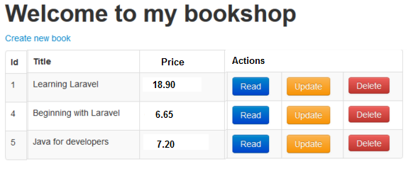

1. Delete - when the button Delete is clicked call onRemoveBook that will use the service's function removeBook(bookId))
2. Support adding a new book:
   1. When clicked, call the function onAddBook() that will

read (prompt) the details from the user: name and price, then will call a function addBook(name, price) that pushes a new book into the gBooks array.

* 1. Call the renderBooks() to redraw the table

1. Support updating a book:

a. When clicked, call the function:  
onUpdateBook (bookId) that will prompt for the book new price and call the service's function

Copyright © misterBIT



updateBook(bookId, bookPrice).

Then Call the renderBooks() to redraw the table

8. Use a modal to show all the details of a selected book

1. When read is clicked, show the modal with details of the selected book.
2. Add a rate property for the book, set 0 as default, the rate should be a number between 0 and 10.
3. In the Book-Details modal, allow the user to change the rate of the book by clicking the + / - buttons:

**Filtering**

9. Support filtering the books by maxPrice, minRate and also by using a search box

**Bookmark-ability**

1. Filtering should be reflected in query-params
2. Bonus: Add bookmark-ability also to the opened modal state (so when refreshing

when the book-details modal is open, it re-opens when page reloaded)

**Paging**

12. Support paging through the books with Next and Prev buttons

13. Update the disabled property of the button appropriately

**More Bonuses**

14. Allow the user to switch between the two presentation modes (cards/table)

a. Remember the user preference in localStorage key: favLayout: table/cards

15. Read the information from the user using an <input> instead of prompt

16. Make the header of the table clickable to support sorting by name or price

17. Add advanced paging:

page2image53020288page2image53029024page2image53034224