**Abdul Baseer** 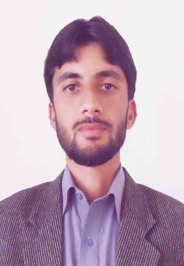

**S/o Abdus Samad**

**Date of Birth: 15 march 1988 Permanent Address:**

**CNIC No: 15601-3998605-3 village fatehma p/o Gat Tehsil Matta Swat**

**Domicile: Swat, KPK kpk Pakistan**

**Cell No: +923469791659 Postal Address:**

**Email: drbaseer44@gmail.com Mohallah miangano Cham Amankot**

**Passport Number: AE3826051 Mingora Swat**

**Objective: Seeking a challenging career in a pharmaceutical organization where I can constantly improve my expertise. I also intend to Experiment with new ideas and grow with your prestigious organization dynamically**.

* **Academic Qualification:**

|  |  |  |  |
| --- | --- | --- | --- |
| **Qualification** | ***Year*** | **Division/percent** | **Board/University** |
| **Pharm D (Doctor of Pharmacy)** | **2012** | **1st 66.54%** | **University of Balochistan** |
| **Intermediate** | **2006** | **1st**  **67%** | **BISE Swat** |
| **Matric** | **2004** | **1st 61%** | **BISE Swat** |

**Pharmacy Areas where able to work**

* **Marketing.**
* **Quality control/quality Assurance.**
* **Product development .**
* **Production department of Liquid, solid ampoules, ware house, micro lab.**

**Computer knowledge:**

* **Microsoft ® office 2010**
* **Sound knowledge of Hardware & Software**
* **Internet browsing**

**Pre-Qualification Experience and Internships:**

* **4 weeks internship in MERCK serono (Pvt. Ltd.)**
* **8 weeks internship of clinical pharmacy in SAIDU GROUP OF TEACHING HOSPITAL**
* **6 weeks hospital pharmacy internship in MAROOF INTERNATIONAL HOSPITAL ISLAMABAD**

**Research:**

* **Measles outbreak in Balochistan, Pakistan 2012-2013 Epidemiology and evaluation of outbreak response.**

**Registration and memebership**

* **Registered with Pharmacy Council of Pakistan (Reg: Number 2962-A/2015-PC).**
* **Active member of Pakistan Pharmacist Association (PPA).**

**Personal Characteristics:**

* **Good communication skill**
* **Self-Motivated & able to take initiative.**
* **Able to adjust in different Environment.**
* **Studious & confident.**
* **Organizing capacity**.

**References:**

* **Available on Request**