**cvFOR THE POST OF area SALES manager FOR faisalabad ZONE.**

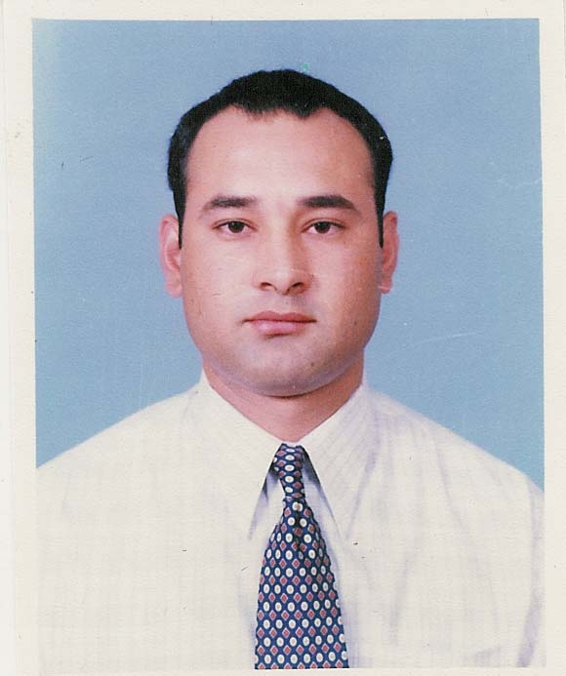

**Name : Altamash Khan**

**Father’s Name : Hushmat Khan**

Date of Birth : 26/12/1974

N.I.C. No. : 33100-3585977-9

Postal Address : Chak No. 279, R.B Kalan, RajaNadir Khan

Wali, ST. No.2 H.No.P-26/5 Faisalabad.

Cell Ph No. : **(0333-8666679)**

Phone Res **: (041-2631536)**

E-mail Address : [altamashkhan355@hotmail.com](mailto:altamashkhan355@hotmail.com)

**Qualification**:

|  |  |  |  |  |
| --- | --- | --- | --- | --- |
| ***Certificate/Degree*** | ***Passing Year*** | ***Full Time/ Part Time*** | ***Division/Grade*** | ***Board/University*** |
| Matriculation | 1991 | Full Time | 1st | Faisalabad, Pakistan |
| F.A | 1993 | Full Time | 1st | Faisalabad, Pakistan |
| B.A | 1995 | Full Time | 1st | University of Punjab |

**Experience**:

|  |  |  |  |  |  |
| --- | --- | --- | --- | --- | --- |
| Employer Name | Type of Business | Job Title | Full Time | From | To |
| AJM,CIPLA Pharmaceuticals | Sales & Marketing | Regional Sales Manager | Full time | May 2015 | To date |
| Himont Pharmaceuticals Ltd. | Sales & Marketing | District Sales Manager | Full time | June 2009 | May 2015 |
| Werrick Pharmaceuticals Ltd. | Sales & Marketing | Area Sales Manager. | Full time | March 2006 | May 2009 |
| Searle Pakistan Ltd. | Sales & Marketing | Product Specialist. | Full Time | July 1998 | Feb 2006 |

**Selling Skills Courses:**

|  |  |  |
| --- | --- | --- |
| **Organization** | **Course Name** | **Department/ Person** |
| SEARLE PAKISTAN Ltd. | Initial Training Program + Selling Skill Training | Marketing Team Searle |
| SEARLE PAKISTAN Ltd. | Professional Selling Skills Course. | Marketing Team Searle |
| SEARLE PAKISTAN Ltd. | Selling Skill Training & Development Course 2000 & Beyond | Marketing Team Searle |
| SEARLE PAKISTAN Ltd. | Customer Focused Selling | Marketing Team Searle |
| WERRICK PHARMA | Leadership &Management Training | Training Department |

**Achievements / Recognitions:**

|  |  |
| --- | --- |
| **Type of achievements** | **year** |
| 1ST Position in “Initial Training program” By Searle Pakistan. | 1998 |
| Consistent Performance and Selected for specialty team. | 1998-99 |
| Consistent Performance in Searle Pakistan Ltd. | 1999 |
| Consistent Performance+ Man of the Year of Tramal Searle Pak. | 2000 |
| Founder Member of Riboxin Club | 2000 |
| Best Detailing Award | 2000 |
| Most Knowledgeable Person & won first prize | 2001 |
| Most Knowledgeable Person | 2002 |
| Man of the Year of the Biocef | 2002 |
| Best Sales Man of Metrozine | 2003 |
| Excellent Performance in implementation of Customer Focused Selling | 2004-5 |
| Excellent Performance in Implementation of Selling Skill Course. | 2005 |
| Excellent Performance in Werrick Pharma as Area Sales Manager & Won Car | 2007-08 |
| Launched the Cardiology group of Himont Pharmaceuticals | 2009-10 |

**Annual Conferences Attented:**

* PC Rawalpindi 1999
* Thailand Bangkok-Phuket 2000
* UAE 2001
* Thailand Pattaya-Bangkok 2002
* PC Lahore 2003

**Languages**:

* English.
* Urdu.

**PERSONAL SKILLS:**

Administrative skills,English spoken, Positive behavior in tense situations,Pleasant Personality, Ready to accept any kind of challenges, Organizer, Motivator.

**EXTRA CURRICULAR ACTIVITIES:**

Books Reading, Computer,Medical literatures, Cricket.

**COMPUTING SKILLS:**

MS Word,MS Power Point,MS Excel,Internet Surfing.

**References will be flourished on demand.**