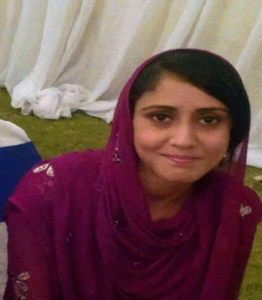Amna Shabih

Pharmacist

+92 305 3020204

amnashabih1991@gmail.com

24 Years Single

PROFILE

Highly motivated and recently certified pharmacist seeking a professional position in INDUSTRY which will utilize the organizational and communication skills developed through my involvement with the organization and promotional work.

During my degree I successfully combined my studies with work and other commitments showing myself to be self-motivated, organized and capable of working under pressure. I have a clear, logical mind with a practical approach to problem solving and a drive to see things through to completion.

EDUCATION

2010-2015 **Pharm-D 78.39%**

Bahaud Din Zakariya University, Multan

2009-2010

**F. Sc. (Pre-medical) 81.27**

Govt. Degree College for Women, Multan

2007

**Matric with science**  **74.2%**

St. Mary’s Convent Higher Secondary School, Multan

EXPERIENCE

Combined Military Hospital (CMH) Multan

2015

**Pharmacist as Internee**

*Key Responsibilities at CMH Multan*

* Properly dispensed an average of 15-20 prescriptions per day.
* Conducted routine inspection of medication storage location.
* Compounded and repackaged topical medication.
* Inspected drug storage sites, monitored drug supply expiration dates and ensure proper supply level.
* Patient counselling on the use of medicine.
* Checked prescription for appropriate dosage, drug interaction, allergies and contraindication before dispensing to patient.
* Displayed patient oriented and comprehensive clinical pharmacy services and pharmaceutical care.
* Provide specialized services to help patients manage condition such as diabetes, asthma, smoking cessation and high blood pressure.

SKILLS

Computer Skills

* MS WORD
* MS EXCEL
* POWER POINT
* HTML-HPSS
* FRONT PAGE
* Basic-C(programming) language

Professional Skills

* Pharmaceutical calculations
* Prescription handling
* Patient counselling
* Health education seminars
* Drug interaction assessment

REFERENCE

Will be provided on demand