**CURRICULUM** **VITAE**

**Personal Profile** :

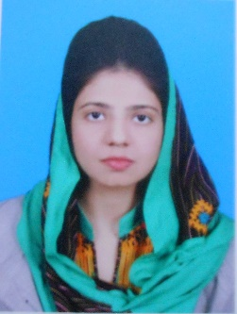 **Name Anum Sarfraz**

**Father CH Sarfraz Ahmed**

**Date of birth** 29 September 1992

**Nationality** Pakistani

**N.I.C number** 35202-3528469-8

**Religion**  Islam

**Marital status** Single

**Address** 112 Mehboob Garden Feroz Pur Road Lahore

**Contact**  0346-4024677

**Email**  [anumsarfraz92@gmail.com](mailto:anumsarfraz92@gmail.com)

**Job preference**:

To work in management, supportive, administration duties of a dynamic and progressive organization.

**Career objective:**

To attain an appropriate position in any reputable organization and work for its advancement in the field of administration, customer support, management and any other department where I can exhibit my skills and knowledge

**Key skills:**

Good presentation and communication skills, analyzing, planning, handling different situations etc

**Education:**

2010-2015 University of Sargodha, Sargodha Pakistan

(Doctor of pharmacy)

CGPA : 3.1

2013-2013 University of Sargodha, Sargodha Pakistan

(Bachelor of Science) Private

2008-2010 Punjab group of colleges, Lahore

Marks : 909/1100 ( 82.6 % )

2005-2007 Government girls high school, Allama Iqbal town Lahore

Marks : 732/850 ( 86 % )

**WORK EXPERIENCE**

June 2012 Internship at STANDPHARM Pakistan Pvt. Ltd

July 2013 As Community Pharmacist at University Model Pharmacy UOS

August 2014 Internship at Himont Pharmaceuticals Pvt. Ltd

July 2015 Children Hospital and Institute of Child Health Lahore

**EXTRA CURRICULAR ACTIVITIES**

2003-2005 Member of Dramatic Society

(Saint Mathews Cambridge School Lahore)

2007 Member of Dramatic Society

(Government Girls High School Lahore)

2009 Participant in English Debate Competition

2012 Member of Blood donor Society

(University of Sargodha)

**LANGUAGES**  English, Urdu and Punjabi, fluent in reading, writing and speaking

**References**  will be provided on demand