

ARIF MUKHTAR

H # 369, Usmania Society,

Nazimabad #1, Karachi.

Cell: 92-321-3898669

E-mail: arifmukhtar@gmail.com

Dynamic 14 year healthcare industry career with record breaking performance in sales & marketing.

Outstanding success in building and maintaining relationship with key opinion customers.

Establishing large volume and high profit accounts with excellent level of loyalty.

Career Objective:

To obtain a challenging position in Sales & Marketing, where I can utilize my education, fruitful experience and skills to achieve organizational goals and objectives.

Professional Strengths:

 Exceptional competence in establishing and achieving personal and business goals.

 Strong sense of identifying and capturing opportunities based on abilities to evaluate motivation.

 Clearly articulate, personal and professional, well defined presentation skills.

 Dedicated, self driven, focused and result oriented always one step ahead of the challenges.

 Acquired salesmanship and marketing skills by way of a more in depth sense of human interaction.

Education:

|  |  |
| --- | --- |
| MBA | MARKETING |
| Institute of Business & Technology | (2010 - 2011) |
| M.Sc. | BIOTECNOLOGY |
| Karachi University | (2000 – 2001) |
| B.Sc. | MICROBIOLOGY, ZOOLOGY, CHEMISTRY |
| Karachi University | (1997 – 1998) |



Professional Experience:

Business Unit Manager ( Emerging Markets ) North America, Fareast & EU

January 2014 – Present

Have sales, distribution and product strategy in place; get agreement from team to ensure fixed brand guidance for eﬀective execution.

Ensure country sales/distribution strategies/executions are aligned with global positioning pillars to get to one “Corporate” brand positioning.

Identify the primary countries with the most opportunities. Prioritize and focus. Provide competitive information.

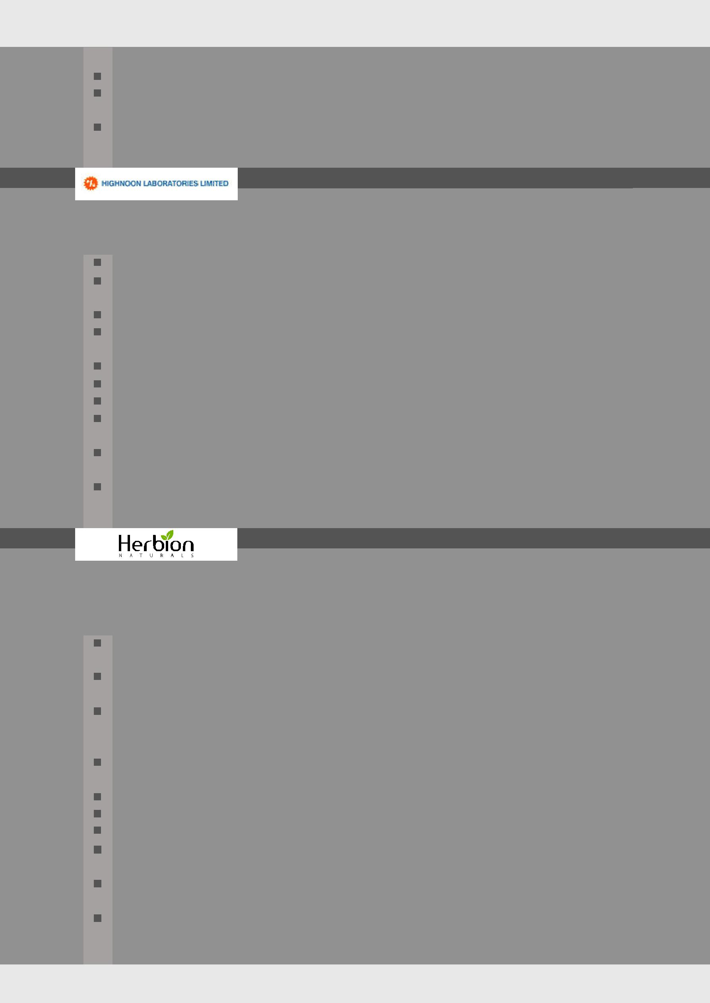Search for new market opportunities.

Lead the integrated sales, product, retail and marketing process together with the other local functions.

Have frequent ‘1 on 1’ with Country Manager to discuss progress on own business goals and personal development.

Senior Product Manager

April 2013 – December 2013 (9 months) Lahore

***Responsibilities:***

Work on Cardio metabolic products including Diabetic, cardiovascular & neuro portfolio.

Maximize support to the Sales force for the implementation of the product strategies and

enhance the profitability of the product lines.

Developed, implemented and monitored marketing related strategies of products assigned.

Provide training to field force on assigned products along with updates on product related

studies.

Regular field visits for customer relationship building and market orientation.

Worked on budget plans for the assigned products.

Analyzing the market (competitors) on quarterly basis and adjusting strategies accordingly.

To identify and manage our participation in congress / symposia as per respective product

strategy.

To ensure the availability of all promotion material (in line with strategies) to field force in

regular manner

Development of literature

For North America, EU, Fareast & CIS

As a Manager Trade & Field Force Eﬀectiveness From : March 2011 - August 2012

As a Sr. Product Manager From : September 2012 - March 2013

***Responsibilities:***

Identifies performance issues for individual territories/regions and develops improvement plans with inputs of field managers.

Manages territory sizing and realignment processes to optimize investment and balance workload.

Ensures proper coverage of retailers by the respective distributors through holding meetings with their managers and salesmen at frequent intervals. Also checks if the salesmen possess the adequate knowledge of his products.

Continuously improves the field force automation system (FFMS) to enable easier data entry (e.g., prevent duplicates, request user interface modifications and call tracking).

Manages FFMS upgrade projects.

Provides inputs to FFMS strategic planning processes

Manages incentive compensation design and implementation for all field teams

Ensures to keep MRs motivated by timely recognition and rewards. Keeps prompt follow-up of their quires and handles grievances of his team members to their utmost satisfaction.

Assess training needs of MRs and communicates on quarterly basis to RSM/ NSM and train-ing department

Anticipates hiring needs and takes a proactive approach to recruiting

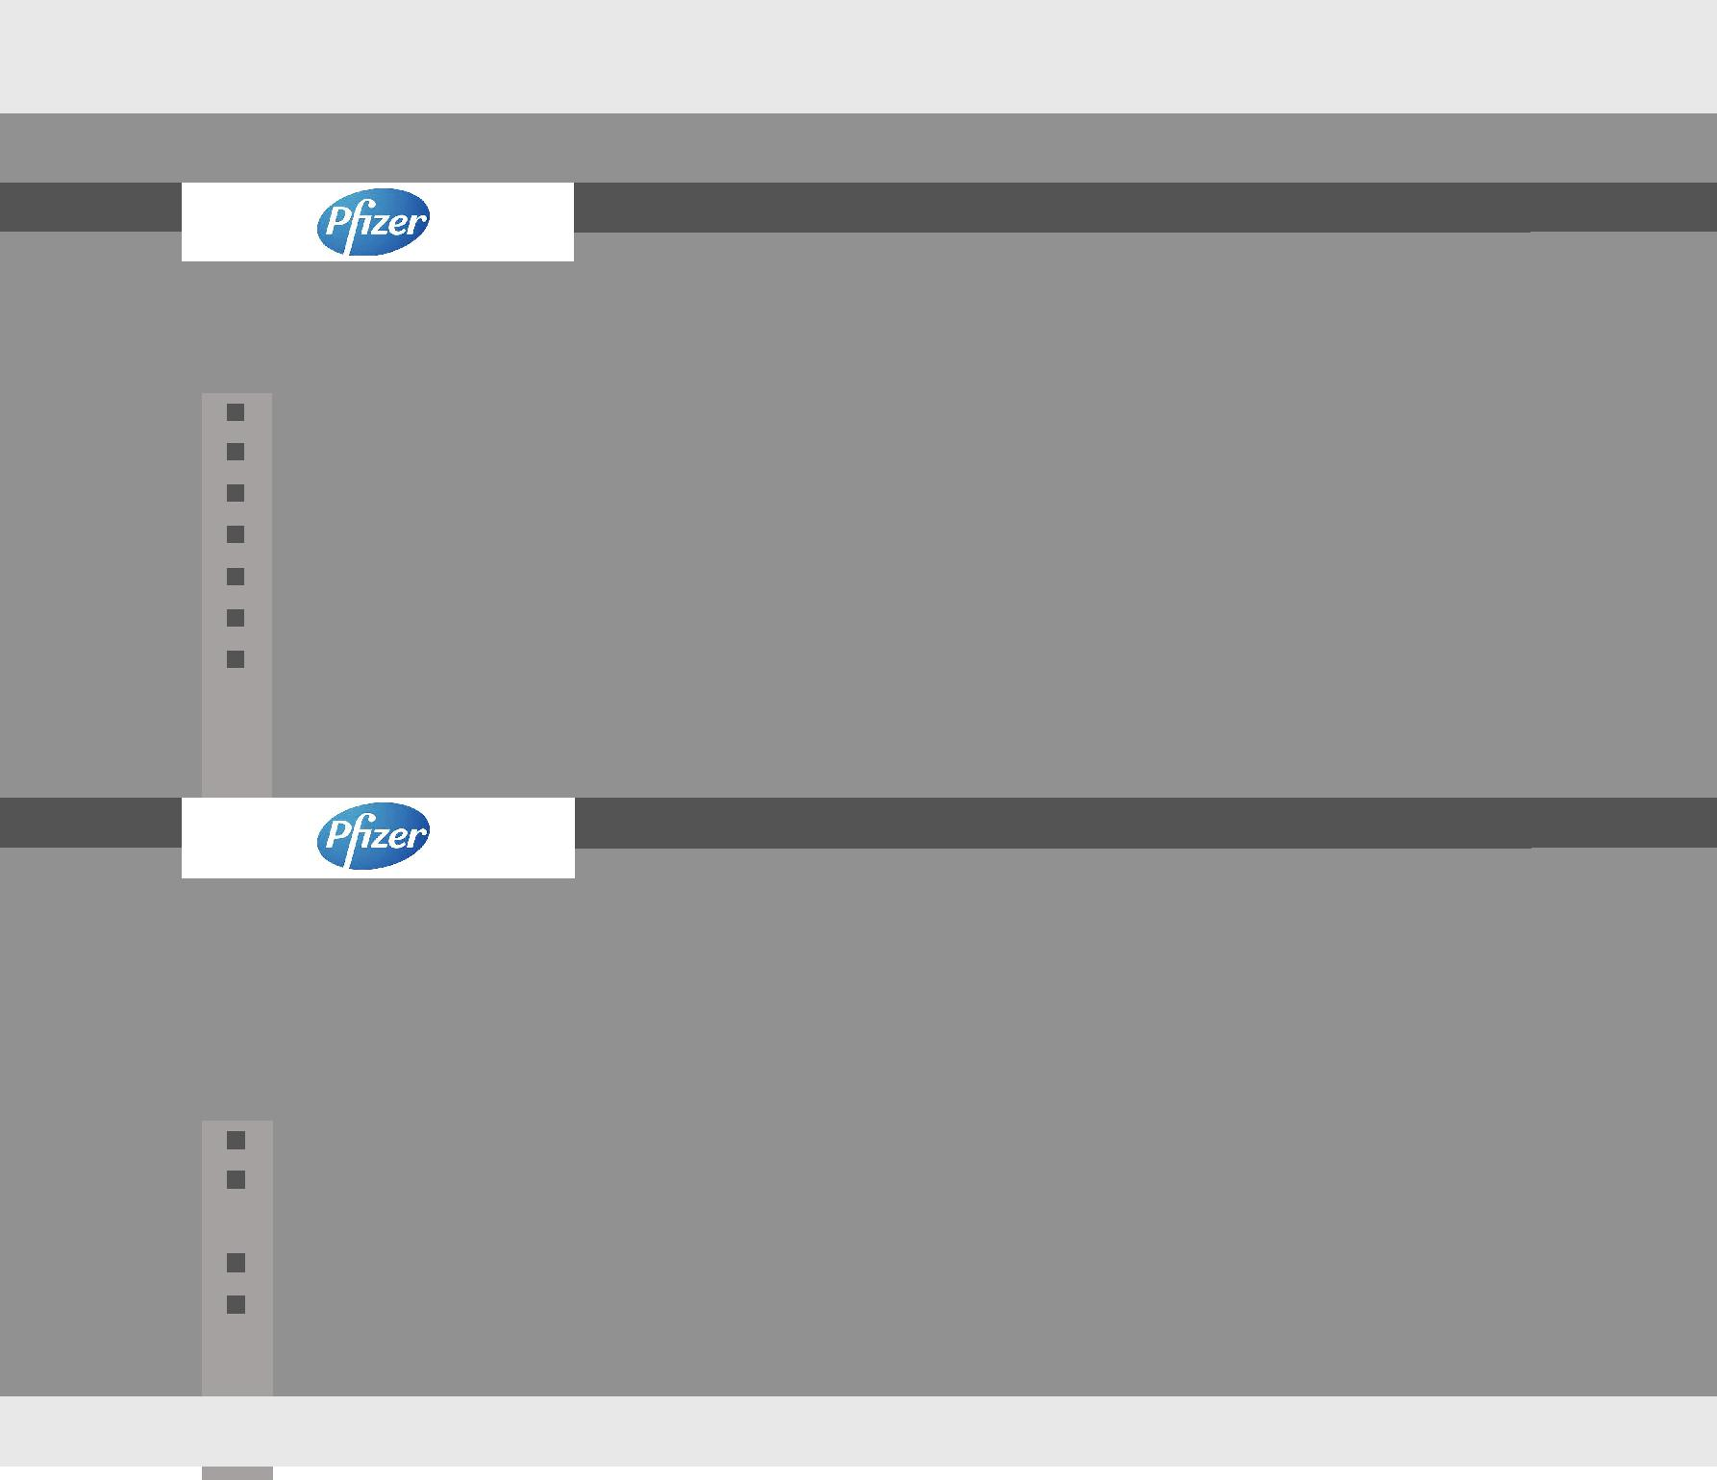As a District Field Manager

2009 to March, 2011

***Responsibilities:***

Same mentioned in experience with Pfizer between June, 2002 to April 2008 in addition with:

Forecasting and allocation of whole team targets.

Monitoring sales.

Arranging activities for team building.

Work in dermatology, orthopedic & medicine segments

Work on field force eﬀectiveness enhancing activities

Responsible for developing and maintaining good relationship with key customers to achieve their objectives.

June, 2002 to April 2008

As a Professional Services Representative From : June, 2002

As a Senior Professional Services Representative From : April, 2005

As a Executive Professional Services Representative From : April, 2007

As a Sr. Executive Professional Services Representative From : April, 2008

***Responsibilities:***

Same mentioned in experience with AGP in addition with:

Developing relationship with key opinion leaders as a guest speaker for community

awareness programs.

Conducting the presentations and educational seminars.

Promote anti-inflammatory, hypertensive and antibiotic products.

Achievements:

YEAR 2005 Received ‘MAN OF THE CYCLE “title consecutive 3 Qtrs. YEAR 2006 Received 3rd Best Performer title.

Received 2nd Best team participant title. YEAR 2007 Received 5th Best PSR title.

Achieve 1st Position for Product Champion category (LINCOCIN) Achieve 5th Position for Product Champion category (FELDENE) Received 1st Best team participant title.

YEAR 2008 3rd Best Performer of the year title

3rd Position for Product Champion category ( FELDENE) YEAR 2010 Manager of the year title

Professional Courses:

Global policies on interaction with health care professionals

Pfizer policies on Business conduct

Basic of presentation skills

Spontaneous reporting of adverse event

Business communications

Pfizer values

Best Managed behaviors

Time Management

Basic systems and product knowledge

Selling skills

Leaders behavior

Integration training

SMART training

Project designing

Additional Assignments:

Certified on Six Sigma Management ( Yellow & Green Belts )

Hands on experience to implementing DMAIC approach for enhancing business productivity in service sector.

Worked on WMP (weighted matrix profile) which is most recent and advanced tool for customer targeting in Pakistan pharmaceutical industry as well as Asia Region.

Technical Skills:

Computer literate, proficient in Microsoft Word, Excel and Power Point

Other Information:

|  |  |
| --- | --- |
| Father Name | Mukhtar Alam Khan |
| Date Of Birth | 03 Nov, 1976 |
| N.I.C. Number | 42101-6601238-1 |
| Marrital Status | Married |
| Number Of Dependent | 03 |
|  |  |
|  |  |