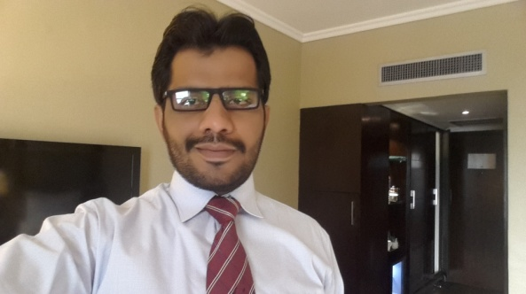***Resume***

**AZAR GUL QURESHI**

**House # 958, Shadadu Muhalla, Rohri, District Sukkur.**

🖩**0333 - 7137414 Email: azgu@outlook.com**

**Career Objective**

I am a man of devotion, diligence, unflinching commitment to work in competitive, changing and challenging business environment, where I can utilize my academic and personal potentials, abilities and skills to achieve the determine targets. I am looking for an opportunity which must provide me a sense of responsibility, reward and satisfaction and fuel my drive to leave no stone unturned

**Personal Information**

**Father’s Name :** Gul Mohammed Qureshi

**Date of Birth :** April 8th 1985

**CNIC :** 45502-0466083-7

**Marital Status :** Married

**Skills & Abilities**

* Selling Skills
* Communication Skills
* Interpersonal Skill
* Sales Analysis
* SWOT Analysis
* Time Management
* Organization Behaviour
* Information Technology
* Presentation Skills
* Team Player

**Education**

**[2007-2008] M.B.A**

University of Sindh Jamshoro

**[2004-2006] B.B.A**

University of Sindh Jamshoro

**[2001-2003] Intermediate**

Govt Atta Hussain Shah Musavi Degree College Rohri

* Biology
* Chemistry

**Training**

**March 2009 Selling Skills**

Novartis Pharma.

**October 2010 Novartis Selling excellence**

Novartis Pharma .

**February 2011 Basic Training Course**

Novartis Pharma**.**

**February 2012 Closing With Confidence**

Novartis Pharma

**December 2012 Physician Partnership Program**

Novo Nordisk Pharma**.**

**August 2013 Situation Source Solution Success Model (4S model)**

Novo Nordisk Pharma.

**November 2013 Competitor Sellings**

Novo Nordisk Pharma.

**September 2014 Sales Leadership Training**

Octara Trainings

**February 2014 Business Plan & Strategies**

Macter International Pharmaceuticals

**September 2015 Initial Sales Product Based Training**

Servier Research & Pharmaceuticals

**December 2014 Successful Product Launching**

Servier Research & Pharmaceuticals

**Employment History**

**Currently working as District Manager In SERVIER Research & Pharmaceuticals**

Responsible For **Diamicron Mr 60, Coversyl, Natrilix Sr (Diabetic & Cardio Metabolic Division)**

Looking after Ghotki, Khairpur, Larkana, Jacobabad, and Dadu Belts

**Worked as Regional Sales Manager in MACTER Pharmaceuticals**

Looking after Ghotki, Khairpur, Larkana, Jacobabad, and Dadu belts

Responsible for **COBOLMIN, DX3, ESANTE, (DIABETIC Portfolio)**

**Worked as Product Specialist in NOVONORDISK Pharma for 2 years.**

Looking after Ghotki, Khairpur, Jacobabad, Larkana, with additional Assignment of Institutions of Rahimyar Khan.

Responsible for Both **ANALOGUE & HUMAN INSULIN (DIABETIC Portfolio)**

**Worked as Medical Information Officer in NOVARTIS Pharma for 3 years.**

Worked in with KOLs of all belts including Dadu, Mehar, Shahdadkot

Promoted **ZATOFEN, CLOMFRANIL & MEPRESSOR (CARDIO METABOLIC)**

**Work Experience**

(Core Responsibilities)

* Implementation of strategies
* Sales management
* Liaison management
* Distributor inventory management
* Team Retention & Development
* Sales analysis
* Factor analysis
* Personal Performance evaluation
* Monitoring of sales forces
* Execution of Marketing plans
* Developing Territory