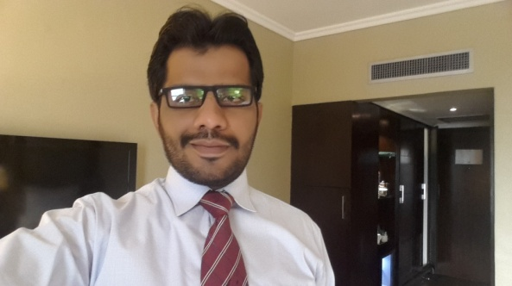***Resume***

**AZAR GUL QURESHI**

**House # NH 63 Neclace house labor square korangi # 3 karachi**

🖩**0333 - 7137414**

**Email: azgu@outlook.com**

**Career Objective**

I am a man of devotion, diligence, unflinching commitment to work in competitive, changing and challenging business environment, I use to utilize my academic and personal potentials, abilities and skills to achieve the determine targets. Always looking for an opportunity which must provide me a sense of responsibility, reward and satisfaction and fuel my drive to leave no stone unturned

**Personal Information**

**Father’s Name :** Gul Mohammed Qureshi

**Date of Birth :** April 8th 1985

**CNIC :** 45502-0466083-7

**Marital Status :** Married

**Skills & Abilities**

* Selling Skills
* Communication Skills
* Interpersonal Skill
* Sales Analysis
* SWOT Analysis
* Time Management
* Relationship Building
* Purposeful Planer
* Presentation Skills
* Team Player

**Education**

**[2007-2008] M.B.A (Marketing & Management)**

University of Sindh Jamshoro

**[2004-2006] B.B.A (Marketing)**

University of Sindh Jamshoro

**[2001-2003] Intermediate**

Govt Atta Hussain Shah Musavi Degree College Rohri

* Biology
* Chemistry

**Training**

**March 2009 Selling Skills**

Novartis Pharma.

**October 2010 Novartis Selling excellence**

Novartis Pharma .

**February 2011 Basic Training Course**

Novartis Pharma**.**

**February 2012 Closing With Confidence**

Novartis Pharma

**December 2012 Physician Partnership Program**

Novo Nordisk Pharma**.**

**August 2013 Situation Source Solution Success Model (4S model)**

Novo Nordisk Pharma.

**November 2013 Competitor Sellings**

Novo Nordisk Pharma.

**September 2014 Sales Leadership Training**

Octara Trainings

**February 2014 Business Plan & Strategies**

Macter International Pharmaceuticals

**September 2015 Initial Sales Product Based Training**

Servier Research & Pharmaceuticals

**December 2015 Successful Product Launching**

Servier Research & Pharmaceuticals

**January 2016 Leadership & Influence**

Servier Research & Pharmaceuticals

**Employment History**

**Currently working as District Manager In SERVIER Research & Pharmaceuticals**

Responsible For **Diamicron Mr 60, Coversyl, Natrilix Sr (Cardio Metabolic Division)**

Looking after Ghotki, Khairpur, Larkana, Jacobabad, and Dadu Belts

**Worked as Regional Sales Manager in MACTER Pharmaceuticals.**

Looking after Ghotki, Khairpur, Larkana, Jacobabad, and Dadu belts

Responsible for **COBOLMIN, DX3, ESANTE, (DIABETIC Portfolio)**

**Worked as Product Specialist in NOVONORDISK Pharma for 2 years.**

Looking after Ghotki, Khairpur, Jacobabad, Larkana, with additional Assignment of Institutions of Rahimyar Khan.

Responsible for Both **ANALOGUE & HUMAN INSULIN (DIABETIC Portfolio)**

**Worked as Medical Information Officer in NOVARTIS Pharma for 3 years.**

Worked in with KOLs of all belts including Dadu, Mehar, Shahdadkot

Promoted **ZATOFEN, CLOMFRANIL & MEPRESSOR (CARDIO METABOLIC)**

**Work Experience**

(Core Responsibilities)

* Select, develop, and coach a professional sales team to meet or exceed specific goals for profitable revenue growth.
* . Implementation of annual sales plans by Business Development Officers.
* .Implement the company's sales process to establish a culture of consultative selling to customer's decision-makers at all levels.
* .Cultivate and maintain effective business relationships with executive decision makers in large accounts.
* .Pursue identified business prospects, participating actively in the planning and sales process for new business opportunities.
* .Collaborate with marketing resources and the sales leadership team to define overall sales strategy, and to develop products and solutions responsive to the customer's business.
* .Coach Business Development Officers to build effective staff relationships that enable them to respond quickly to emerging customer opportunities, and provide for seamless execution of the company's business processes that exceed customer expectations.
* .Establish a planned program for sales coaching, working with Business Development Officers on all aspects of the sales process.
* .Makes coaching sales calls with Business Development Officers to provide feedback, and to assist with large opportunities.
* . Travels extensively to meet customers and to coach Business Development Officer in the field.
* Perform all other duties as needed or required to maintain and grow profitable business within the assigned account base.
* Implementation of strategies.