***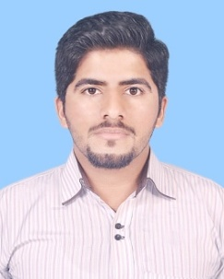  
 Flat#1ground floor,waseem center,  
 latifabad # 9,hyderabad  
 03322923959***

***Bilalmushtaq1@hotmail.com***

m. bilal raza qadri

|  |  |  |
| --- | --- | --- |
| ***Objective*** |  | ***To join a dynamic organization with a professional environment that offers Excellent opportunity in terms of career and rewards growth and thereby contributes to the success of organization*** |
| ***personal information*** |  | ***Father’s name : Mushtaq Ahmed***  ***Surname : Meo***  ***Religion : Islam***  ***Nationality : Pakistani***  ***Gender : Male***  ***CNIC # : 41304-7325154-5***  ***Domicile : Hyderabad***  ***Marital status : Single***  ***Date of birth : 14, september, 1991*** |
| ***Education******key skills .*** |  | ***Matriculation from BISE Hyderabad***  ***Intermediate from BISE Hyderabad***  ***Pharm-D from University of Sindh Jamshoro***  ***Ms office(power point,excel,ms word),internet browsing.*** |
| ***languages*** |  | * ***Urdu*** * ***English*** * ***Sindhi*** |
| ***hobbies and interest*** |  | ***Reading books,photography,playing tenis, cricket.*** |