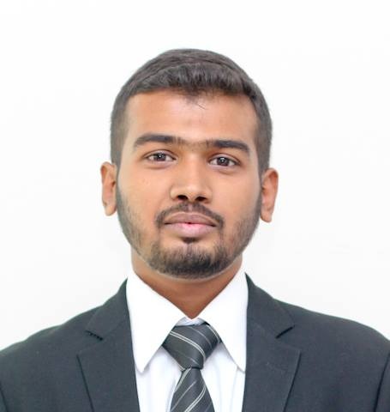

**MAJOR: Marketing** **BILAL AHMED**

 Flat# -1/33, Rabia Palace, Bl 10-A, Gulshan-e-Iqbal, Karachi

 0345-2111591

bilal.ahmed_91@hotmail.com**Sex** Male**| Date of birth** 09/12/1991 **| Nationality** Pakistani

**CAREER OBJECTIVE:**

Seeking long term employment in an organization where I can grow professionally and further enhance my skills, knowledge and experience to face and overcome the challenges of today’s changing work environment.

**ACADEMIC CREDENTIALS:**

**Degree Year Institution Grade/GPA**

MPA 2015 University of Karachi 1st Division

B.com 2013 University of Karachi 1st Division

Intermediate 2009 D.J. Sindh Govt. Science College B Grade

Matriculation 2007 S.M.S. Aga Khan School A-One Grade

**INTERNSHIP/EXPERIENCE:**

* Worked as **Business Development Officer** in ENTICE-SOL Call Centre (2 months)
* Worked as **Business Development Officer** in GENOVA NEXT Call Centre (1 month)
* Worked as **Joint Secretary** at Students’ Executive Council, Department of Public Administration, UoK from Feb 2014 to Jan 2015

**CERTIFICATES / SKILLS:**

* Quick learner and Self Oriented Individual
* Possess good Interpersonal and communication skills
* Proficient in English speaking and writing
* Leadership Qualities
* Detail Oriented
* Self-Motivated, Initiative with high level of energy
* Efficient Team Player
* Ability to work on my own without being constantly supervised
* MS Office
* Conducting Research and writing up report using SPSS
* Certificate of training on Peace, Advocacy and Social Entrepreneurship by Pakistan Youth Change Advocates

**PROJECTS / ACTIVITIES:**

* Campus Ambassador of Peace Archives-Redefining Harmony
* Organized Internship Fair 2015 at Department of Public Administration, UoK
* Organized Internship Fair 2014 at Department of Public Administration, UoK
* Represented University of Karachi at Dawn Educational Expo 2015
* Conducted a research on **“The Impact of Advertising practices on sales volume of a company”.**
* Conducted a research on **“Online Shopping Consumer Behavior”.**