**CURRICULUM VITAE**

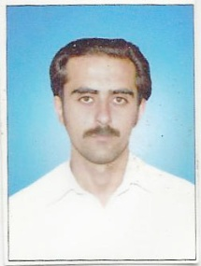**DALEEP KUMAR**

Cell no: 0332 9463152

**OBJECTIVE:**

To achieve a position which give me opportunity to experience & expand my

Knowledge while contributing creative for the advancement of organization.

|  |
| --- |
| PERSONAL INFORMATION: |
| FATHER NAME PERHILAT |
| DATE OF BIRTH 17 Mar 1985 |
| CNIC NO 15602-3930355-7 |
| DOMICILE Swat |
| GENDER Male |
| NATIONALITY Pakistani |
| MARTITAL STATUS Un-Married |
| POSTAL ADDRESS New Ikram General Store Near GOVT Girls Middle  Shahdara Watkay Mingora Swat |

**ACADEMIC QUALIFICATION**

|  |  |  |  |
| --- | --- | --- | --- |
| EXAM | YEAR PASSING | OBT Marks | BOARD/UNIVERSITY |
| S.S.C | **2001** | **536/850** | **BISE Swat** |
| F.S.C (Pre Med) | **2004** | **682/1100** | **BISE Swat** |
| B.S.C (Pre Med) | **2007** | **247/550** | **Malakand University** |

**EXPERIENCE**

* 1 Year experience as Territory Manager in Helix Pharma.
* 6 Years experience as Territory Manager in Hilton Pharma.

**LANGUAGES**

* English.
* Urdu.
* Pashto.