|  |
| --- |
| Key Competencies |
| * Always eager to learn of new technologies and skills ― **a quick learner** * Constructively working under tough circumstances either individually or within team of any size ― **highly devoted** * Self-motivated, excellent planning ability, up to date knowledge as well as command over many latest technologies ― **well learned**  |  |  | | --- | --- | | Qualification | | | 2012 ― 2016 | **BS (Hons.) Chemistry**  **Major**: Analytical Chemistry  **Minor**: Inorganic Chemistry  **CGPA**: 2.81/4  University of Gujrat(Main Campus), Pakistan | | 2009 ― 2011 | **F. Sc. (Pre-Engineering)** (BISE Gujranwala)  **Marks**: 780/1100  Gujrat College of Commerce, Gujrat | | 2007 ― 2009 | **Matriculation (Science Group)** (BISE Gujranwala)  **Marks**: 860/1050  Govt.High School Malik Pur Mirza, Gujrat | |

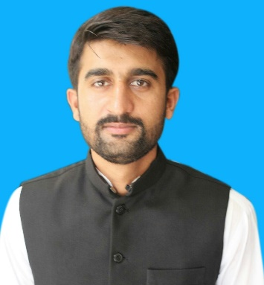 **FARHAN ARSHAD**

|  |  |
| --- | --- |
| C:\Users\Shoaib\AppData\Local\Microsoft\Windows\Temporary Internet Files\Content.IE5\7Y5JK7ZM\MC900442122[1].png | P/O Village Malik Pur Khurd TEH & DISTT Gujrat |
| C:\Users\Shoaib\AppData\Local\Microsoft\Windows\Temporary Internet Files\Content.IE5\NCP37PJF\MC900442135[1].png | +92-345-6943142 |
| C:\Users\Shoaib\AppData\Local\Microsoft\Windows\Temporary Internet Files\Content.IE5\2BZ50A2S\MC900432681[1].png | faanimalik@yahoo.com |

|  |
| --- |
| Objective |
| “Being a dedicated and self-motivated individual, I am seeking a work opportunity in your organization that will add to my personality a disciplined professional’s experience and enhance my skills and qualities. |

**Computer Skills**

|  |
| --- |
| Extracurricular Activities |
| * Football , Cricket, Book Reading |

* MS office ( MS Word, MS Excel, MS Power Point)
* Windows Operating System ( Win 10/7/2000/XP )
* Chem Draw and Chem Ultra

|  |
| --- |
| Reference(s)  Will be provided on request. |