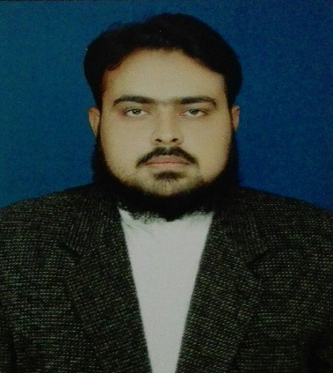**MUHAMMAD RIZWAN**

Email: mmrizwan903.hr@gmail.com

Contact No:03313107590

***Applied as a Pharmacist***

**OBJECTIVE**

I am seeking employment within the Organization where I can use my talent and skills to grow and expand the company and also want a competitive and challenging environment where I can serve the organization and establish an enjoyable career for myself.

**QUALIFICATION**

* MATRIC: From BISE SUKKUR in 2008.
* INTERMEDIATE: From BISE SUKKUR in 2010.
* PHARM-D: From Shah Abdul Latif University 1st division in 2015

**PERSONAL INFORMATION**

* Name: Muhammad Rizwan
* Father’s Name: Muhammad Ramzan
* CNIC: 45504-5696946-5
* Date of Birth: 14 January 1990
* Address: New Dahir Colony Khanpur district Rahim Yar Khan

**EXPERIENCE**

Two month internship experience in Sheikh Zayed Hospital/ Medical College Rahim Yar Khan.

**PARTICIPATION**

National level DICE OUG 2013 Competition in Gujrat.

**COMPUTER SKILL**

Microsoft Office.

**OTHER QUALIFICATIONS**

Hafiz-e-Quran.

**LANGUAGES**

English, Urdu, Sindhi And Punjabi.

**REFERENCES**

Will be provided on demand.