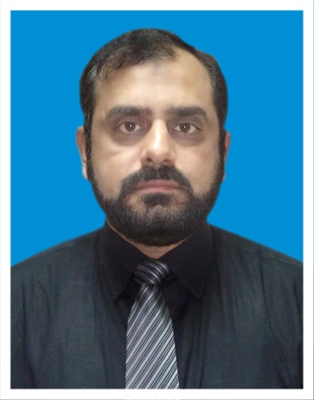**RESUME**

**Contact Information**

Name : HAMMAD MASOOD CHUGHTAI  
Address : House # E-104 Defense View Phase II near Iqra University Karachi  
Cell Phone **: 0300-6308590 /021-35388590**

Email:[hammadchughtai8590@gmail.com](mailto:hammadchughtai8590@gmail.com)

**OBJECTIVE:**

* Enthusiastic, hardworking sales professional seeking to obtain a challenging marketing position providing professional career growth in the pharmaceutical industry.
* A demonstrated self-starter with strong technical, communication, and presentation skills. Proven leadership and achievement of results by creating and implementing projects for increased revenue.

**EXPERIENCE**

* Senior Product Manager (SPM) SJG Fazul Ellahie (Pvt.) Ltd (Still Working
* Product Manager (PM) Indus Pharma (Pvt.) Ltd. (March 2008 – Oct 2015))

Brand Detail is Maxef (Ceftriaxone), Maxpan (Cefixime), Cidpro (Omeprazole), Indofer (IPC) and OEM (ORS), Erythrocin

Training Manager Indus Pharma (Pvt.) Ltd. (March 2005 – March 2008)

* District Sales Manager (DSM) SCHARPER Pharmaceuticals (Sep 2003 – March 2005)
* Sales Promotion Officer & RSM with AGP (Oct 1995 – Sep 2003)
* **EDUCATION**

MBA 1993- 1995 (BahuddinZakariya University Multan)

PGD Post Graduate Diploma in Computer Sciences and Programming

B.Sc. 1990- 1992 (Govt. College Bosan Road Multan)

F.Sc. 1990 (Govt. Civil Lines College Multan)

Matric 1987 (Govt. Muslim High School Multan)

* **Personal Information**  
  Date of Birth: 26th May 1971  
  Place of Birth: Multan Pakistan  
  Gender : Male
* **Optional Personal Information**

Marital Status: Married  
Children : Three Kids (Two Daughters & One Son)