**CURRICULUM VITAE** 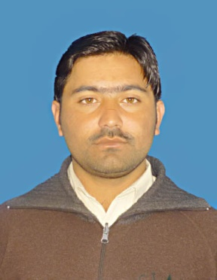

**Personal Information**

Name: **Hikmat Yar**

Father Name: **Malak Yar Permanent Address**

Gender: Male Village Kharkano, P/O Khar, Tehsil Salarzai, Bajaur

NIC No: 21106-3695812-5 Agency, FATA Pakistan.

DOB: February 01, 1992

Location: Bajaur Agency (FATA) **Contact Information**

Religion: Islam. Cell No: +923449813990

Marital status: Singl +923035137550

Nationality: Pakistani hikmatyar_uom@yahoo.com

# **C a r e e r O b j e c t i v e**

* Seeking a chance in developed organization with a competitive and progressive environment in order to enhance my qualification, skills, abilities, having an international exposure.

# **E d u c a t i o n**

##### Doctor of Pharmacy University of Malakand

**(Session 2010-2015)**

* **Major Subjects:**
  + - * Pharmacology & Therapeutics
      * Biochemistry
      * Human Physiology & Anatomy
      * Pharmaceutics
      * Industrial Pharmacy
      * Clinical Pharmacy
      * Microbiology & Pathology
      * Quality Control
      * Medicinal Chemistry
* **Scored cGPA 3.4/4.0 (Overall)**
* **First Division.**

##### F. Sc. Govt Post Graduate College Khar Bajaur Agency

**(2008-2010)**

* **Major Subjects:** Zoology, Botany, Chemistry and Physics.
* **Scored 76.37%** In the final examination.

##### S.S.C Govt High School Inayatkalay Bajaur Agency

**(2003)**

* Major subjects: Biology, Chemistry, Physics, Mathematics
* Scored 82.77% In the final examination.

# **Skills and Capabilities**

* Demonstrate sound written, verbal and presentation skills.
* Possess good inter-personnel, leadership and analytical skills.
* Ability to take initiatives and accept challenges.
* Self-motivated and enthusiastic.

# **Work Experience**

* 4 months Internship experience in Medical Teaching Institute, Lady Reading Hospital Peshawer.
* Working with Neomedix Pharm as a production pharmacist from 1st January, 2016 upto date.

# **Language Skills**

* English Fluently Speak, Read & Write.
* Urdu Fluently Speak, Read & Write.
* Pashto Fluently Speak, Read & Write.

# **Field of Interest and Future Plans**

Field of Interest

* Research

Future Plans

* Job opportunity that enhances my qualification, skills and abilities.

# **R e f e r e n c e s**

* + **Dr Farhatullah**

Assistant professor, department of Pharmacy, University of Malakand

Contact No: 00923339361513