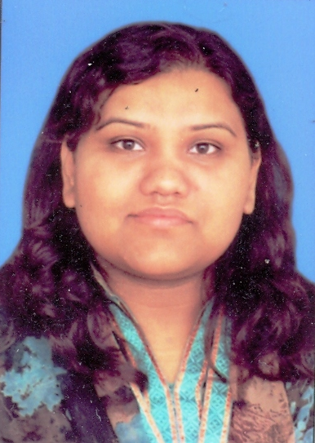

**OBJECTIVE**

To pursue a challenging career in a leading and progressive organization that promises learning and career building opportunities by utilizing my skills towards the growth of the organization.

**HiraNaureen Khan**

**PROFESSIONAL EXPERIENCE**

House # B-IV/874/M-9, SohanColonyMuslimTown, Rawalpindi, Pakistan

Cell # 92-03215188860

92-051-4472228

*hiramomina*[*@gmail.com*](mailto:xyz@yahoo.com)

JULY 2012_ AUG 2015 **SANOFI** Islamabad

Worked as Pharma Associate

Responsibilities and routine tasks included:

Marketing and sales of products to HCPs with polished skills to get business with fast and focused objective

I’d worked on;

* convincing, recommending and selling nutraceutical products to medical institutions and Health Care professionals (doctors and nurses).
* visiting hospitals and medical institutions according to the planned call frequency to promote (detailing, selling and presentation) to doctors, for them to recommend products to their patients.
* responsible for enhancing Sanofi ethical image in medical contacts as a specialist through detailing.
* organizing scientific activities for doctors.
* monitoring competitor activity and competitors' products.
* working with team managers to plan how to approach contacts and creating effective business plans for a particular area.

NOV 2011-JUNE 2012 **Danone Baby Nutrition** Islamabad

Worked as a Medical Representative.

Responsibilities and routine tasks included:

Introduction of company and infant formula to HCPs with polished skills while abiding Local code for protection of Breast feeding to get business with fast and focused objective.

JUL 2008-OCT 2011 **Nestle Nutrition** Islamabad

Worked as a **Medical Delegate**.

***Computer Skills: -***

* Microsoft Office (2000, XP, Windows 6 & 7)
* Internet

Responsibilities and routine tasks included:

Dissemination of updated knowledge to HCPs about infant products with polished skills while abiding Local code for protection of Breast feeding

In this duration I had worked on;

* convincing, recommending and selling clinical infant nutrition products to medical institutions and Health Care professionals (doctors and nurses,).
* visiting hospitals and medical institutions according to the planned call frequency to promote (detailing, selling and presentation) special infant nutrition products to doctors, nurses, dieticians and pharmacists for them to recommend these products to their patients.
* responsible for enhancing Nestle ethical image in medical contacts as a specialist through Infant Nutrition detailing and other activities to improve their brand awareness and understanding.
* organizing scientific activities for doctors and other medical staff.
* monitoring competitor activity and competitors' products.
* maintaining knowledge of new developments in [The National Health Service (NHS)](http://www.nhs.uk/) especially infants and young children , anticipating potential negative and positive impacts on the business and adapting strategy accordingly.

Foreign Exposure

Thailand 2007 & 2009  
Malaysia 2010

Dubai& Abu Dahbi 2011

* developing strategies for increasing opportunities to meet and talk to contacts in the medical and healthcare sector about nutrition awareness.
* staying informed about the activities of health services in a particular area.
* working with team managers to plan how to approach contacts and creating effective business plans for a particular area.
* self-development and motivation while considering my coaching areas recommended by manager
* taking initiatives to help and develop other team members and help them to keep the required pace and motivation
* continuously keeps medical contacts updated of Infant Nutrition and scientific information.

JUL 2006-08 **Abbott Nutrition**  Islamabad

Duration: (2Years)

Worked as **Medical Delegate**

Responsibilities and routine tasks included:

* arranging appointments with doctors, pharmacists and hospital medical teams, which may include pre-arranged appointments or regular 'cold' calling;
* making presentations to doctors, practice staff and nurses in GP surgeries, hospital doctors, and pharmacists in the retail sector. Presentations may take place in medical settings during the day or may be conducted in the evenings at a local hotel or conference venue;
* organizing conferences for doctors and other medical staff;
* building and maintaining positive working relationships with medical staff and supporting administration staff e.g. receptionists;
* managing budgets (for catering, outside speakers, conferences, hospitality, etc);
* keeping detailed records of all contacts and reaching (and if possible exceeding) annual sales targets;
* planning work schedules and weekly and monthly timetables. This may involve working with the area sales team or discussing future targets with the area sales manager. Generally, medical sales executives have their own regional area of responsibility and plan how and when to target health professions;
* regularly attending company meetings, technical data presentations and briefings;
* keeping up with the latest clinical data supplied by the company and interpreting, presenting and discussing this data with health professionals during presentations;
* monitoring competitor activity and competitors' products;
* working with team managers to plan how to approach contacts and creating effective business plans for making sales in a particular area.

**Other Experience**

* Coaching Experience in an Academy for two year 2003 to 2005

**Academic Education**

2004 **University of Punjab** Lahore, Pakistan

Bachelors of Sciences (Botany, Chemistry &Zoology ) 2nd Division

2002 **Rawalpindi Board** Rawalpindi, Pakistan

Fsc (Pre-medical) 1st Division

2000 **Rawalpindi Board** Rawalpindi, Pakistan

Matric (Pre-medical)) 1st Division

**Certification**

* IELTS from NationalUniversity of Modern Languages (NUML)

(Summer Course in the year 2004)

**Professional Achievement**

* Best Presenter Award
* Best Detailer Award
* Best Knowledge Award
* Super User of Team

**Professional Skills**

* Professional Detailing Skills from Achieve Global
* Presentation Skills
* MDMS Skills
* Personality Development

**Personal Profile**

Father’s Name: Muhammad Afzal Khan (late)

Date of Birth: September 03, 1984

Nationality: Pakistani

C .N. I .C # 37405-4734075-8

Languages: English, Urdu & Panjabi.

Marital Status: Single

**Reference**

Will be furnished upon request.