Jai ram

B.E (industrial engineering and management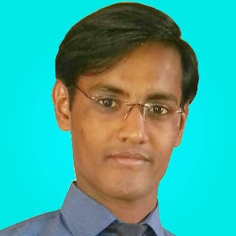)

contact:

* Email: jairamodhano@gmail.com
* Phone: +92-336-3491287

**OBJECTIVE:**

To work at challenging position, under dynamic environment, so as to apply my working experience and professional education towards continuous organization benefits and personal growth. As an Industrial Engineer and Manager, I pursue contemporary ideas of Technology and Management.

**personal information**

Full name: Jai Ram

Father’s Name: Sawai

CNIC No: 44301-4978297-3

Date of Birth: 20-02-1993

Domicile: Tharparkar

Religion: Hinduism

Marital Status: Single

Present address: gulistan-e-johar Karachi Pakistan.

**EXPERIENCE:**

* Internship at Hintax Textile Mill Karachi (Eight Months)
* As a Trainee Engineer

**Academic Qualification**

|  |  |  |
| --- | --- | --- |
| GRADUATION:  B.E Industrial Engineering & Management | Mehran University of Engineering and Technology Jamshoro, Sindh  1st Division | 2011-2014 |
| H.S.C  Pre-Engineering | B.I.S.E  Mirpurkhas, Sindh  A-Grade (863/1100) | 2008-2010 |
| S.S.C | B.I.S.E  Mirpurkhas, Sindh  A-1 Grade (663/850) | 2006-2008 |

**Language Proficiency:**

* English
* Urdu
* Sindhi

**Field of Interest:**

* Industrial Engineer
* Quality QA/QC
* Logistic Management
* Project Management
* Marketing management
* Administration
* Decision Maker

**Job Tasks:**

* Optimization of existing work force
* To develop a technical curriculum
* Inventory Control
* Management
* Planning Manager
* Social Organizer
* Human resource Management

**Communication Skills:**

* While working on projects, acquired good communication skills with supervisors, co-supervisors and group members.
* As an intern, acquired good communication with mentors, supervisors, chief engineers and staff.

**Social Skills and Competences:**

* Team Work: Worked in various tasks of NGO projects.
* Leadership Skills: Worked as group leader during undergraduate thesis
* Resourceful in the completion of plans

**Seminar Attended:**

* One Day seminar on TQM by National Productivity Organization
* One Day Seminar on “Explore Yourself” with Omer Jaliawala – 2013
* One Day Seminar on “Nurture Career” with Arsalan Larik – 2014

**COMPUTER COMPETENCES:**

* Full Command On MS Office
* Expert In Using Windows XP, windows 7, windows 10
* Browsing

REFERENCES ARE AVAILABLE ON REQUEST