**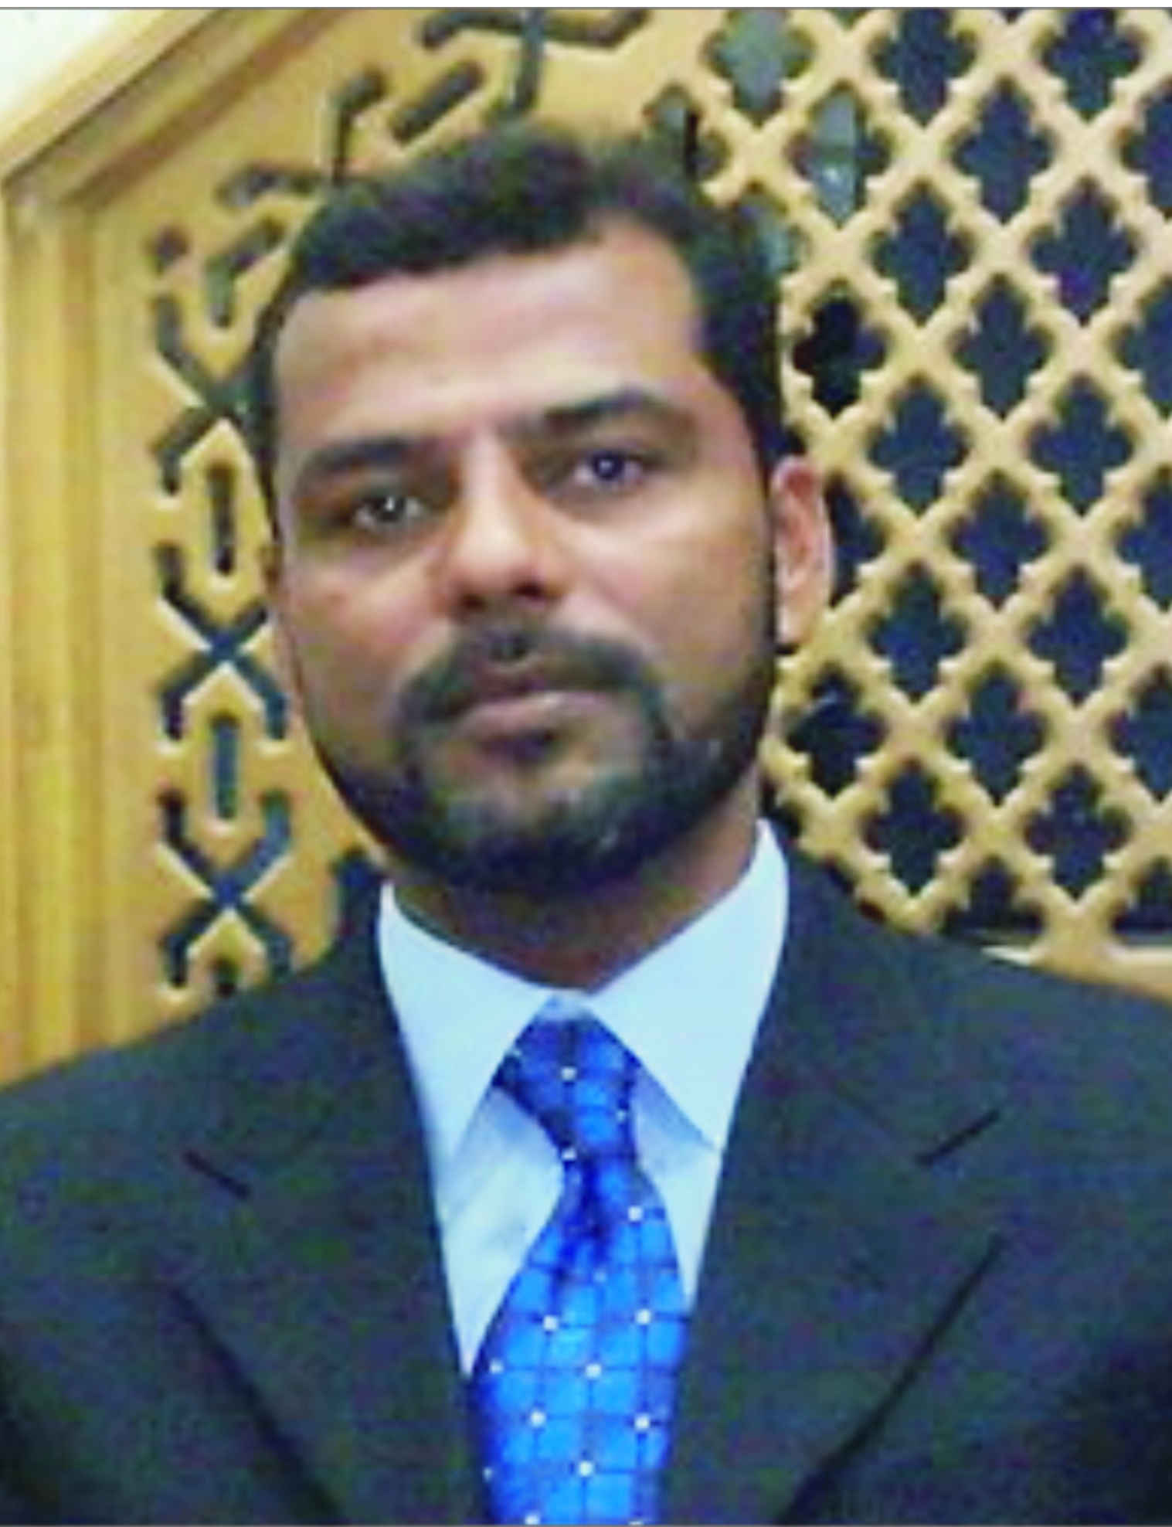 *JAWAD KARIM***

**Rehmat Colony MDA road,**

**Near Lodhy Colony chowk,**

**Multan.  
Cell #:O300-9688921**

**0321-6327108**

**jawadqarim@yahoo.com**

## *Personal:*

**Father’s name: Muhammad Akram (Late)**

**Date of Birth: 17th March 1975**

**N.I.C.No: 31202-0237835-3**

**Marital Status: Married**

**Nationality: Pakistani**

## *Career Objective:*

**To seek challenging position in the competitive organization and to become**

**a multidisciplinary individual who can work for the growth of the organization**.

## *Academic Record:*

**Degrees Division Institution**

**Graduation 2nd Islamia University, Bahawalpur**

**D.A.E 2nd Govt. College of Technology Bahawalpur**

**Matriculation 2nd Govt. Abbasia High School Bahawalpur**

## *Computer Skills*:

* **Microsoft Office: Excellent in MS Word, MS Excel, MS Power Point etc.**
* **Internet: Grasp in using Internet. Able to utilize Internet . application in business**

## *Personal Skills:*

* **Language: English, Urdu, Punjabi and Saraiki.**
* **Enjoy working in challenging atmosphere.**
* **A good listener with thrust for learning.**
* **Good communication and interpersonal skills.**
* **Good leadership qualities.**

## *Practical Experience:*

|  |  |
| --- | --- |
| **Smith & Nephew Pakistan (Pvt) Ltd**. **KARACHI**  Aug, 1997 to Jan,2003 | * **Worked as “S.P.O” Based at Bahawalpur.** * **Responsible for Bahawalpur + Bahawalnagar + Rahim yar khan.** * **Win best participation and Detailing prizes in different training sessions.** * **Successfully launched 2 products (OPSITE & OPSITE POST-OP) and win prizes.** |
| **Excel Healthcare Labs. KARACHI.**  Jan, 2003 to Apr, 2006 | * **Worked as “S.S.P.O” Based at Bahawalpur.** * **Looking after Bahawalpur + Bahawalnagar + Rahim yar khan.** * **Promoted high tech hormonal preparation for infertility treatment. (H.C.G. H.M.G. Pure F.S.H. Natural progesterone)** * **Responsible for BWP + R.Y.KHAN.** * **Promoted as ‘PRODUCT SPECIALIST’ and transferred to LAHORE on special assignment.** * **Promoted as ‘GROUP LEADER’ responsible for MULTAN Region.** * **Promoted as ‘DISTRICT SALES MANAGER’ responsible for MULTAN Region.** * **Got best sales achievement prizes as S.S.P.O and DISTRICT MANAGER.** |
| **Matrix Pharma (Pvt) Ltd. KARACHI**  Apr, 2006 to Aug, 2014 | * **Working as “REGIONAL BUSINESS MANAGER” responsible for MULTAN Region. (Gynae Group).** * **Latter on looking after (2) Groups (Gynae + Peads)** * **Successfully launched ‘FOREVA, CRAN MAX, DMAX tab.** * **Got special prize of Rs. 10000. On “FOREVA” target achievement.** |
| **OBS Pakistan (Pvt) Ltd. KARACHI**  Aug, 2014 to June, 2015 | * **Looking after Multan Region as “REGIONAL MANAGER”** * **Looking after “Cardiac” group from OKARA to SADIQ ABAD** * **Team Rebuilding and reorganized Territory structure** * **Sales growth within 8 month up to 74%** |
| **AGP (Pvt) Ltd.**  **KARACHI**  **June, 2015 to Dec, 2015** | * **Looking after Multan Region as “REGIONAL SALES MANAGER”** * **Responsible for “Gynae-A” Group** |

## *Interest and Activities:*

* **Reading books**

## Playing & Watching Cricket.

## Music.

## *References:*

## Will be furnished upon request.