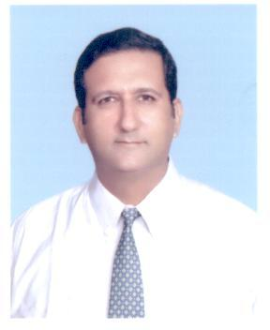

**Junaid Safdar**

Phone # 0300- 45 76 803

87-A /H. Johar Town,

Lahore

**Professional profile:**

* Experienced Sales Manager with impressive record of success in products regarding Cardiology, Diabetes, Hypertension, Gynecology and Orthopedics.
* Possess superior communication (oral and written) and interpersonal skills to develop rapport with customers, team members and business partners.
* Skilled in developing new prescribers
* Ten years as Sales manager of Central zone
* Have worked in all major towns of Punjab as sales Manager

**Expertise includes:**

* Team development, coaching and monitoring
* Developing relations with key customers
* Optimization of resources
* Monitoring distributional operations and trade network.
* Achieving sales targets through sales force
* Presentation skill

**Employment History in Pharmaceuticals**

Oct 2013’ to date Sales Training Manager

June 2008’ to September 2013’

Pacific Pharmaceuticals Sales Training Manager

September 2004’ to April 2008:

Lahore Chemical & Pharmaceutical Works (Pvt) Ltd: Product Manager

November 1999’ to 15th Oct 2002’

**Venture Pharmaceuticals (Pvt) Ltd: SALES MANAGER** (Central) **(3 years)**

August 1996 to November 1999’

CCL Pharmaceuticals (Pvt) Ltd:Product Manager,

June 1989 to February 1995’

**Boehringer Mannheim (Now Roche)**: **SALES MANAGER** (Punjab & North) **(6 years)**

August 1986 to January 1989’

**Hoechst (Now Sanofi Aventis) Medical Information Officer**

February 1985 to August 1986’

**Glaxo (Now GSK): Medical Representative**

**Education and Professional Development:**

B.Sc (Chemistry, Biology)

* Participated in “**Sales Management**” Course by P.I.M
* Attended “**Effective communication and interpersonal skills**” (C.C.L)
* Completed course on “Developing Marketing Skills” by P.I.M
* Attended course on “Training Techniques for Managers” by P.I.M
* Learnt “Principles of growth and decline of products” at DAFFODILS Pharma Marketing Consultants
* Product training courses at GSK, Sanofi Aventis and Boehringer Mannheim.