**KHURRAM SHAFIQUE**

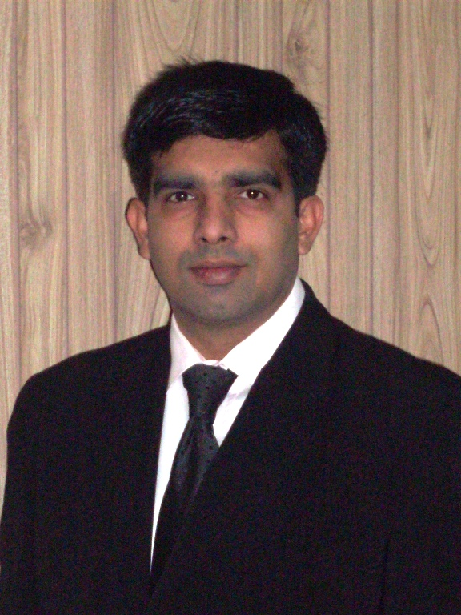

**S/O Muhammad Shafique Rahat**

**Date of Birth: 02 Dec 1977**

**Marital Status: Married**

**H.NO.535 M Block, Model Town (Ext.), Lahore**

**Cell: 03154219898- 03215600914**

**Email: shafiquekhurram07@gmail.com**

**Objective:**

Utilize my past experience and skills for the progress of company at the highest standard of efficiency and performance to achieve the required objectives in the interest of the national/multinational company.

**Professional Experience:**

**MSR Hospitality (Nirala Group of Companies): (Nov 2013 to Till)**

Working as Institutional Manager (Distribution network, Key Outlets CSD/USC/Government/Semi-Government All Pakistan)

**Job Responsibilities:**

* Coordinate with USC Project Manager for USC Brand Products provided by Nirala
* Conduct Sales & marketing research report to the higher management.
* Produce USC Brand Products

• Visit all regions & zone to collect demands and replacement.

• Tackle all kinds of consignments clearance in professional manner.

• Follow up the daily and weekly sales reports.

• Promotion of the sales and product

**Skin Care Cosmetics (Pvt.) Ltd: (July 2011 to Oct 2013)**

Worked as Field Manager (Lahore) Distribution network, Key Outlets)

**Job Responsibilities:**

**•** Conduct Sales and report to the higher management.

• Visit all Key Outlets & A+ Stores to collect demands.

• Tackle all kinds of consignments clearance in professional manner.

• Follow up the daily and weekly sales reports.

• Promotion of the sales and product

**Marhaba Laboratories (Pvt.) Ltd: (Aug 2005 to July 2011)**

Worked as Institutional Manager (Distribution network, Key Outlets CSD/USC/Government/Semi-Government All Pakistan)

**Job Responsibilities:**

**•** Conduct Sales and report to the higher management.

• Visit all regions & zone to collect demands and replacement.

• Tackle all kinds of consignments clearance in professional manner.

• Follow up the daily and weekly sales reports.

• Promotion of the sales and product

**Bahria Town (Pvt) Ltd: (Aug 2003 to July 2005)**

Worked with Bahria Town (Pvt) Ltd, Lahore as Marketing Executive

**Job Responsibilities:**

* + - Coordinate with the current clients, prepare their financing cases and sent them to the bank for processing.
    - Coordinate with the bankers for evaluation of the cases.
    - Prepare concern reports.
    - Arrange meetings with the management for further improvement in performance

**Progressive Traders (Pvt.) Ltd: (Jan2001 to Aug2003)**

Worked as a Sales Executive (Distribution network, Key Outlets)

**Job Responsibilities:**

**•** Conduct Sales and report to the higher management.

• Take advertising decisions.

• Tackle all kinds of consignments clearance in professional manner.

• Follow up the daily and weekly sales reports.

• Promotion of the sales and product

**Old Spice (Pvt.) Ltd: (Nov2000 to Dec2001)**

Worked as Territory In charge.

**Job Responsibilities**:

• Conduct Sales and informing the development to the Sales manager.

• Distributing and advertising decisions

• Tackle all kinds of consignments clearance in professional manner.

• Submitting daily and weekly sales report.

• Demonstration and mechanizing the product at the dealer’s showroom

• Promotion of the sales and product

**Distinction:**

**Advertising and Marketing**

• Have sound knowledge of marketing strategies by media campaign including T.V, newspaper, and Radio.

• Can prepare strategies for promotion/publicity/advertisement including hoarding, banners and all sort of promotion material

**Client Service:**

• Convincing power in client dealing

**Management:**

• Managing day-to-day matters related to any sort of business concerns, human resources administration.

• Understanding of system development life cycle, including requirement analysis, system design development, implementation and post implementation to any concern

**Education:**

BA (1997-2000)

Punjab University Lahore (Grade B)

FSC (1995- 1997)

Federal College Islamabad (Grade A)

Matriculation (1993- 1995)

Lahore Board of Intermediate and Secondary Education (Grade A)

**Interests:**

* Extremely social person, like to develop relationships to different fields of people
* Marketing, Management and client dealing
* Advertising and Media

**References:**

* Furnished on request