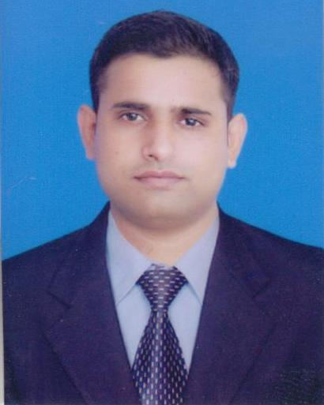

**KOUSAR ALI  
Address: Flat # 202, Block C4, Sawana City**

**Apartment, 13D-3, Gulshan-e-Iqbal**

**Karachi**

**Contact: +92-331-3068505**

**Email: pmkousar@gmail.com**

**EXECUTIVE SUMMARY:**

**More than four years of proficiency in Sales and Marketing of Pharmaceutical & Consumer division of an organization from conception to implementation.**  
**Expertise in diverse segments and practices such as Product management, Business Development and Product planning.  
Experience in revamping business processes, managing product life-cycle and developing functional workflow in new product development. Proficient in setting diversified business portfolio based on market research and changing market dynamics.**

**PROFESSIONAL WORK EXPERIENCE:**

**Current Organization:** **ACE Healthtek (Lahore)**

**Designation: Product and Marketing Services Manager**

**Tenure: From May 02, 2016 till date.**

**Previous Organization:**  **Opal Laboratories (Pvt.) Ltd (Karachi)**

**Tenure:**  **August 12, 2011 – January 04, 2016**

**Designation:** **Product Manager** from July 2014 to January 2016

A**ssistant Product Manager** from July 2012 to June 2014

**Marketing Assistant** from August 2011 to June 2012

**RESPONSIBILITIES:**

* Responsible for providing sales team with the necessary technical expertise which enable them to sell product. This involved printed and electronic material, product manual, trainings, and relevant clinical studies.
* Frequent visits in field (All over Pakistan) in-order to boost sales and ensure presence and quality of work by field representatives and to strengthen professional relationships with customers by having a direct interaction.
* Responsible for reviewing products data on new developments regarding the company’s and competitors’ products through IMS and SALS.
* Acting as point of first reference for all products related enquiries and work collaboratively with product development and regulatory departments in order to entertain raised query.
* Close liaison with the field force to assess the suitability of current promotional material and to ensure that printed promotional material is being used optimally in order to increase sales figures.
* Design market research projects to access customer attitudes towards current products range and new product introductions.
* Assist marketing manager to develop and execute annual marketing plans for controlling advertising, promotion and sales strategies.
* Assist marketing manager to prepare forecast and constantly monitor inventory levels; work closely with planning and distribution department to ensure timely availability of stock for domestic market and export.
* Arranging seminars, meetings and conferences depending upon nature of event.

**ACADEMIC EDUCATION:**

**EXAMINING BODY: YEAR**

* Masters of Business Administration (Marketing) Iqra University (Main campus), Karachi 2011
* Bachelors of Business Administration Shah Abdul Latif University Khairpur 2007
* Intermediate (Pre-Medical) BISE, Sukkur 2005

**THESIS:**

* “To study the relationship between product characteristics and choice of exhibition participation”.

**ACHIEVEMENTS:**

* Successful Launching of new Brands into portfolio of Opal Laboratories (Pvt.) Ltd
* Achieved title of best event planner for International seminar held at IQRA University on “Youth Leadership”.

**COMMUNICATION AND INTERPERSONAL SKILLS:**

* Strong organizational, problem solving, interpersonal and negotiation skills.
* Outstanding command over verbal and non-verbal communicative & interpersonal skills.
* Confidently able to work independently or in a team to deal effectively with customers & employees.
* Flair to organize & prioritize tasks to meet deadlines.
* Have a good level command over English and Urdu Languages.
* Punctual and devoted to job.
* Capable and desirous of learning new concepts.

**PROFESSIONAL SKILLS:**

* MS Office Professional
* SALS Professional
* ERP Advance Level
* IMS Learner
* SPSS Medium
* QM Medium

**INTERESTS AND HOBBIES:**

Market search, Public speaking, Training, Travelling, and Community work for acquiring latest information.

**PERSONAL INFORMATION:**

**Father’s Name** : Naseer Ali

**Date of Birth** : June, 03, 1988

**Religion**  : Islam