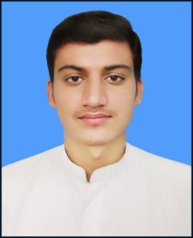

# Liaqat ali

PERSONAL INFORMATION:

**Address:** Village & P/o Harichand Tehsail Tangi District Charsadda KPK

***Mobile No:*** +92-344-8211190

## *C.N.I.C #:* 17102-4025333-3

***Father’s Name:*** Ahmad Jan

***Date of birth:***  16-05-1996

***Domicile:*** Charsadda (Khyber Pukhtoon Khwa)

***Gender:*** Male

***Religion:*** Islam

***Nationality:*** Pakistani

***E-mail:***  Ce_liqat.ali@hotmail.com

* **EDUCATION & SKILLS:**

|  |  |  |  |
| --- | --- | --- | --- |
| **Exam** | **Session** | **T.Marks/ob.marks** | **Board/ University** |
| ***S.S.C*** | 2012 | 1050/659 | B.I.S.E Peshawar |
| ***D.A.E (Civil 3 year)*** | 2015 | 3350/2534 | Technical Board Peshawar |

* ***COMPUTER SKILL:***

1. 6 months Computer Course Ms Office, Ms windows, Internet Browsing

* **Experience:**

1. 6 th months (1st nov 2014 to 31 st Aprail 2015) Experience in Linear Pharmaceutical islamabad on Mingora Base.
2. 6 months experience from B.M.G Pharma Sawabi Base: Since 1st June 2015 to till date now.

* ***LANGUAGE:***
  1. English: Write, Speak and understand
  2. Urdu: Write, Speak and understand
  3. Pashto: Write, Speak and understand