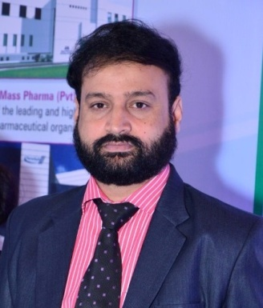**M. IMRAN AHMED GHAURI**

Mob # 0314-6120810

[aims1782003@yahoo.com](mailto:aims1782003@yahoo.com)

__________________________________________________________________________

**Career Objective:**

To have a competitive Managerial position in Marketing with a dynamic organization to apply accumulated skills in contributing towards the achievement of Organizational Goals and Career Growth.

|  |
| --- |
| **Education:** |
| **2014: MBA** (Marketing) VU Pakistan CGPA 3.26/4.00 |
| **1999: B. Pharmacy** BZU Multan 1st Div. |

**Professional Experience**

**Sr. Product Manager** (May 2012 – To date): **Mass** **Pharma (Pvt.) Ltd.**

-Product Management

-Business Plan Designing, Training, Launching

-Delivering Product Presentations

-Key Customer Development throughout the country

**Sales Coordinator / Product Development Manager** **Bio Pharma** (April 2004 – Feb. 2012):

-Product Planning & Forecasting, Development strategies.

-Designed Literatures, PILs and Training Manuals.

-Regulatory Affairs

**Career Accomplishments:**

* Launched Brands like **D-Gest** (Specialized Dydrogesterone) made it 50 Million Rupees Brand during 1st year of Launch.
* Launched Hormone Division with the name of MDHR in 2016
* Launched CAM Products Like
* ENZ-10 (CoQ10) Brand Leader in Pakistan worth 70 Million
* Hunger Up (Appetite Stimulant) A Leading Brand
* Got Dubai Trip on the achievement of Set Objectives

**Segments & Area of Exposure**

Gyne / Paeds / Cardio / Physician / GPs All Over Pakistan

**Skills & Abilities**

* Excellent Written, Oral and Communication Skills
* Likes to be a Mentor, Coach rather than a Boss
* Eager to Learn and improve all the time
* Result Oriented
* Punctual, Responsible & Dedicated to the Tasks
* Flexible Personality, Easy to Adapt to all situations
* Team Player

**Miscellaneous Skills**

-Good Command on Microsoft Word, Excel, Power Point, Internet surfing etc.

-Proficiency in English, Urdu, Punjabi, Saraiki languages.

**Personal Information**

|  |  |
| --- | --- |
| Father Name | Ghulam Rasool Anwer |
| Birth Date: | 15th January 1976 |
| Marital Status | Married |
| CNIC No.  Current Address | 36302-6639562-7  123 G-4 Wapda Town Lahore |
| Permanent Address | H# 4 St# 6 Block “W” New Multan, Multan |

|  |  |
| --- | --- |
|  |  |
|  |  |
|  |  |
| References: | **Mr. Syed Sohail Abbas** Director Eminent Pharmaceuticals  0321-8503377  **Dr. Rahat Ali** Chief Executive Farhat Ali Pharmalinks Lahore 03008438863  **Mr. Zahid Hussain** Product Manager Indus Pharma 0300-2017168  **Mr. M Ramzan Malik** Ex Sales Manager Helix Pharma 0300-6634086 |