|  |  |  |  |
| --- | --- | --- | --- |
| Address | | | A-201, Saima Flowers, Block-G  North Nazimabad, Karachi 74700 |
| E-mail | | | fawadlari@hotmail.com |
| Cell # | | | 0347-2418944 |
| Date of Birth | | | 19th July, 1992 |
| **SPECIALIZATION** | | | ***Human Resource Management*** | |
| **Field of Interest** | | | *Strategic Planning, Training & Development, Employee Engagement* | |
| Objective |  | I am pursuing an opportunity to acquire professional skills and abilities in a challenging environment where I could learn tactics to cope with the issues arising and solve them in an efficient manner and implement those in a future professional working career. | | | |
| education |  | |  |  |  |  | | --- | --- | --- | --- | | **Degree** | **Year** | **Institute** | **Grade/Division** | | MPA | 2015 | University of Karachi | 1st | | BPA (Hons.) | 2014 | University of Karachi | 1st | | Intermediate | 2010 | Board of Intermediate Education, Karachi | 1st | | Matriculation | 2008 | Board of Secondary Education, Karachi | A-1 | | | | |
| PROFESSIONAl EXPERIENCE |  | GEO TV NETWORK **-** (4-Months)  Responsibilities   1. Managing the HR affairs of nearly 250 employees 2. Forming Organogram with the coordination of the respective department 3. Assisted and involved in Job Analysis with BU HR Manager 4. Formulation of JD’s and KPI’s for different positions 5. Conducted salary survey to make compensation ratio for different designations 6. Interviewed and offered contracts to the incumbents 7. Coordinated with Recruitment & Selection for the process of on-boarding and off-boarding 8. Employees file management and updating HRIS | | | |
| internship experince |  | * GEO TV NETWORK * SUI SOUTHERN GAS COMPNAY (SSGC) * PAKISTAN TELECOMMUNICATION LIMITED (PTCL) | | | |
| PROJECTS/ REPORTS |  | |  |  | | --- | --- | | * Report on Communication Skills * Report on Analysis of Pakistan’s economy | * Report on Functions of Management * Report on Public Policy Analysis | | | | |
| activities/ skills |  | |  |  | | --- | --- | | * Self-motivated, initiative with a high level of energy. | * Good observer and a passionate learner. | |  |  | | * Strong Leadership and analytical skills | * Efficient team player | | * Effective communication and interpersonal skills. | * Basic knowledge of MS office | | | | |

Urdu

**MUHAMMAD FAWAD LARI**

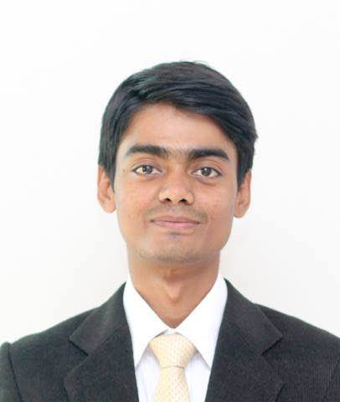

# 

* Urdu (Proficient)
* English (Proficient)
* French (Beginner)

# LANGUAGES