**Resume**

My name is Muhammad Imran Khatiyan and I am a successful and high paced professional with Diversified blended experience in Pharmaceutical market………………………….......  
  
It has been a long story starting from 1996 when I had started my professional journey with keeping in mind a very aggressive ambitious and career dream. The key attributes of my professional career can be identified as diversity and change management.

After graduation from University, I had been selected worked in a Multinational Company (Merck) for the role of Scientific Promotion officer where I attended many trainings and seminars by which I learned a lot. During job I also completed my Master’s in Business Administration major in Marketing and focused in Human Resource management to accomplish my dream to be a successful marketer. My approach has been holistic with focus on delivering additional value, building a high-performing team and executing with rigor.

My current role is a mixture of diverse business audiences & objectives; on one side I am tasked with driving revenue generation as per company’s objectives through new customer and business acquisitions, delivering greater depth in key-accounts and increase market share of my Company by developing a productive and result oriented sales team throughout the Pakistan. At the same time, I also work to shape the structural landscape changes through business partners (Distributors) development, channel development and strategic management by working with influencers such as Board of Directors, trade bodies and customer group.

***Future goals: (Professional)***

Continue to build on my knowledge / skill-set by exploring opportunities that offer a multi-cultural setting and an emerging discipline to access customers. I am fascinated at the potential of how ‘digital-footprint’ of consumers can be used to create new marketing and sales channels in Pharmaceutical market which having great potential. I want to continue to be part of a dynamic and enterprising work-culture that inspires to improve people’s health every day.

***Specialties:***

♣ Hiring, Coaching & Counseling  
♣ Leadership  
♣ Administration

♣ Profitability

♣ Field Visit Management  
♣ Effective Meetings  
♣ Sales Analysis and Planning  
♣ Pillars of Professional Relationship  
♣ Field Force Retention Toolkits plans  
♣ Strategic Marketing  
♣ Leadership behavior  
♣ Branding

♣ New products Launch

♣ Team management  
♣ Target the customers  
♣ Strong Analytic Skills  
♣ Focus on the potential Audience  
♣ Professional Communication

♣ Event Organization

***Important Brands***

* Antibiotics (Oral & Parental)
* Antihistamine/Anti Allergic
* Analgesics/NSAID’s
* Proton Pump Inhibitors/H2 Receptors Antagonists
* Iron Preparations
* Anti Malarial
* Respiratory
* Multivitamins
* Anti Psychotics
* Anti Depressants
* Gastro Prokinetics

During my professional life, I received many awards and accolades as a top performer whilst working with different companies.

I look forward to be considered for subject mentioned position within your organization.

Best Regards

***Muhammad Imran Khatiyan***

0331 33 88 007

[imrankhatiyan@hotmail.com](mailto:imrankhatiyan@hotmail.com)

Muhammad Imran Khatiyan 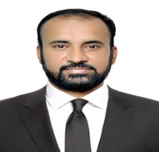

0331 – 33 88 007

Flat No: A-225, Serena Towers, Sakhi Hassan Round, Bufferzone-1, North Karachi. Karachi. Pakistan.

[imrankhatiyan@hotmail.com](mailto:imrankhatiyan@hotmail.com)

***Academic:***

|  |  |
| --- | --- |
| **Degree / Certificate** | **Completion Year** |
| M.B.A (Marketing) | 2005 |
| B.Com | 1995 |
| H.S.E II (Pre – Medical) | 1991 |
| S.S.C II (Science) | 1988 |

***Computer Skills:***

* + - Windows 10
    - Out Look
    - Ms-Office
    - Graphic Software
    - Internet Browsing

***Professional Experience***

** Product & Sales Manager**

***May 2014 to August 2015***

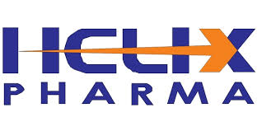 **Business Unit Manager**

***June 2011 to January 2014***

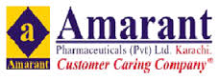 **Product & Sales Manager**

***May 2010 to May 2011***

**Pharma Private Limited. Product Manager**

***May 2009 to April 2010***

**Pharma Private Limited. Senior Sales Manager (South)**

***June 2007 to April 2009***

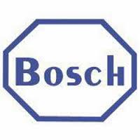**Pharmaceuticals (Pvt.) Limited. Senior Area Sales Manager (Hyderabad)**

***From Sep 2002 to May 2007***

**Pharmaceuticals (Pvt.) Limited. Senior Sales Promotion officer (Hyderabad)**

***From July 2001 to August 2002***

**(Pvt.) Limited. Scientific Promotion Officer (Hyderabad)**

***From October 1996 to June 2001***

***Accolades and Awards***

* **Many Prizes & Awards won in Qirat, Naat, Debate, Table Tennis and Hockey etc. in School, College and University Life. (Certificates in hand)**
* **Won many incentives in cash & abroad visits on sales Achievements**.

***Languages***

**\* English * Urdu * Sindhi * Panjabi**

***References***

***References can be furnished on Demand***