**pharmacist**

**CELL: +92-333-4838931**

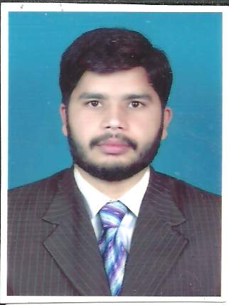

**IDENTIFICATION:**

First Name: Muhammad

Last Name: Jameel

Father Name: Mashooq ali

Date of Birth: 4th April 1992

Passport Number: N/A

N.I.C: 35201-3941259-3

Address Line 1: Attari Saroba ,Pak Arab society 17 KM Ferozpur road Lahore

House NO#77 Tehsil Cantt lahore

Email: jameelips@gmail.com

Sex: Male

Nationality: Pakistani

City : Lahore

Country : Pakistan

Cell: +92-333-4838931

**ACADEMICS:**

|  |  |  |  |  |
| --- | --- | --- | --- | --- |
| **Degree** | **Institution** | **Majors** | **Division** | **Year** |
| **SSC** | Dine islam public school | **science** | **1st 723/850** | **2007** |
| **HSSC** | Nishter college lahore | **Pre medical** | **1st 921/1100** | **2008** |
| **PharmD** | **UVAS - IPS** | **BIO SCIENCE** | **3.45 cgpa** | **2015** |
|  |  |  |  |  |

**OBJECTIVE:**

Looking for a position where I can use my knowledge and skills in a challenging and congenial environment for my personal and professional development.

**EXPERIENCE AND COCURRICULAR ACTIVITIES**:

* Worked at JAIDE Jinnah hospital as diabetes educator for three months in patient education.
* Community pharmacy internship 2014.
* Teaching throughout degree in different academies in Lahore.
* Major event organizer in UVAS.
* Organized IPS badminton tournament in 2013.
* Organized and participated in one day seminar on pharmacy practice at institute of pharmaceutical sciences Lahore 2014.
* Organized spring quiz event at UVAS 2015.
* Participated in drama festival of UVAS 2014.
* Coordinated and organized qirat and naat competition 2014.
* Participated in department decoration spring festival2014.
* Organized war of brain competition at UVAS 2014.
* Chief organizer of debate society 2015.
* Remained proctor in school and college.
* Participated in flood relief activities in JHUNG in 2014.

.

**LANGUAGE SKILLS:**

Language Read Write Speak Understand

English Fluent Fluent Fluent Fluent

Urdu Fluent Fluent Fluent Fluent

Punjabi Fluent Fluent Fluent Fluent

**PERSONAL PURSUITS:**

* **Reading books related to pharmacy and clinics.**
* **Science documentaries.**
* **Reading scientific articales and daily news paper.**
* **Playing cricket and football.**

**PERSONAL STRENGHTS:**

* Very good communication and presentation skills in Urdu and English .
* Capability to convince someone .
* Capability to work in multi culture environment.
* Good cool temperament.

**I.T Skills:**

Expert in MS office (Power point, Excel, Word)

Well familiar with Internet explorer and Mozilla firefox.

SPSS 17.0

E-Mail

**PUBLICATIONS:**

1. **Competed research during Pharm D on drug interaction surveillance.**

**REFERENCES:**

Available on demand.