**CURRICULUM VITAE**

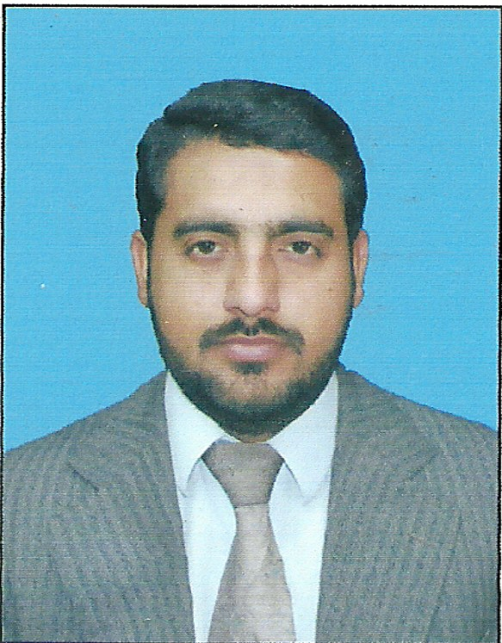

**MUHAMMAD QASIM**

OBJECTIVE:

To secure a challenging position in a reputable organization and seeking a dynamic environment with tremendous opportunities for personal learning, growth & development. In order to ensure optimum use of human capital for the benefit of the organization.

**PERSONAL INFORMATION:**

**NAME:** MUHAMMAD QASIM

**FATHER NAME:** SAID WAHAB

**NATIONALITY:** PAKISTANI

**DATE OF BIRTH:** 04/07/1986

**RELIGION:** ISLAM

**MARITAL STATUS:** MARRIED

**DOMICILE:** MARDAN KPK

**CNIC:** 16101-9846770-1

**MOBILE:** 0301-8888963

ADDRESS: Mohallah Molliyan, Village Kandar Post Office Garhi Kapura, MARDAN, KPK.

**EMAIL ID:** kkj.qasim@gmail.com

**ACADMIC RECORD:**

|  |  |  |
| --- | --- | --- |
| Pharm-D  (Doctor of Pharmacy) | SARHAD University of Science and Information Technology Peshawar | 2006-2011 |
| F.Sc (pre-medical) | FAZAIA Degree College Peshawar | 2006 |
| S.S.C | IQRA Cadet School Garhi Kapura Mardan | 2004 |

**EXPERIENCE:**

* One year experience in Sanofi Aventis as a Pharma Associate (P.A) at Mardan base Pakistan and still working here.
* Three year experience in Searle Pharmaceuticals as a Medical Information Executive (M.I.E) at Mardan base Pakistan
* Two months work Practice as an Internee in RORYAN Pharmaceuticals (pvt ltd.).
* 40 days Hospital training in Northwest General Hospital and Research Center Hayatabad, Peshawar Pakistan.
* Two months Pharmacy Training in Mardan Medical Complex (MMC) Mardan Pakistan.
* As an independent monitor the main experience counts in the monitoring and evaluation functions.

**ADDITIONAL SKILLS:**

* Voluntarily worked in flood relief camps in Mardan and Peshawar as a Group Leader.
* Voluntarily worked as Team Leader in IDP’s allocation and welfare in Mardan city.
* Presentation and good communication skills
* Proficient in the usage of Internet
* Having good leadership Quality
* Believe on Quality of the work
* Ability to deal with variety of people and situation
* Flexibility and ability to work under pressure and within limited time frames.
* Adequate reporting skills. Learning attitude. (From supervisors, peers and subordinates) and taking initiatives.
* Innovative and creative mind.

**REFRENCES:**

References shall be provided on demand.

**LANGUAGES SPOKEN:**

English: Speaking, writing and reading very frequently.

Urdu: Speaking, writing and reading very frequently.

Pashto: Speaking, writing and reading very frequently.