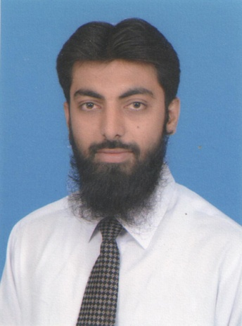**Dr. Muhammad Raheel**

Pharm.D, R.Ph.

✆ +92-334-3073386

🖂 raheel3344@gmail.com

images.jpg/phr.raheel

 raheel3342

**Objective:**

Self-motivated and determined pharmacy graduate with pharmaceutical marketing and query handling experience. A passion for customer service. Seeking a full-time position where I can apply my medical knowledge and marketing skills to provide exceptional services to customers.

**Professional Experience: (2 Years & 5 Months)**

* **Sindh Institute of Urology and Transplantation:**

**April 22nd, 2013 – April 21st, 2014: Trainee Pharmacist (1 Year)**

* **Ziauddin University Hospital, Karachi:**

**May 1st, 2014 – August 31st, 2014: Pharmacist (4 Months)**

* **Galaxy Pharma. (Pvt.) Ltd., Karachi:**

**November 17th, 2014 – November 16th, 2015: (FSRO) (1 year)**

As a Field Scientific Research Officer, I was responsible for the following tasks:

* Dissemination of Knowledge, through trainings and presentations
* Clinical Trials
* Research studies
* Customer Query handling
* Rebuttals/ Updating Bluebook
* Customer Satisfaction
* Protocol visit
* **Galaxy Pharma. (Pvt.) Ltd., Karachi:**

**November 17th, 2015 – Present (APM) (1 month)**

As Assistant Product Manager, I am responsible for the following tasks:

* Review and undertake market and competitor review
* Undertake customer research
* Articulating customer problems
* Identify current and future market opportunities
* Participate in the budgetary process
* Prepare Market and Product Required documents
* Review and report on performance indicators
* **Personal Information:**

**Father’s Name** :RUSTAM KHAN

**Date of Birth** :11-06-1987

**Nationality** :PAKISTANI

**Religion** :ISLAM

**CNIC** :42401-7109824-7

**Language** : Urdu, English, Pushtu

* **Education:**

|  |  |  |  |
| --- | --- | --- | --- |
| **Degree** | **Year** | **Institution** | **CGPA/Rank/Grade** |
| Pharm.D | 2013 | Ziauddin University, Karachi | **3.26** |
| H.S.C.  Karachi Board | 2007 | S.M. Govt Science College, Karachi | **B** |
| S.S.C.  Karachi Board | 2005 | Fairy Land Secondary School, Karachi | **A** |

* **Thesis Work:**

Worked on the thesis entitled, **“To evaluate the clinical significance of FDA approved Nanotechnology based formulations”**.

(**Supervisor: Farrukh Rafiq Ahmed,** Assistant Professor, Ziauddin College of Pharmacy, Ziauddin University, Karachi**).**

* **Professional & Communication Skills:**
* Professional in Microsoft Office Word, PowerPoint for making Presentations and Documents, also knows basics of Adobe Photoshop.
* Good know-how on different Medical Search Engines like Micromedex, Uptodate, Pubmed, Sciverse Hub and Clinical Trials Database.
* Liaising with other Health Care Professionals, Peers and Colleagues to make positive working relationship.
* Fluency in Both English and Urdu.
* **Reference:**

Can be furnished on request.