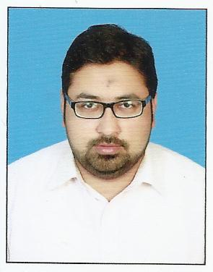

MUHAMMAD SAAD KHAN

R-1615/18 F.B AREA GULBERG KARACHI-75950, PAKISTAN

(021) 36368277, +92 346 2775547

msk_1615@hotmail.com

Date of Birth: 05/21/1989

**EDUCATION:**

**Institute of Business Management (IoBM)(CBM), Karachi**

* (MBA) - Health, Hospital and Pharmaceutical Management
* Graduation: Expected in 2015
* Cumulative GPA: 3.2

**ELECTIVES:**

|  |
| --- |
| * Pharmaceutical Branding |
| * Product Management * Pharmaceutical Administration   **UNIVERSITY OF KARACHI, KARACHI**   * Pharm-D, 2011 * cGPA: 2.7   **GOVT DEHLI COLLEGE, KARACHI**   * Intermediate (Pre-Medical), 2006 * Attained (75%) Marks   **METROPOLIS ACADEMY, KARACHI**   * Matriculation (Science), 2004 * Attained (82%) Marks |

**HONOURS / ACHIEVEMENTS:**

* Successfully promoted (Augmentin) antibiotic Division in GSK Pakistan.
* Achieved 98% marks in “Initial Training Course” conducted by GSK.

###### SKILLS:

* Teaches/trains/instructs, counsels/coaches, delegates’ responsibility, makes decisions.
* Develops strategies, assesses situations, identifies problems and works well with others.
* Competitive selling

**MAJOR TERM PAPERS / RESEARCH WORK / PROJECTS:**

* Pharmaceutical Administration / Environment Health and safety practices in national and multinational Pharmaceuticals.

**PUBLICATIONS:**

Attitude of Future Healthcare Provider towards Vitamin D Significance in Relation to Sunlight Exposure

Saudi Pharmaceutical Journal

**HOBBIES:**

Cricket, Movies, Music.

ACADEMIC ACTIVITIES

Attended seminar on “GMP with Regulatory Compliance”

**PROFESSIONAL EXPERIENCE**

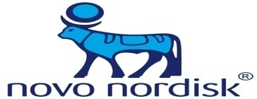**NOVONORDISK PAKISTAN (PVT) LIMITED**

Feb 17th 2015 – Present

Product Specialist

* Responsible for selling and Promotion of pharmaceutical health care products (**LEVEMIR, NOVORAPID**).

**MEDINET PHARMACEUTICALS (PVT) LIMITED**

May 27th 2014 – Feb 6th 2015

Territory Manager

* Responsible for selling and Promotion of pharmaceutical health care products (**Geneplat, Paclitaxel Varifarma, Filatil, LiquiBand**).
* Part of Liquiband (first ever surgical skin adhesive) launch Team.

**EUREKON INTERNATIONAL**

Aug 8th 2013 – Mar 11th 2014

Product Executive – Marketing

* Managed consumer portfolio including **Intimate Feminine Wash** (vaginal wash) and **De-Scar stretch marks cream**.
* Responsible for providing the sales team with the necessary technical expertise. This involves printed promotional material, product training, and relevant clinical papers.
* Assist with the development of the annual marketing plan and for controlling advertising, promotion and sales aids in accordance with the annual marketing plan.
* Liaise with the advertising agency regarding the product campaign.

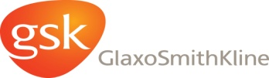**GLAXOSMITHKLINE, PAKISTAN**  
Feb 24th 2012 – Aug 6th2013  
Medical Service Executive

* Responsible for selling and Promotion of pharmaceutical health care products (**Augmentin. Calpol, Fortum, Starvits**).
* YTD of 101% (Jan 2013 – Aug 2013)
* Performed one-on-one meetings with pharmacist, doctors, and nurses.

**REFERENCE**

**M. Umair Khan, Mobile# 0345-2651832**

**Assistant Product Manager**

**Barrett Hodgson Pharmaceuticals.**