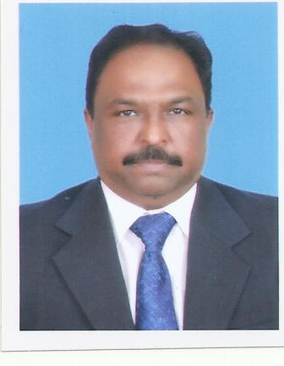**Muhammad Shahid MERAJ**

***Add:-*** Flat No. E-3, Five Star Luxury Apartment,

Gulshan-e-Iqbal, Block – 14, Karachi.

E-mail:- zsmeraj@yahoo.com

Cell #: 0300-8372397

**Objective:**

To utilize my experience, expertise and skills on challenging position in Sales/Marketing that translate my acumen for fostering growth and profitability of organization.

**Career Summary:**

I am decisive and proactive professional having sound experience of Sales Management, product management with successful track record of achievements.

I had lead a team of 356 Sales Representatives 45 District Managers and Sales Mangers along with Sales Co-ordination department. Effectively managed sales of Rs.5 Billion which including cardiovascular, pain management, anti-infective and vitamins port folios.

I have strong believed in team building, initiatives, innovation and consistency of performance by developing peoples. i also worked as   
Co-trainer of six sigma yellow belt, WMP (weighted matrix profiling) and compliance project. I have been exposed through different workshops and training on Sales Management, leadership, proactive business approaches strategic management.

**Academic Credentials:**

MBA ; Marketing 2010

M.A : Economics 1991

B.Sc. ; Life science 1988

**Experience**

1. **National Sales Manager**

Himont Pharmaceutical (Pvt) Ltd.

20th May 2015 to September 30, 2015

I was leading team of 110 SPOs, 15 District Managers and 3 Sales Managers. Re-align team structure, products allocation, customer targeting and Inclusion of products in different hospitals formulary.

2. **National Sales Manager**

Pfizer Pakistan Ltd.

(Cardiovascular, Pain Management, Anti-infective and vitamins)

September 2012 to February 2015.

I had lead a team of 356 Sales Representatives, 45 District Managers and 6 Sales Mangers. Over all portfolios was 5 Billion PkR and I was directly reporting to CEO. I revamped anti tuberculosis business by changed the strategic direction of the business to improve decline Sales trend of Myrine. Also realign business of Norvasc by improving geo coverage and focusing on customers.

3. **Sales Manager / (Specialty National Basis):**

Pfizer Pakistan Ltd.

(Cardiovascular, Ophthalmology and Oncology)

1 May 2010 to August 2012)

Lead a team of 70 Sales Force and 12 District Managers.   
I Initiated and revamp business of by introducing KCM (Key Customer Management) model. Successfully launched “Enbril” (Biologic), regain Sutent business and won best Sales Manager Award.

4. **Product Manager (Secondment) Ponstan Brand**

Pfizer Pakistan Ltd.

1 March 2009 to May 2010)

On secondment i worked one year in marketing department as a Product Manager for Ponstan brand. During this period Pfizer leading brand Ponstan crossed 1 billion Sales Mark. We initiated “Early Bird”, “Chemist Awareness” and LHVs Programs also organized across the country road shows on Ponstan.

5. **District Field Manager / Senior DFM:**

Pfizer Pakistan Ltd.

1 Sept. 2000 to March 2009)

Worked in this capacity in Karachi, Hyderabad, Mirpurkhas Districts. I built high performance team and won best District Manager Award. My team declared as a best team on National basis.

6. **Professional Services Representative / SPSR**

Pfizer Pakistan Ltd.

1 Jan. 1990 to Sept. 2000

In this capacity promoted different products of Pfizer and worked in different geography of Hyderabad region. I won “Best PSR” award 3 consecutive years, also declared best detail man in midyear conference 1992.

**Cross functional Team Members / Co-trainer:**

* Six Sigma yellow belts.
* Customer focuses selling approach.
* WMP (weighted metrics profiling of customer.

**People Development**

* Developed and provided 3 Manages to organization.

**Skills:**

* Excellent interpersonal communication, leadership, presentation and mentoring skills.
* Creative and innovative
* Organized and focused.

**Key Trainings Attended:**

1. Pro-active Sales Management
2. Coaching for performance
3. Team building for high performance
4. Situational leadership.
5. Applied strategic thinking
6. Target Recruitment Selection
7. Leaders behaviors
8. IMS Plus
9. IMS Blue book
10. DM Planning for Success
11. Time and territory management
12. Key account Management

**Bio-data:**

Father’s Name : Meraj-ud din

Date of Birth : 18th November 1964

CNIC No. : 44103-2931101-5

Marital Status : Married

Children : 3