***­Curriculum Vitae***

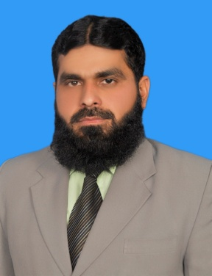

**MUHAMMAD TARIQ**

**Postal Address:**

Village & Post Office Wania Wala,

Gujranwala (Punjab), Pakistan.

Cell No. ***+92-333-8256684***

Email : [tariqgrw@gmail.com](mailto:tariqgrw@gmail.com)

Skype: tariqmhr1

.

**PERSONAL PROFILE**

* Date of Birth : 14-08-1984 , Marital Status : Married
* CNIC : 34101-8912735-1
* Religion : Islam , Nationality : Pakistani

**PROFESSIONAL QUALIFICATION**

* MBA Marketing (3.5 year) Virtual University Lahore (Febuary,2015)
* B.A (General) A.I.O.U ,Islamabad (2011)

**ACADEMIC QUALIFICATION**

* I.C.S B.I.S.E, Gujranwala (2002)
* Matric B.I.S.E, Gujranwala (2000)

**PROFESSIONAL EXPERIENCE**

* Working as a **Product Specialist** in **Wilson Pharmaceutical Ltd**  from November 2015 to Present.
* Working as a **Sales Executive** in **Pharmatec Pakistan (Pvt) Ltd** from November 2013 to October 2015.
* 7.5 Years Experience as **sales Promotion Officer** in **Herbion Pakistan (Pvt) Ltd** From July 2006 to November 2013.
* 1.5 years as a **Sales Rep** in **UDL Distribution (Pvt) Ltd** from Jan 2005 to June 2006.

**KEY RESPONSIBILITEIS.**

* To meet the sales targets of the organization through effective planning & budgeting.
* Motivate doctors and chemist for prescribing the product of the company by discussing the benefits of the products.
* Maintained and improved relationship with Customers.
* Achieved the budget of the organization by working under the policies giving by the organization.

**SKILLS**

* Selling Skills
* Communication Skills
* Salesmen ship
* MS Office
* Internet Application
* Installation of Operating System like windows XP & 7.