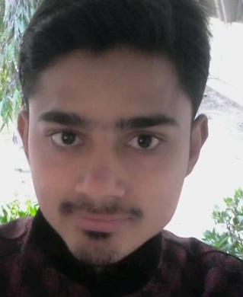Muhammad Mustafa

Civil Engineer

**Address:** HOUSE#E-111 M/9E, AKHARA TRUST SCHOOL COMPOUND BHIMPURA RANCHOREPURI ROAD, SADDAR TOWN KHI.

**Contact No.** +923352119700

**Email:** [mustafasheikh96@yahoo.com](mailto:mustafasheikh96@yahoo.com)

Education Profile

**B.E Civil Engineering (2016)**

NED University of Engineering & Technology, Karachi, Pakistan, 2016

Key Skills

Team lead / Management and solution analysis

Ability to rapidly build a relationship and Set up a trust

Site work & Execution.

Billing & Costing through Rate Analysis.

Confident and Determined

Ability to cope up with different situations.

Experience

To work in a firm with a professional work driven environment where I can utilize and apply my knowledge, skills which would enable me as a fresh graduate to grow while fulfilling organizational goals.

IT Skills

Engineering Software: MATLAB

AUTOCAD, C#

**MS Office**  Microsoft office including Word, Power Point, Spread Sheet (Excel).

•**BAHRIA ICON TOWER** **(20 APRIL - 24 JUNE 2014)**

Work as an internee in HRL

•**NESPAK (Dec 2014 – Jan 2015)**

• Work as an internee on “Trauma centre civil hospital”

• Twelve week workshop on communication gap between Civil Engineers and Architects from **Indus Valley Institute of Architects**

  • Experienced the engineering designs, drawings, surveying, execution and batching plant.

Project and Reports

* Final Year Project (Effect of Wheat Straw and Lime on Consistency Characteristics of Clay in Soil Mechanics ).

.

* Rate Analysis .
* Attended a seminar on “Construction Engineering” as final year civil engineering students in NED, Karachi.
* Review of following codes
* ACI -318/318R-05

Communication & Presentation Skills

* Fluent in written and spoken English.
* Fluent in written and spoken Urdu.
* Proficient project presentation skills.

Scholastic

|  |  |  |  |
| --- | --- | --- | --- |
| Qualification | Institute | Grade/Division/G.P.A | Year of Passing |
| BE CIVIL Engineering | NED University Of Engineering And Technology | 2.65 | 2016 |
| H.S.C | DJ Science College | A-1 Grade | 2011 |
| S.S.C (Science) | Hameed Muhammad Sec School | A-1 Grade | 2009 |

Achievements, Extra Curricular Activities and Interests

* Participated in workshop organized by ACI.
* Involve myself in attending Workshops and Seminars
* Playing cricket, football.

Personal Information

Father Name : Suleman

Gender : Male

Date of Birth : 15 may , 1993

Place of Birth : Karachi, Sindh, Pakistan.

Marital Status : Single

Nationality : Pakistani

N.I.C : 42301-9000110-9