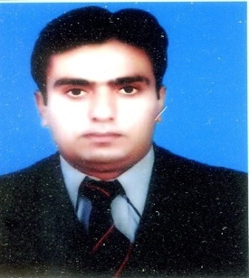**Muhammad Zulqarnain Zaheer**

**House no 2. Street no.2 mohalla islampura tahsil Yazman**

**Dis. Bahawalpur**

**Mob # 03007812045**

**PERSONAL DETAILS:**

Father’s Name : **Zaheer Anwer**

Date of Birth : 23-08-1986

CNIC No : 31205-6844840-1

Domicile : Bahawalpur (Punjab)

Religion : Islam

Nationality : Pakistani

Marital Status : married

Gender : Male

E-mail : zulqarnan_1943[@yahoo.com](mailto:msaqlainzaheer@yahoo.com)

**ACADEMIC QUALIFICATION**

|  |  |  |  |
| --- | --- | --- | --- |
| DEGREE | INSTITUE | BOARD/UNIVERSITY | MARKS OBTAIN |
| M.Sc (chemistry) | Islamia university | The islamia university bwp | 809/1450 |
| B.Sc | Govt.S.E college Bahawalpur | The islamia university of Bahawalpur | 371/800 |
| F.Sc | Govt.S.E college Bahawalpur | BISE.BWP | 639/1100 |
| Metric | Govt.high school yazman | BISE.BWP | 687/850 |

***ManagerialExperience***

* 2.5 year experience as ASM in Getz pharma
* 1 years experience as ASM in Kaizen pharma
* 1 year experience as ASM in Gemix pharma.
* Currently working as ASM in Highnoon labourties.

**Achievements and Certificates**

* Best Territory Manager in 2009 in Getz pharma.
* Certificates of basic pharmaceutical selling skills
* Certificate of Sale Excellence Training
* Certificate in leadership development program
* Certificate in pharmacovigilance Orientation program
* Appreciation certificate for the highest achiever of sales in national level from Getz.

**COMPUTER SKILLS**

* Inter Net, (Browsing, E-mail Processing)
* Office Management (Ms-Word, Ms-Excel, Ms-Power Point)

***Extracurricular Activities And Interests***

* Book reading
* Outing, traveling and discovering.

**OTHER SKILLS**

* A fast decision maker.
* Flexible attitude and confident.,Convincing skills with a logical mind.