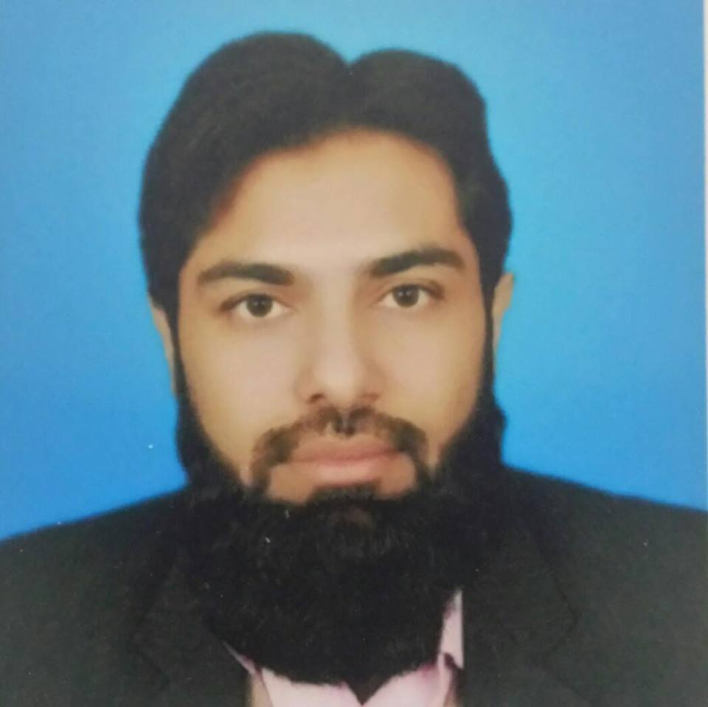

**Contact**

**Address**

House# A-253, sindh baloch cooperative housing society, Blk-12 Gulistan-e-Johar

Karachi, Pakistan

**Phone**

+923337802896

**Email**

naveedhussain221@gmail.com

**Personal**

**Father's Name**

Fida Hussain

**Date of Birth**

March 12th, 1980

**CNIC. No,**

54400-0518118-1

**Field(s) of Interest**

Field that optimizes my managerial skills.



Field that optimizes my communication skills.



**Personal Statement**

An optimistic thinker, capable and committed to work with an ability to meet agreed deadlines and co-ordinate work within a structured environment.



**Naveed Hussain**

**Objective:**

To enhance and use my managerial skills in the best possible way for achieving organization’s goals

**Work Experience**

|  |  |  |
| --- | --- | --- |
| **Duration** | **Organization** | **Designation** |
| 1-Jan 2013 - Present | Maxitech Pharma (Pvt)Ltd | Product Manager |
| 2-Jan 2012-Dec-2012 | Maxitech Pharma (Pvt)Ltd | District Sales Manager(Balochistan) |
| 3-Aug 2008- Dec2011 | Pfizer Pakistan | PSR (Norvasc Team Quetta) |
| 4-Dec2003-Aug2008 | Schering Asia GmbH | SPO ( Derma group Quetta) |

**Scholastics**

|  |  |  |  |
| --- | --- | --- | --- |
| **Year** | **Institution** | **Qualification** |  |
| 1998 -2003 | Balochistan UniversityQuetta | B-Pharmacy |  |
| 1996 - 1997 | Tameer-e Nau Public College Quetta | Intermediate |  |
| 1994 - 1995 | Islamia High School Quetta | Matriculation |  |

**Distinctions &Achievements**

* 3rd Position holder in B-Pharmacy .
* Highest sales achievement award in 2005 and won a trip to Germany.
* Won Pfizer’s FFRP award in 2010.
* Best Team award in 2011.
* Selected to launch Chantix (Tab) in balochistan.
* Selected for Pfizer’s Pilot project of online reporting.
* Preparation of training manuals for Maxitec Pharma(Pvt)Ltd.
* Conducted training session all over the country.
* Successfully Launch 2 mega products i.e. GlutaMax range (Skin Whitening Formula) and Hair Aid Capsules (To prevent hair loss) in 2013.

**Skills**

* Attended and got 1st position in initial class room training at Schering Asia.
* Successfully completed selling skill program (Rep-1) training.
* Attended and got 3rd position in Pfizer’s ICT.
* Successfully completed Pfizer’s selling skill module training and other international compliance and ethic programs training.
* Expertise in Ms Office, Product Package designing and printing, Sales Analysis, Territory and customer profile analysis.
* Expertise in field force training.
* Trade Mark registration from searching, filing, publishing, opposition, demand note submission and certificate issuance.

**Interests**

* Critical Thinking
* Analytical Skills
* Negotiating Skills
* Team Leader
* Religion
* Team Development

