**AADIL SALMAN KHALIQUE**  
Address: A-554, Phase 2, Gulshan-E-Hadeed, Bin Qasim, Karachi, Pakistan.  
Phone: +92 (0)300 4923893, +92 (0)21 34711231  
Date of Birth: 27th Oct 1989  
E-mail: [aadilsalmank@gmail.com](mailto:aadilsalmank@gmail.com)  
Website: <http://www.linkedin.com/pub/khaliqueaadil/55/877/1a9>  
  
  
Profile:

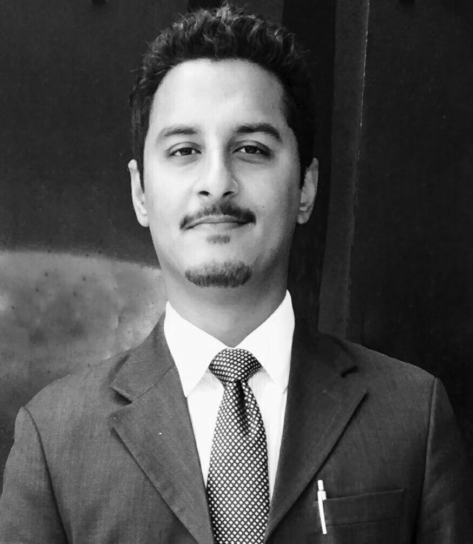

I have a passion to work in challenging sales and marketing atmosphere, i love meeting new people and good at convincing the masses as well as individuals by utilizing strong verbal and written communication. I always try to incorporate my skills and knowledge with enthusiasm and self believe in every task i work and consider every assignment as a learning opportunity. Creating & executing comprehensive tactics to derive business growth in persuasion of long term strategy of organization’s success is one of my strongest points. I'm always adaptable to change; i welcome new type of responsibilities that i have never done before gives me the most satisfaction and inspiration.  
  
  
**Work Experience:**  
Medical Information Officer- Sales and Marketing, at Novartis Aug 2015 to date  
I’m contributing wisely in marketing products to target potential customers, and firmly focusing on strike rate (prescriptions or demand) plus order size as well,   
In addition to retail sales boost up, i have also provided significant sales growth in key hospitals by navigating distribution network and in close liaison with KAM,  
Proactively participating in the sales promotion activities to enhance sales growth through full coverage of target territory spending 90% of available time in detailing activity and implementation of cycle plan,  
Simultaneously, I’m also playing a vital role in identifying key areas of improvement in order to increase market share.  
  
Product Specialist - Sales and Marketing, at 3A PharmaceuticalsOct 2014 to July 2015  
I provided dramatic increase in market share during my short tenure within the limited budget by successfully organizing market promotional activities,   
My major responsibility was to detail specialty product to clients and contribute in achieving organization’s sales goal by meeting as well as exceeding target qualitative and quantitative objectives,  
Optimistically scheduled calls by using my tome management skills and made productive sales presentations to clients, I have also performed contract and/or tender management activities, preparation and documentation of sales reports was also one of my responsibility,  
  
Territory Manager– Sales and Marketing, at Xemberg Pharmaceuticals   
Jan 2014 - Sep 2014  
  
Supervisor - Exam Services, at British Council Pakistan   
May 2013 - Oct 2013  
  
  
**Education:**   
Master of Business Administration - Marketing Sep 2015 – Aug 2017 (expected)   
*Institute of Business Management*

Bachelor of Science (16 Years) - Microbiology Jan 2010 - Dec 2013  *Federal Urdu University of Arts, Science & Technology*Higher School Certificate (12 Years) - Pre Medical Mar 2007 - Apr 2009 *Board of Intermediate and Secondary Education*Secondary School Certificate (10 Years) - Science Mar 2003 - May 2005 *Board of Secondary Education***Skilled Qualification and Training:**  
  
Novartis Customer Solution Model Apr 2016

*Novartis Academy of Excellence*

Diploma in Sales & Marketing Nov 2014 - Mar 2015  
*University College of Karachi*  
IELTS Certificate, Jan 2012  
*British Council Pakistan*   
  
Diploma of Computer Information TechnologyAug 2007- Jan 2008   
*Progressive Institute of Information Technology, Karachi*  
  
  
**Interests and Skills:**  
Sales and Marketing Management, New Business Development, Entrepreneurship, Excellent Presentation and customer service, Good working knowledge of MS-Office, Salesforce.com & CRM

Strong communication, excellent learning capacity, influencing and convincing capacity,Languages; English, Urdu, Punjabi and Sindhi

Traveling, reading, socializing, charity, sports,  
  
**References**

Available on request