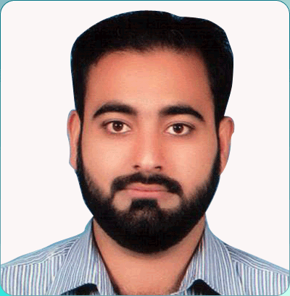

OWAIS HASSAN

|  |  |  |  |
| --- | --- | --- | --- |
| *Address : R-829 Sector 7D3, Shadman Town, Karachi.*  *Email : owaishassan10@yahoo.com*  *Cell : +92-345-2830009* | | |  |
| Objective: | Pursue a challenging position in an organization, by offering my enthusiastic services, and to polish my skills besides attaining organizational goals. |
| Experience: | February 2016 to Present IMS Health Pakistan  *AMERICAN – PHARMA CONSULTING*  **Admin Assistant**   * Tasks and Responsibilities same as my first joining   (Mentioned below).  March 2013 to Sept 2015 IMS Health Pakistan  *AMERICAN – PHARMA CONSULTING*  **Admin Assistant**  **Administrative Responsibilities:**   * Provide administrative support and assistance to senior management and business heads. * Drafting of emails, letters, memos, notices, business correspondence, and announcements for and on behalf of office. * Handling issues related to disposal of company’s assets in a cost effective manner. * Events organizing/planning, arrangement of client’s training. * Planning, coordinating and handling of all domestic & international incoming/outgoing mails, requests, queries to the Manager and ensuring that these are deal with expeditiously and where required, monitoring responses. Forwarding to others where applicable, and chasing up on responses. * Petty cash supervision and monitoring of expenses. * Dealing with clients and vendors (contract management) to ensure smooth business process. * Office & facility management (housekeeping supervision, maintenance of office assets, equipment & fixtures, ensuring timely submission of utility bills and other expenses). * Responsible for all domestic & international travelling (visa processing, visa letters/invitations, ticketing, hotel arrangements. * Involve in company’s budgeting of administrative expenses such as Domestic/International traveling, company’s assets management & procurement for the department. * Responsible for company’s assets procurement (collection of quotation, comparative analysis of costs, budgeting, raising POs, bills processing, payment settlement). * Fleet management.   **HR Responsibilities:**   * Responsible to maintain office attendance (in HCM i.e. employee leaves record along with leave application approval procedure). * Dealing in employee’s group insurance matters like (accidental, life and hospitalization insurances) and handling issues of OPD expenses. * Maintain HR files & employee database. * Assist in payroll after monitored and tracked the monthly attendance. * Provide support in posting internal/external job ads, in recruitment process (Managing profiles, short listing, and scheduling interviews) maintain database of candidates in EBI). * Handling matters related to the employee full & final settlement. * Responsible of implementation of HR/Admin policies & procedures. * Ensuring performance management cycle timely completion. * Organize trainings/employee orientations of new hires. |
|  |  |
|  | **July 2010 to March 2013 Aaj Television News**  *BUSINESS RECORDER GROUP*  **Admin Executive**   * Handle the acquisition, distribution, and storage of equipment and supplies. * Managing of company assets i.e. tagging, scheduled inspection. * Responsible for requisition and maintenance of office equipment including furniture and fixtures. Responsible for printing of office (brochures, newsletters, profiles & other stationary items). * Procurement (quotations, POs, bills processing). * Store handling/management. * Transport management (arranging & allotting of In-house/outsource vehicles for official purposes). * Monitor facility for security/Liaison with Govt. functionaries related to office security and other registration matters. * Communicate with internal and external customers & vendors on matters related to administration / office management activities. * Supervise the housekeeping and janitorial work. * Dealing in insurance & leasing matters of company’s vehicles. |
|  |  |
| Qualification: | M.B.A (HRM) Preston University  B.B.A University of Karachi    Intermediate Karachi Board  Matriculation Karachi Board |
| Extra Qualification: | Certification “Specialization in Human Resource Management”  (*Skill Development Council)*  Participation Certificate “HR Summit 2011”  (*Karachi University)*  Diploma “Information Technology”  (*Karachi University)*  Certification “e-Time/e-Attendance Management System”  (*EfroTech Services)* |
|  |  |

**Personal &** 1- Organizational & time management 2- Problem Solving

**Technical Skills:** 4- Negotiation 5- Event Management 6- Multi tasking

**Area of**  1- Administration 2- Human Resource

**Interest:** 3- Procurement

**Personal**

**Information:** Date of Birth : 14 Nov 1987

Religion : Islam

Nationality : Pakistani

C.N.I.C : 42101-9893840-3

Passport No. : AG1718402

**References:**

References will be furnished upon demand.