**Dr.QAZI FAHAD**

**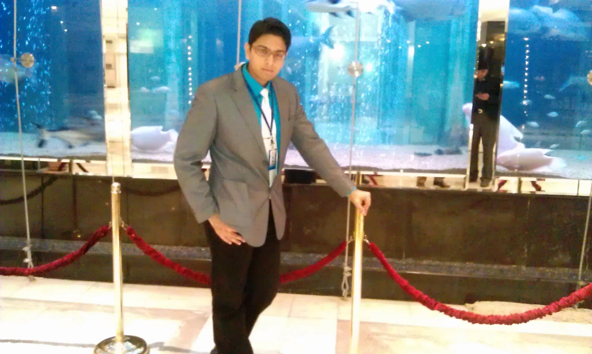  Mobile #** : 0333-3809808

03333005484

**P.T.C.L #** 02134650660

**E-mail** : hawk_qf@hotmail.com

**Address** : R-1012 block#1 Metrovile III

SCH 33 Gulshan-e-Iqbal Karachi

**Career Objective:**

To work in the marketing department of renown company

To obtain a position that will enable me to use my educational skills, educational background and ability to work well with people in the Field of Pharmaceutical & Skin care Marketing.

**Education:**

Post-Graduation                   MBA (Marketing & Branding)

                                                In 2013 from Iqra University KARACHI

 Graduation                           PHARM-D (Doctor of Pharmacy) (Registered Licensed Pharmacist)

                                                3.67   T.G.P.A

                                                In 2010 from FEDERAL UNIVERSITY (KARACHI)

 Intermediate                       ‘A’ grade with Medical science

                                                In 2004 from Karachi Board

                                                BAHRIA COLLEGE KARACHI

 Matriculation                       A-1 grade with Medical Science

                                                In 2002 from Karachi Board

                                                AGA KHAN SCHOOL KARACHI

**Work Experience (Total 5 years experience)**

1. **Brand Manager in Herbion International**

**From Oct 2013 till to date (two years)**

* Digital marketing
* Media planning including TVC, radio and out of house promotional activities
* Consumer division with prescription based products
* Local and International marketing
* Define the Brand strategy and roadmap for Brand growth
* Manage the entire product line life cycle from strategic planning to tactical activities Manage the product/brands growth as per market and segment growth
* Improve and extend existing market

1. **Assistant Product Manager in Martin Dow Limited**

**From June 2012 to Oct 2013 (1.5 years)**

* Define the product strategy and roadmap for product growth
* Manage the entire product line life cycle from strategic planning to tactical activities
* Specify market requirements for current and future products by conducting market research supported by on-going visits to customers and non-customers
* To monitor and conduct awareness sessions with doctors and building strong relationships with Key opinion Leaders
* Manage the product/brands growth as per market and segment growth
* Efficient utilization of human, finance and material resources
* Visiting field force all over Pakistan and providing them product training
* Improve and extend existing market

**ACHIEVEMENTS:**

- Successfully launch INSPRA (Montelukast) Brand

- Successfully launch MOKSECURE (Moxifloxacin) Brand  
 - Successfully represent company in Annual Neurosurgical conference 2012   
 - Successfully represent company in Annual Orthocon conference 2012

1. **MARKETING OFFICER IN AL-HABIB PHARMACEUTICALS**

**From 2010 to 2012 (2 years)**

**Performed following tasks**

* Sales Field work of both Oncology and Pharma division
* Training of field force
* Chamber meeting presentation to customer doctors
* Exploring new segments for old products
* Tender business management
* Customer relationship management

1. **INTERNSHIP IN BARRETT HODGSON (PVT) LTD**

Training in different departments of manufacturing plant, which are:

1         tablet manufacturing and blister department

2         liquid manufacturing and packaging department

3         sterile area, optical inspection and packing hall

4         Q.C lab including microbiological testing

5         Q.A inspection, documentation and validation departments

6         research and development department

7         Cephalosporin department

1. **JINNAH POST GRADUATE MEDICAL CENTRE (JPMC) KARACHI**

Clinical training in different departments (Clinical Pharmacy Practical of Pharm-D)

1         Taking Patient Case History and checking the Treatment Regime to optimize drugs effect.

2         Guiding Doctors regarding the side effect of several drugs in chronic diseases.

3         Prepared Assignment on Patient case history and treatment regime.

**Interest:**

**Marketing of Pharmaceutical Products**

**Skills and Abilities**

|  |  |
| --- | --- |
| SOFT SKILLS | ANALYTICAL SKILLS |
| Good Communication Skills  Good Presentation Skills,  Team Player,  Goal Oriented, | Creativity and Innovation  Customer Satisfaction Oriented,  Out of the Box Thinking,  Business Analysis Skills |

**Other Trainings and work shops**

* 1. English language course from **DOMINO ENGLISH LEARNING CENTRE**
  2. TOWS ans Space matrix workshop
  3. MBTI workshop

**Computer Skills**

* 1. IMS Plus
  2. MS Office 2000, Xp, 2003, 2007, 2013
  3. Familiar with Eviews, SPSS, QAM and all basic software

**Personal Information:**

**Father Name** :          QAZI SALIM

**Date of Birth**   :           23-08-1986

**Nationality** :           Pakistani

**Gender**            :           Male

**Religion**           :           Islam

**Marital Status** :           Single

**NIC #**             :           42101-1046654-5

**Phone** :           0213-4650660

**Mobile #** :0333-3809808

**E-mail** :**hawk_qf@hotmail.com**

**Address** :           **R-1012 block#1 Metrovile III SCH 33 Gulshan-e-Iqbal** **Karachi**

**Awards and Certificates:**

**1st** Position in QUIZ COMPETITION in class 7th held in Aga Khan School on 16-5-1998

**1st** Position in QUIZ COMPETITION held in Bahria Collage on 10-3-2003

**Reference:**

Will be provided upon request