Rao Atif Jahangir

Pharmacist (Pharm.D IUB)

Multan, Punjab, Pakistan

+92 300 7307244

raoatif11@gmail.com

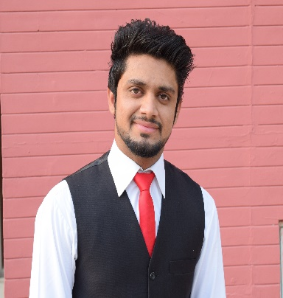

Carrier Objective: __________________________________________________

To work as a pharmaceutical marketing professional in an organization where I can generate dynamic results through my experience, to contribute to the development of a profitable client relationship and product success.

Work Experience____________________________________________________

* 6-months clinical clerkship in Bahawal Victoria Hospital (BVH) Bahawalpur.
* Survey based research conducted on “Evaluating Sources of Drug Information Being Used by Health Care Professionals and Quality of Preferred Sources in Contrast with Given Standards”.
* Survey based research conducted on “Prevalence of Underweight, Overweight and Obesity Among University Students and Their Associated Factors in Relation With Diet and Physical Activity.

Core Competencies__________________________________________________

* A demonstrated self-starter with strong technical, communication, and presentation skills
* strategic plans
* forecasting
* client relationship management
* negotiation
* Marketing
* product management
* Honesty with work

Computer skills_____________________________________________________

* MS Word
* MS Excel
* MS Power point
* MS Windows
* Internet and E-mail
* Different Software Utilities

Interests____________________________________________________________

* book reading
* web surfing

Communication Languages___________________________________________

* english
* urdu
* punjabi
* saraiki

Academic qualifications_____________________________________________

|  |  |  |  |
| --- | --- | --- | --- |
| Degree | Year | Division | Institute |
| Pharm D | 2010-2015 | 1st | IUB |
| Fsc Pre Medical | 2008-2010 | 1st | Misali Zakaria |
| Matriculation | 2006-2008 | 1st | Allama Iqbal |

References__________________________________________________________

* references will be provided on demand.