Rao Atif Jahangir

Pharmacist (Pharm.D IUB)

Multan, Punjab, Pakistan

+92 300 7307244

raoatif11@gmail.com

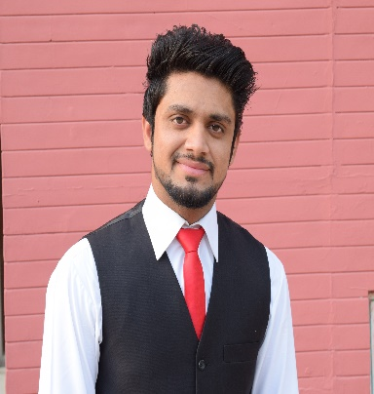

Carrier Objective: __________________________________________________

To work in a pharmaceutical industry as Pharmacist is my passion, in an industry I can generate dynamic results through my experience, passion, hard work and competency.

Work Experience____________________________________________________

* One day visit of Quality Control department, Production department and Raw material department of Shaigan Pharmaceutical.
* 6-months clinical clerkship in Bahawal Victoria Hospital (BVH) Bahawalpur.
* Survey based research conducted on “Evaluating Sources of Drug Information Being Used by Health Care Professionals and Quality of Preferred Sources in Contrast with Given Standards”.
* Survey based research conducted on “Prevalence of Underweight, Overweight and Obesity Among University Students and Their Associated Factors in Relation With Diet and Physical Activity.

Core Competencies__________________________________________________

* A demonstrated self-starter with strong technical, communication, and presentation skills
* strategic plans
* forecasting
* Management
* Calculations
* Honesty with work

Computer skills_____________________________________________________

* MS Word
* MS Excel
* MS Power point
* MS Windows
* Internet and E-mail
* Different Software Utilities

Interests____________________________________________________________

* book reading
* web surfing

Communication Languages___________________________________________

* english
* urdu
* punjabi
* saraiki

Academic qualifications_____________________________________________

* Pharm. D
* F.Sc (pre-Medical)
* Matriculation (Science)

References__________________________________________________________

* references will be provided on demand.