Rao Atif Jahangir

Pharmacist (Pharm.D IUB)

Multan, Punjab, Pakistan

+92 300 7307244

raoatif11@gmail.com

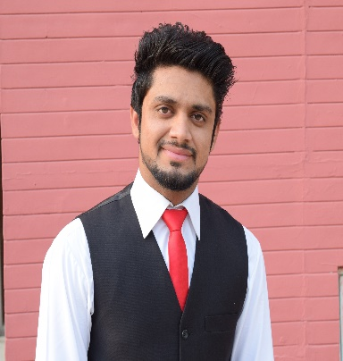

Carrier Objective: __________________________________________________

To work as a pharmaceutical sales/marketing professional in an organization where I can generate dynamic results through my experience, to contribute to the development of a profitable client relationship.

Work Experience____________________________________________________

* 6-months clinical clerkship in Bahawal Victoria Hospital (BVH) Bahawalpur.
* Survey based research conducted on “Evaluating Sources of Drug Information Being Used by Health Care Professionals and Quality of Preferred Sources in Contrast with Given Standards”.

Core Competencies__________________________________________________

* A demonstrated self-starter with strong technical, communication, and presentation skills
* strategic plans
* forecasting
* client relationship management
* negotiation

Computer skills_____________________________________________________

* MS Word
* MS Excel
* MS Power point
* MS Windows
* Internet and E-mail
* Different Software Utilities

Interests____________________________________________________________

* book reading
* web surfing

Communication Languages___________________________________________

* english
* urdu
* punjabi
* saraiki

Academic qualifications_____________________________________________

* Pharm. D
* F.Sc (pre-Medical)
* Matriculation (Science)

References__________________________________________________________

* references will be provided on demand.