CURRICULUM VITAE

**MUHAMMAD**

**RIZWAN**

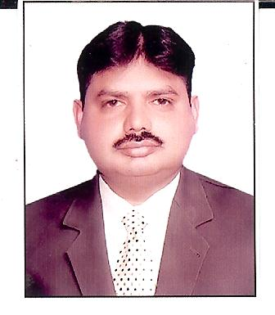

House # E/354, Al-Sadaf Colony Sector 10 Orangi Town Karachi 41.

Cell # +92303-2311982

+92334-3759476

**Email:** [mrizwan3546@gmail.com](mailto:mrizwan3546@gmail.com);

mrizwan_30@yahoo.com

Skype id: Muhammad.rizwan599

**Personal:**

• Father’s name

Muhammad Ihsan

• Marital Status

Married

• Languages

English, Urdu,

Sindhi, Punjabi

**References:** Will be provided on demand.

**Objectives:**

• Seeking a position in a dynamic organization, a place where I can further boost-up my skills while applying my present expertise to exceed company’s expectations.

**Professional Experience:**

**Senior Territory Manager**

**Abbott Laboratories Pakistan**

**December 20th, 2004-------- Present.**

**Job responsibilities:**

* Achieving and exceeding annual sales target.
* Arranging regular appointments with doctors, pharmacists and hospital medical staff.
* Planning work schedules, weekly and monthly timetables. This may involve working and discussing future targets with the district sales manager and Sales Manager.
* Organizing continuous medical education programs for doctors.
* Building and maintaining positive working relationships with medical staff and supporting administrative staff.
* Keeping detailed records of all contacts.
* Regularly attending company meetings, presentations and briefings.
* Keeping up to date with the latest clinical data supplied by the company, and interpreting, presenting and discussing this data with health professionals during presentations.
* Monitoring competitor activity and competitors' products.
* Developing strategies for increasing opportunities to meet and talk to contacts in the medical and healthcare sector.
* Ensuring proper supply and availability of my products in hospitals and on chemist level.

**Professional Achievements:**

**Other Functions/Roles:**

**Academic Qualifications:**

**Professional Trainings:**

• Achieved and exceeded company’s objectives/targets within given timeframe for 8 years.

• Established pool of KOL’s for company’s products.

• Achieved highest ever institutional business.

• Developed new businesses in the given territory.

• Established Serc brand extension (24mg).

• Arranged several successful CMEs on different products.

• Provide field training and guidance to new Medical Representative.

• Conduct fortnightly meeting in absence of Regional Sales Manager.

|  |  |
| --- | --- |
| **Degree** | **Institution/University** |
| Bachelor of Science  (Pre-Medical) | Shah Abdul Latif University  Khairpur Mers Pakistan |
| Master of Business Administration (Marketing) | Iqra University Karachi Pakistan |

|  |  |
| --- | --- |
| **Name of the Training** | **Institution/ Organization** |
| TOPS----Techniques of Persuasive Selling. | Abbott Laboratories Pakistan |
| FOS-------Focus on Selling. | Abbott Laboratories Pakistan |
| I-Sell Training. | Abbott Laboratories Pakistan |
| Pharmacovigilance Training. | (Abbott Laboratories Pakistan) |

|  |
| --- |
|  |