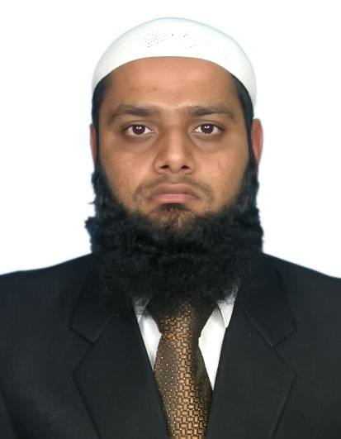SALMAN KHATRI

**Address:**Flat no.9, 5th Floor, Baitul Hashim Manzil,

Adjacent Liyari Telephone Exchange,

Baghdadi Liyari Karachi.

**Mob #** **0333-3085312**

**E-mail:**[salman.khatri@hotmail.com](mailto:salman.khatri@hotmail.com)

**Professional Objective**

**To Achieve a Bright Career in Pharmaceutical Management & Marketing.**

### Professional Experience

* **Currently** worked as **Product Manager** in **Solace Pharma (SJ&G Fazull Elahi)** from **5th May 2014** till date.
* Responsible for **Drate** (Alendronate)**,Edonax** (Zoledronic Acid)**, Adenuric** (Febuxostat)**,Motu** (Meloxicam)**,GabaFix**(Gabapentin)
* Training & Development of All Products
* We Took this Division from **9 Million** and in year bring group on **15.5 Million per month**.
* **Burgeon Macrobiotics** as **Product Manager** from **17 Dec 2013 to 5th May 2014 .**
* Launch World # 1 Vitamins Quali by DSM.
* **Zephyr Pharmatec (Pvt) Ltd** as **Assistant Product Manager** from **26 Feb 2013 to 16 Dec 2013.**
* **Glaxosmithkline** as **Medical Representative** since **31 March 2011to 5 April 2012.**
* Attend PSM at Multan in Jan 2012.
* Part of New Research Product Launch **DUODART**.
* Attend PSM at Thailand in July 2011
* Done Initial Training Course from GSK (40 Days Training Program)

**Academic Development**

* **MBA (Marketing) from Bahria University Karachi 2013.**.
* **Pharm D. ( Doctor of Pharmacy )** from **Hamdard University** Karach,**2010**.
* **F.Sc (Pre-Medical)** from **Bahria College NORE 1**, Karachi, **2005**
* **S.SC** from **Agha primary and secondary school**, Karachi, **2003**

**Relevant Skills**

* Team Development
* Sound Knowledge of drugs with generic, brand names
* Good negotiating communicating skills.
* Ability to work under pressure, individually or as part of team.

### Extra Curricular Development during Academic Life

* Internship in **(ELKO Pharmaceutical – Organization (Private) Ltd)** from **(21 Dec 2009- 12 Jan 2010)**

* Participated in **(Novartis Local Biocamp) (18-19 June 2010)** organized by **(Novartis Pharma (Pakistan) Limited) at Pearl Continental Hotel Karachi.**
* Participated in **(Three –hour turnshop on Leadership in Action)(19 June 2010)** organized by **(Torque for Novartis Pharma Biocamp) at Pearl Continental Hotel Karachi.**
* Internship in **(PATEL HOSPITAL)** at **Gulshane - Iqbal** in july 2010.
* Arranged Seminar with **ingrope information services** at **Hamdard University** on **(22 Sep 2010)The Expert Speaks** on **(Understanding the Fundamentals of GMP & Pharmaceutical Industry Expectations From Young Pharmacist)**
* Participated in (**Training for Effective Presentation Skills Program) (17 Apr 2010)** organized by - **(Ingrope Information Services)**
* **Presentation Skills (21 June 2007)**  
  Training for presentation and personal skill developments - **(National Productivity Organisation Ministry of Industrial, Productivity and Special Initiatives, Government of Pakistan)**
* **ISO 9001 : 2000 Quality Standards (5 July 2007)**  
  **Training for standards and procedures for quality standards.** – **(National Institute of Labour, Manpower and Overseas Pakistanis, Government of Pakistan)**
* Participated in **Debate Competition** **(19 Apr 2008)** and **attend Workshop** at Jamshoro **(26&27 Aug 2008)** organized by – **(Transparency Internaional – Pakistan)**
* Participated in **Debate Competition (10 Sep 2009)** organized by **(Culture Wing Community Development Department City District Government Karachi)**
* Participated in Seminar on **Fundamentals of GMP** **( 23 Feb 2010)** organized by – **(Ingrope Information Services)**
* Attend Symposium on **Violoence in Health Care Settings Responces & Way Forward** **(26 March-2010)** at **Aga Khan University Hospital.**
* Attending Seminar on (**Current status and future scope of pharmacy in Pakistan) (11 May 2010)**  organized by (**Baqai Medical University)**.
* Attend Seminar on **(Research and Development Startegies and Application in Pharmaceuticals) (10 June 2010)** organized by **(Federal Ministry of Health Research & Development Government of Pakistan)**

**Computer Skills**

* Microsoft Office tools.
* Browsing Ability

**PERSONAL**

* Father Name: Muhammad Yousuf
* Date of Birth: 08-Aug-1986
* Marital Status: Married
* Religion: ISLAM
* NIC #: 42301-3693345-7
* Language Urdu,English

**References**

Will be furnished upon request.