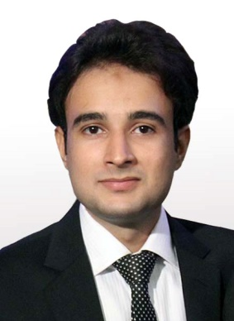Shaheryar Hassan

* House No # A-52 L.S.R Staff Society Block/14 Gulshan-e-Iqbal Karachi.
* +92-315-0200603 +92-321-2710101 +92-21-34890776

[shaheryar.hassan@outlook.com](mailto:shaheryar.hassan@outlook.com)

 https://pk.linkedin.com/in/shaheryar-hassan-7731a596

# Objective:

To have the opportunity to be a part of a team in an established company, that will allow the use of my Experience, abilities and knowledge. Along with personal growth and enhancement collegiately, improving and acquire new skills.

# Personal Skills & Competences:

Leadership: A proven leader, Friendly with an upbeat attitude work effectively with diverse group of people, Committed to Excellence.

Professional: Ambitious, Hardworking, Fast Learner. Adept well to change and pressures in work place.

# Education & Antecedents:

MASTERS, MBA-Marketing (Under Process)

GRADUATION, B.COM

INTERMEDIATE, Commerce

MATRIC, Science

# Professional Qualification:

AMSP, Arena Multimedia Specialist Program.

# Professional Experience:

Novartis Pharmaceuticals Consumer Health OTC: **Mar 2010 – Dec 2012**.

2 Year Experience as a BMD Supervisor

# Core Responsibilities:

Arrange BMD camp for awareness on Deficiency of Calcium

Close interaction with 6 BMD coordinators in Karachi

To achieve the sales target assigned by marketing Department.

To Develop KOLs in the define Territories

To arrange Patient awareness programs.

# INTERNATIONAL BUSINESS:

Neospirax Healthcare Export Division.

2.5 Year Experience as a Assistant Product Manager -Afghanistan: **May 2013 – Oct 2015**

Mediate Pharmaceuticals Pvt Ltd.

1 Year Experience as a Product Manager-International Business. **Oct 2015 Present**

# Core Responsibilities:

* Market Development
* Product Management:
* Sales Management:
* Logistics Management:

# Professional Travelling:

2 professional Visit Afghanistan

4 visit Peshawar for field force training

# Software Proficiency:

Graphic Software. Special FX.

Adobe Photoshop Adobe After effect

Adobe illustrator Cinema 4-D

# Microsoft Office:

MS WORD

MS EXCEL

MS POWER POINT

# Operation System:

Mac

Windows XP, 8 , 10

# Personal Info:

Father Name: Shadab Hassan

Date of Birth: July 27, 1992

N.I.C No: 42201-2117028-3

Religion: Islam

Nationality: Pakistani

Martial Status: Single

# Reference:

Available Upon Request