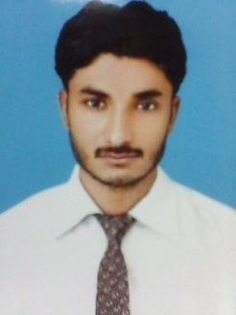 **SOHAIL AHMED**

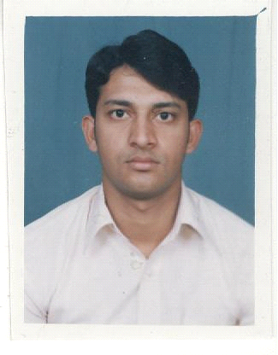

HOUSE NO. 139, AREA 51B,

KORANGI NO.6, KARACHI.

Contact No.: **0343-3523025**

E-mail:[**sohailsiddiqui1000@gmail.com**](mailto:sohailsiddiqui1000@gmail.com)

**OBJECTIVE:**

Challenging opportunities in a dynamic firm that can use my skills and allow Professional Growth

**ACADEMIC QUALIFICATIONS:**

* B-PHARMACY (2006) University Of Sindh Jamshoro
* Intermediate Hyderabad Board
* Matriculation Hyderabad Board

**WORKING EXPERIENCE:**

Executive Production Officer in **NABI *QASIM* INDUSTRIES (LIQUID MANFUCTURING AREA)** from November 2014 to November 2015.

**JOB DESCRIPTION**:

* Manufacturing of Syrups and Suspensions
* Manufacturing of Creams and Ointments
* Manufacturing of Eye drops Ear drops
* Manufacturing and filling of purified water
* Manufacturing of Keen Enema
* To increase the productivity by controlling the production losses, increasing the Batch sizes, Process alteration, Machine efficiency and Rejection control
* To implement the compliance of all the activities in the Production as per cGMP requirements
* To ensure that working in Plant is safe, Healthy & Environment friendly
* Production planning with available resources and capacity.

**EXPERIENCE:**

Worked as Sr. production officer in **INDUS *PHARMA* KARACHI** from MAY- 2013 to JUNE- 2014

* **WORKED IN FOLLOWING DEPARTMENTS:**
* CALCIUM SACHET FILLING AND MANUFACTURING SECTION HEAD (PLUG)
* TABLET MANUFATURING AND PACKAGING
* (O.R.S) SACHET FILLING AND MANUFACTURING

Worked as *production officer* in **NOVARTIS *PHARMA*** from Feb- 2007 to Jan- 2012

* **WORKED IN FOLLOWING DEPARTMENTS:**
* TABLET MANUFACTURING (EFFERVECENT)
* TABLET PACKAGING
* PRINTING PRESS
* RED PRODUCTS (ANTI TUBERCULOSIS)
* DRY SUSPENTION MAUFACTURING AND PACKAGING AREA
* TABLET MANUFACTURING OF CALCIUM PRODUCT (QALSAN)
* WORKING ON S.O.P
* TABLET PACKING (EFFERVECENT) CAC 1000.

**TRAININGS:**

* Current Good Manufacturing Practice (cGMP) training
* Good Documentation Practices (GDP) training
* Teamwork skill development training
* QRM (Quality Risk Management) training

**INTERNSHIP / TRAININGS:**

|  |  |
| --- | --- |
| *Internship* | Six Weeks **Novartis Pharma** Jamshoro, Sindh  **Trainee Pharmacist**  **Pharmaceutical Production Section.**  -1 Solid Oral Section.  -2 Syrup Section.  -3 Ampoule Section.  **Pharmaceutical Quality Assurance Section.**  -1 Raw Material Laboratory.  -2 Semi-Finished Laboratory.  -3 Stability Laboratory.  -4 Micro Laboratory.  -5 IPC Laboratory.  -6 Packaging Laboratory.  -7 Research & Development Laboratory.  **Pharmaceutical Warehouse.**  -1 Raw Material Warehouse.  -2 Packaging Material Warehouse.  -3 Finish Good Warehouse. |

**OTHERS:**

Participated in Annual sell conference held in Malaysia 5th Jan to 10th January

**MERITS:**

* Good communication and interpersonal skills
* Excellent Scientific & Analytical Capability
* Confident and capable to work independently & Leadership skill
* Good computer skills (MS OFFICE, INTERNET, MS POWERPOINT, MS OUTLOOK)

**PERSONAL PROFILE:**

* Name Sohail Ahmed
* Father’s Name: Ahmed Saeed
* Phone No: 0345-3653068
* Mobile No: 0343-3523025
* N. I. C No: 41303-1479686-5
* Domicile: Hyderabad (Sindh)
* Date of Birth: Feb 20, 1983.
* Marital Status: Married.

**REFERENCES:**

* Jamil-ur-Rehman siddiqui (Head of solid department)

Novartis pharma jamshoro.

* Syed shakir ali bukhari ( production head ) linz pharma karachi