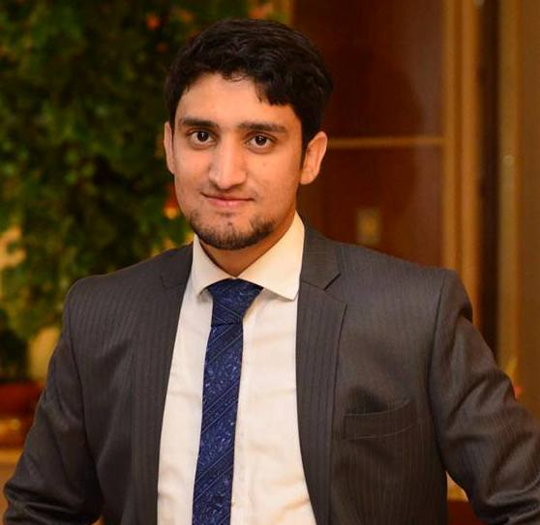**SOHAIL SIDDIQUE KHAN  
Address:** House No 651/43,Tariq Lane, Range Road, Afshan Colony, Rawalpindi,Pakistan.  
**Mobile :** +923365243609  
**Email:** sohailkhan4200@gmail.com

**Career Objectives:** To motivate the sales force for the target oriented customers and training a team on new dimension of marketing strategies.

**Educational Qualifications:**

* Matriculation from Bahria Foundation College,Westridge in 2008.
* Intermediate in Pre medical from Army Public College in 2010.
* Bachelors from Sargodha University in 2012
* Doctor of Pharmacy from Hamdard University,Islamabad in 2014.
* Master in Business Administration from Preston University Islamabad in Progress

**Professional Experience:**

Territory Manager in Abott Laboratories(Pvt)Ltd from 1st of July 2014 to 1st of March 2015

Product Development Manager in Orbit Naturals(Pvt)Ltd from 1st of March 2015.

**Job Description:**

* Engaging and Managing sales force of Nutritional Products.
* Responsible for managing and analyzing potential customers and target sales force on effective product portfolio.
* Organizing educational conferences, Seminars and Knowledge sharing sessions on product portfolio**.**

**Special Assignment :  
  
Working for the Nutritional products registration with regulatory Affairs department. So have expertise in dealing with drug regulatory health matters.**

**AREAS OF EXPERTISE**

* Targeting opening
* Core Message Deliver
* Will to Win
* Obstacles Handling
* Closing With Confidence
* Micro-Marketing (Arrow) Salesmanship
* Exceeding targets
* Direct sales
* Forecasting planning
* Promotions
* Sales initiatives
* Negotiation skills
* Product knowledge
* License2Sell

**Soft Skills:**

* Expertise in Microsoft Office,CS5 and Corel Draw.
* Report Writing
* Budgeting

**Professional Memberships:**

* Working as a core team member of Meddy Bear International which is an forum for medical professionals around the world.
* Working as a core team member of Pakistan Pharmaceutical Student Federation.

**Interests:**

* Reading Books
* Writing
* Blogging

**Personal Information:**

Date of Birth : 29/03/1992

Father Name : Sardar Muhammad Siddique Khan

NIC : 37405-1737133-7